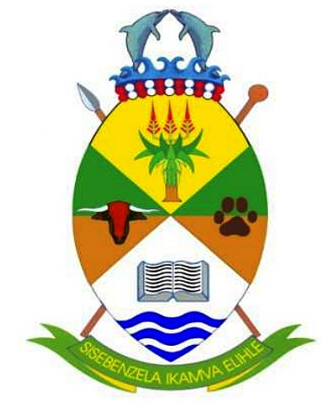
NDLAMBE LOCAL MUNICIPALITY
PUBLIC NOTICE TO CONVINE A COMMUNITY MEETING

PROJECT NAME: COMPLETION OF 2.6 ML WATER ELEVATED TOWER AT THORNHILL-WARD 6, 7, 8 AND 9-PORT ALFRED.
PROJECT SPONSOR: NDLAMBE LOCAL MUNICIPALITY AND OTHER SECTOR GOVERNMENT DEPARTMENTS.
Notice is hereby given in accordance with 1996 Constitution Act 108, s 152 (1) sub-paragraph (e) which instructs local municipalities to encourage the involvement of communities and community organizations (explicitly, organs of civil society).
Both direct and indirect affected residents of ward 6, 7, 8 and 9 are cordially invited to attend a community meeting to be updated about the work that will or is taking place to Complete Thornhill Water Elevated Tower which is linked to Thornhill Ministerial Housing Development.
Details of the Community Engagement are as follows:-
- Venue: Titi-Jonas Multipurpose Centre;
- Time: 17h:00;
- Date: 13th June 2024 (Thursday).
For any further information or clarity please do not hesitate to contact Mr. Sipho Tandani, 1012: ISD-Sub-Consultant at (082) 3510 202, email: sipho.tandani@yahoo.com/tandani@amangwevuinevstment.com or Mr. D Mkhwelo at (063) 7824 223-Ndlambe Local Municipality.
_____________________ ________________________
Adv. R Dumezweni Contract: 143/2023
Municipal Manager

