NDLAMBE WATER, WASTE WATER & WASTE: RINGFENCING, COST OF SUPPLY AND TARIFF STUDY – 2022/2023 COSTS

Table of contents:

1. INTRODUCTION. 1
2. METHODOLOGY. 1
3. RINGFENCING. 2
3.1. Key focus areas 2
3.2. Methodology applied 3
3.3. Overhead cost allocation 3
4. CUSTOMER CONSUMPTION PATTERNS. 6
5. TARIFFS. 6
6. ALLOCATIONS WITHIN EACH DEPARTMENT. 8
7. PRICING 8
8. INDIGENT POLICY. 9
9. WATER SUPPLY 9
10. SEWERAGE / SANITATION 21
11. WASTE MANAGMENT. 28
12. PROPOSED TARIFFS 36
13. CONCLUSIONS 38

INTRODUCTION.

Ndlambe Municipality (Ndlambe) sanctioned a comprehensive Water, Waste water & Waste pricing study which contains 3 main components:

- Ringfencing. The key objective of this part of the study is to establish the true cost and revenue of the specific service in the municipality.
- The Cost of Supply study. The objective of the cost of supply study is to know the cost of supplying customers on each tariff and to compare this with the revenue from current tariffs and thus the cross-subsidies.
- Tariff study. The final step is to analyse the structure of the tariffs and how it differs from the cost structures and identify the cross subsidies within the tariffs and then to propose new tariffs.

This paper describes the details relating to all three components of the study undertaken for Ndlambe Municipality. It contains the detailed results for the whole area.

METHODOLOGY.

Nation treasure has issued a model by which to undertake the cost of supply for the various services. The approach followed by Elexpert is similar but different:

- The National treasure model only addresses the revenue requirement of each service. In other words the average revenue to be generated to cover the relevant cost.
- The Elexpert method identifies the costs per activity so that appropriate tariffs with the cost based charges can be developed.
- National treasury approach uses the budgeted figures.
- Elexpert used the actual data for the completed financial year and then applies and average increase based on the budgeted figures. The reasons for this is as follows:
  - Experience has shows massive differences between the budgets and the actual amounts spent per service. This is mainly due to budget cuts that take place during the year. The budget figures thus do not represent the reality.
  - Details budgets are not prepared per different activity within the various services.
  - The asset registers are not yet updated to reflect the capital expenditure of the previous year.
  - The sales per tariff charge is not done in detail.
  - Situations such as drought and load shedding make it almost impossible to forecast and based tariffs on such uncertain data.
- The bottom line of the Elexpert approach is that the future costs are reflected in the proposed annual price increase.

RINGFENCING.

Before one can calculate the revenue requirement, a ringfencing study needs to be completed to determine the true costs and revenues and specifically overheads that should be charged to the specific service by the municipality.

Because it is best to do cost functionalization as early as possible in the process, it is done as part of the ringfencing study. In other words, the costs within the specific service are identified and then costs are allocated from the various support functions in the municipality towards each of the various functions in the specific service.

Key focus areas

There are a host of practices that affect the accuracy of the cost and revenue of current municipality the specific service distributors. The following ones will take the key attention:

The focus will firstly be on the larger items and thus the 20% of items that have 80% of the impact.

Services being supplied by the specific service to the rest of the municipality where no charge is levied to cover the cost of supplying such service. The services involved here include the following: Electrical maintenance of municipality facilities such as water works, sewerage works, buildings, houses etc.

Specific service equipment and other resources being used by the rest of the municipality with no charge. This typically includes the following: Heavy vehicles, large machinery, meter readers etc.

Public lighting including streetlights, high mast lights, robots, parking lot lights, etc. This service is considered a municipality service and not part of the specific service supply although the service is provided by the specific service.

Specific service for own use by municipality. Many municipalities have a different set of tariffs for the supply of the specific service for use by its own facilities, such as municipal buildings, stores, sewerage supplies, water pumping and sometimes also for staff. If these tariffs are not cost reflective it has the effect of distorting the true the specific service supply cost/revenue and thus surplus. In some cases, an overcharge is made to the municipality in the tariff and in other cases an undercharge.

Services provided to the specific service by the municipality. Typical services include the following: Meter reading and billing, revenue collection, general accounting and administration, call centres, stores, supply chain, etc. The extent to which this is done, differs significantly between various distributors. The big problem here is the extent of allocation of these costs made to the specific service department. As accurate as possible method should be used.

Methodology applied

The process starts with an analysis of the Total Municipal Trial Balance for the completed financial year. These are the figures that are used as the basis for the compilation of the Annual Financial statements.

In analysing the Ndlambe data the following key steps were followed to achieve accurate ringfencing:

- The data was ordered as follows:
  - The head office, support and administrative functions. These are not considered primary service delivery but act as support to the various line functions and as such the line departments should cover their costs.
  - Community services, the economic services trading services. These are considered the primary service delivery to the community and need to carry all costs of the overheads and service departments.
- The various sub-departments and cost categories are grouped to make viewing practical.

This process is illustrated graphically in Figure 10 below.

Figure 10
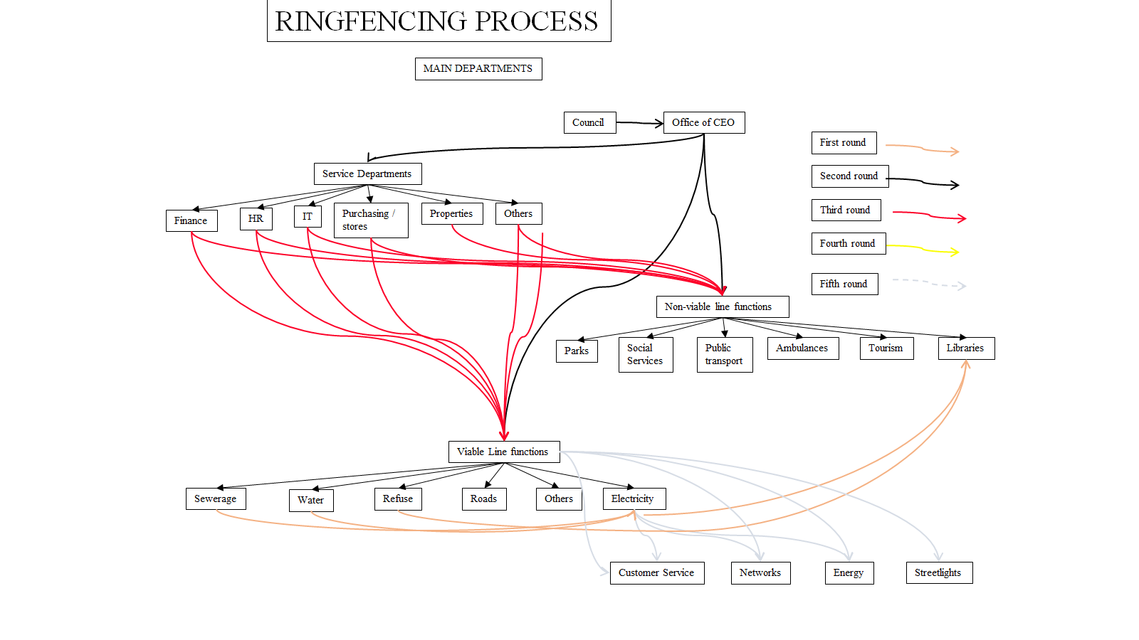

Table 24 shows the trial balance per group before any adjustments.

The only adjustment done is to remove the capital grant income as this must cover capital costs not operating costs.

Overhead cost allocation

The next step is to calculate the fair portion of the municipal overheads that should be covered by the the specific service department. It was previously stated that no overhead costs have been allocated to the specific service. The next section does a calculation of a fair amount which should be allocated to all the line functions in the municipality by overhead and service departments. The first step is to calculate the ratios of various possible allocation factors using actual data.

Various ratios were analysed. The problem found was that in many cases the data required was inadequate in terms if not reflecting the required departments or in many cases were all grouped together. It is however believed that these ratios provide a fair means of allocating overhead costs.

The table below then shows the following:

ALLOCATER DATA.
- This refers to the various allocation bases which are to be used.
- The first line shows the data used
- The second line shows the ratio which will be applied in allocating the service department costs to that line department.
- This is calculated by dividing the line department units by the total units of all line departments.

ALLOCATION TO LINE DEPARTMENTS
- This shows the amounts allocated from each service department to the various line departments.
- The first column shows the name of the Service department.
- The second column shows the basis for allocation of the cost. Various basis were considered and inputs from staff was obtained at the workshops. Unfortunately, only those where data was provided could be used.
- The third column shows the percentage of the service department costs to be allocated on the basis.
- The cells in yellow shows the amounts allocated from the service department as a (_).
- The other cells show the amounts allocated to each line department.
- The last column shows that the net amounts sum to zero.

NEW NET INCOME
- This shows the new costs / revenue per department after the cost allocations.
- The subsequent new net income.

The following should also be noted:

- The Municipal and General is a problematic cost centre because:
  - The majority of grant funding is collected under this account. This will not be off-set against line department costs.
  - Various very big costs which belong to line departments are also collected here. The following is proposed in this respect:
    - Only the big cost items minus the small, related incomes will be allocated to the line departments.
    - Bad debt written off. This mainly relates to rates income thus based on total line depart cost.
    - Depreciation. This is only on common assets. Total line depart cost.
    - Inventory and consumables. Total line depart cost.
    - Interest costs relating to retirement benefits. Line department labour cost.
    - Leave pay. Line department labour cost.
    - Various operational costs. Total line depart cost.
- Municipal manager. All costs allocated to Line departments based on total own costs.
- Financial services.
  - Asset and risk based on asset values.
  - Billing finance based on number of bills per service.
  - Debt collection based on outstanding debt per service.
  - Supply chain based on inventory.
  - Remainder based on total cost. Net amount minus property rates income.
- Corporate services. Total net amount.
  - All HR functions according to staff numbers.
  - Remainder based on total cost.
- Strategy and Economic development. Net amount all based on total cost.

The actual allocations from the various departments are shown in Table 27.

The next step is to allocate the costs between the various sections within the specific service. This is done in the various sections relevant to each service.
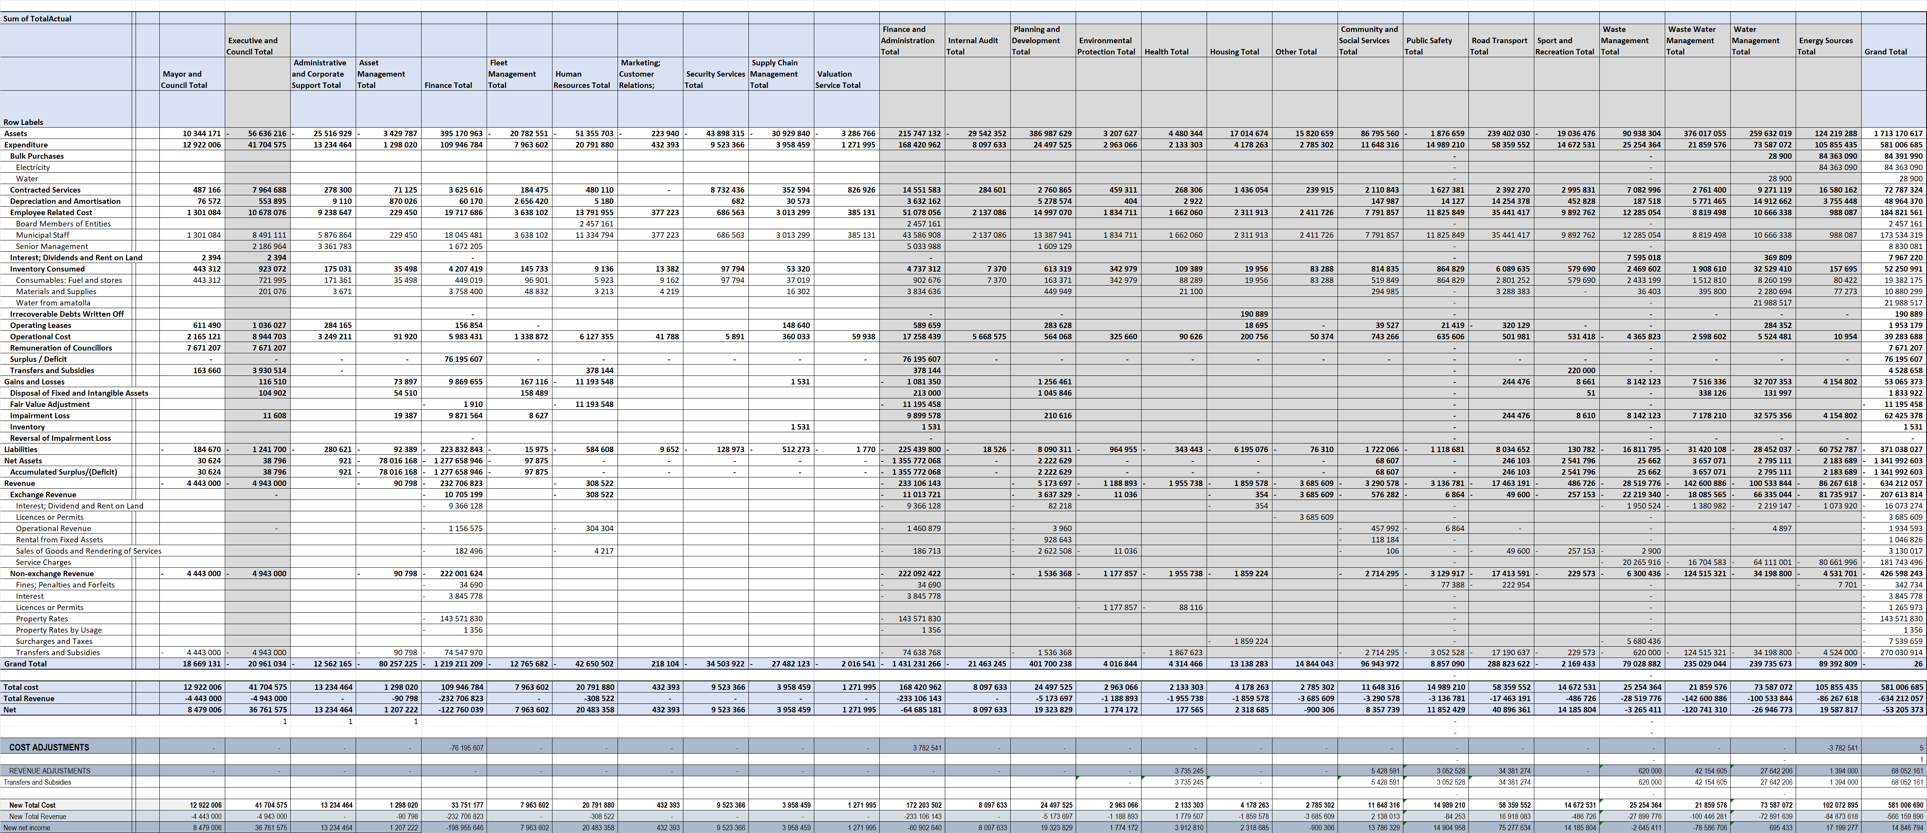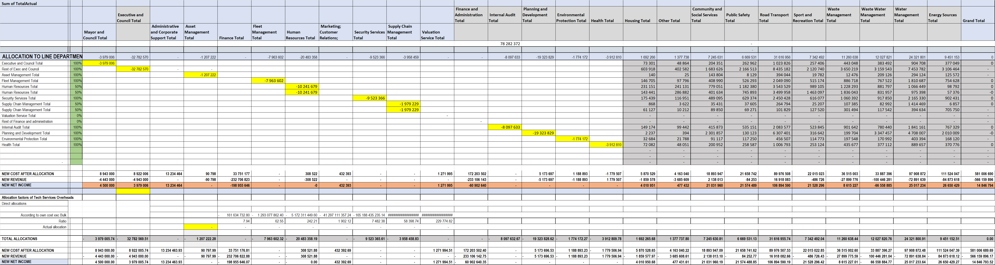

CUSTOMER CONSUMPTION PATTERNS.

The sales are then analysed even further to determine the number of consumers per consumption block. This is important when deliberating about categorising consumers and developing appropriate tariff structures and consumer impact. The tables and graphs below show a section of the analysis for each of the small consumer tariffs. In case of each tariff the graphs after each table illustrates this graphically:

- The first graphs show:
  - the cumulative kWh vs each kWh block. (vertical axis)
  - the kWh per kWh block (horizontal axis)
- The second graphs show:
  - the cumulative consumers vs each kWh block. (vertical axis)
  - the consumers per kWh block. (horizontal axis)

TARIFFS.

The Ndlambe tariffs for the relevant services are shown in table below.

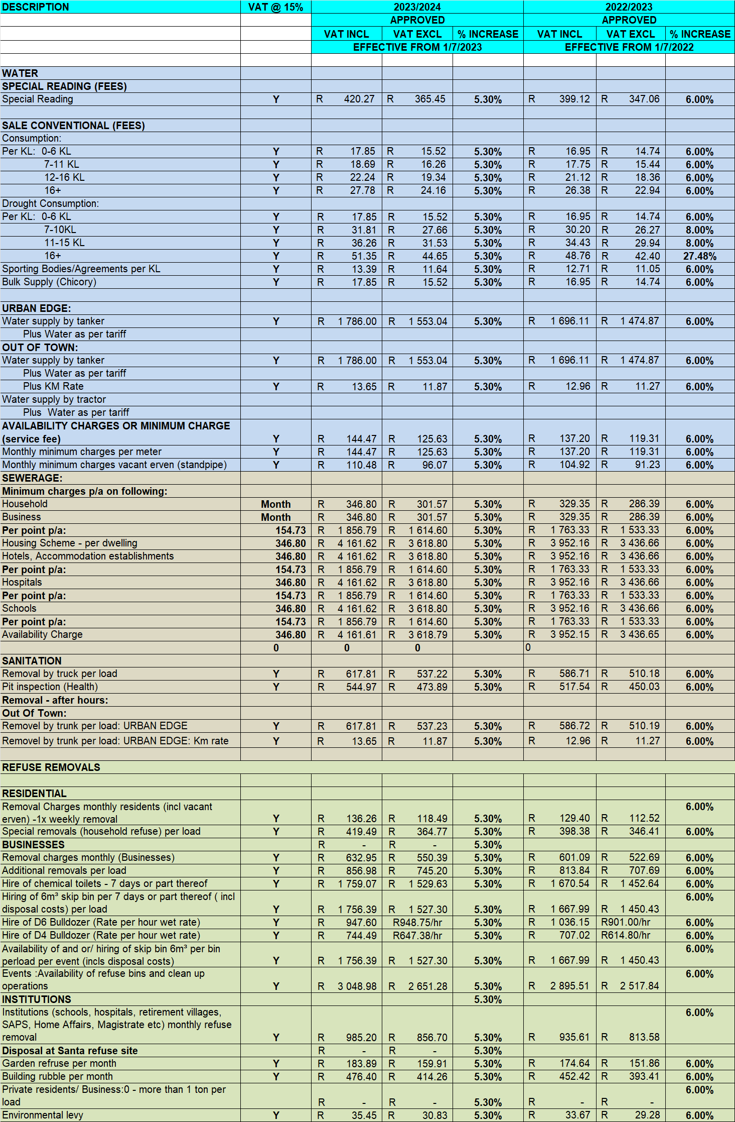

ALLOCATIONS WITHIN EACH DEPARTMENT.

Now that ringfencing has been done and allocations of overheads have been done to each department, the next step is to allocate the costs to the various activities within each department. The following data will be used for this purpose:

- The asset values relating to each activity. Shown in Table below.

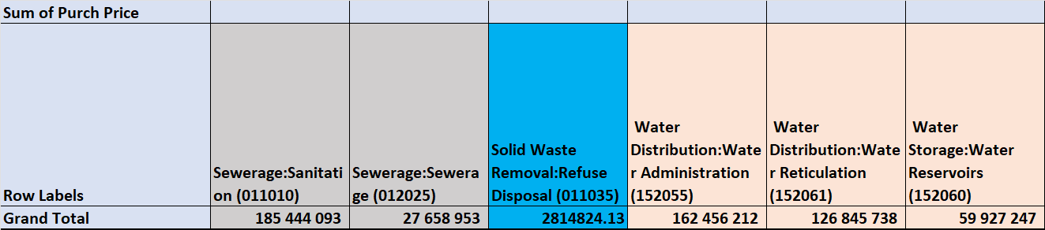

- Number of staff on each activity. Shown in table below.

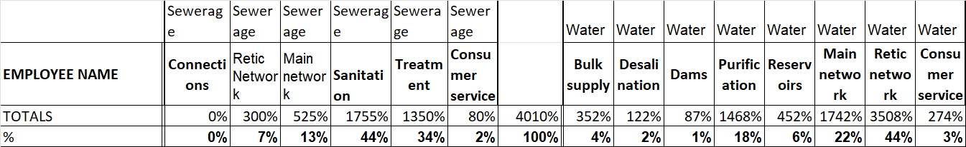

All staff in Refuse is linked to refuse removal as a contractor has been appointed to handle all the environmental issues including the rehabilitation of the Landfill sites.

PRICING

The challenge is to determine what must guide the changes to be made to become more cost reflective. This section proposes the pricing principles and policies to be followed in making tariff changes.

The key sources used for purpose of formulating these policies are:

- The South African Constitution.
- The South African the specific service Pricing Policy (EPP).
- Municipal Finance Management Act (MFMA).
- Municipal Systems Act (MSA).

Principles obtained from the Municipal Systems Act are as follows:

INDIGENT POLICY.

The current Indigent Policy for free basic services is as follows:

An indigent policy adopted by Council in line with the National guidelines whose executive summary was published and made available for public inspection, guides the implementation of free basic services. These services consist of the following monthly allocations:

- 6 kilolitres of free water and basic charge;
- 50 units of electricity and basic charge;
- Free sewerage/sanitation pump outs;
- Free refuse removal;
- Full property rates and service charges;

It can be said that the municipality’s indigent register is credible and accurate in that Ward Councillors were given an opportunity to scrutinize the register and submit amendments to the register for their respective wards. As part of ensuring the credibility and accuracy of the register, the municipality updates it annually.

The municipality has procured an indigent management system through which verification of indigent applicants is done to establish if the applicant meets the criteria as per the Indigent policy. The system is aligned to the CAAT’s verification done by the Auditor General. The committee established for Finance is the rates and Valuations committee which services as the steering committee for Indigent matters as well.

The Ndlambe Municipality will ensure that starting from July 2023 the indigent register is send to the district
Municipality on a monthly basis.

WATER SUPPLY

The following background information relating to water supply in Ndlambe:

Ndlambe Municipality was appointed to act as both the Water Services Authority (WSA) and Water Services Provider (WSP) and fulfils both of these functions. However, the institutional arrangements profile consists of the following bulk & retail functions listed below. Currently all the WSP functions and duties are conducted by either Water Services Providers, Water Services Support Service Agent or the Municipality itself and are as follows:

Water Services Authority: Ndlambe Municipality, with Community Protection Services doing all water quality control monitoring operations.
Water Services Provider: Ndlambe Municipality, with Infrastructural Development doing all water provision, with the exception of the following operations:

- Alexandria Water Supply: P&S Consulting Engineers has been appointed to provide bulk water within a Water Services Support agreement
- Kenton/Bushmans Water Supply: Amatola Water Board has been appointed to provide bulk water within a Water Services Provider agreement
- Cannon Rocks/Boknes Water Supply: P&S Consulting Engineers has been appointed to provide bulk water within a Water Services Support agreement
- 5ML RO Plant in Port Alfred : Nuwater has been appointed to operate, maintain and manage the Reverse Osmosis Plant.

All other Water Supply Systems are managed and operated by Ndlambe Municipality’s Infrastructural
Development Directorate, as the Water Services Provider. These include the following Water Supply Systems:

- Port Alfred Water Supply System
- Kleinemonde Water Supply System
- Bathurst Water Supply System
- Cannon Rocks / Boknes Water Supply

Ndlambe Municipality operates and maintains all water supply systems within both Water Services Authority and Water Services Provider functions, with the exception of the Amatola Water Board (previously Albany Coast Water Board) supply footprint, where bulk water is supplied by the Amatola Water Board.

There are six (6) local water supply schemes which service the main settlements within the area. Port Alfred, Seafield and Bathurst are all fed mainly from surface water , ground water and desalinated water through the Reverse Osmosis plant schemes whilst Boesmansriviermond, Kenton on Sea, Alexandria, Boknestrand and Cannon Rocks are supplied from ground water scheme .

Boesmansriviermond, Marselle, Klipfontein and Kenton on Sea augment their groundwater supplies with desalinated water through the Reverse Osmosis plant situated at Boesmansriviermond. The towns of Cannon Rocks and Boknes receive Reverse Osmosis processed water from saline borehole sources.

Potable, treated water is piped to all formal urban communities within Ndlambe, and is available to the vast majority of households. However, some of the Bathurst, Martindale and Trappes Valley communities still rely on rainwater and private boreholes. The latter are considered for municipal supply within the IDP.

Where informal settlements occur, such as on the Brakfontein Farm commonage on the periphery of Alexandria, tankers transport water to strategically placed tanks, which are accessible to those that need.

It is the objective of Council to achieve and sustain “Blue Drop” status throughout all of Ndlambe. This is a compliance monitoring system which is managed and implemented by the Department of Water and Sanitation. This quality and service goal is being achieved by improving management performance, which should lead to acceptable discharge water quality.

The following statistics with reference to water supply.

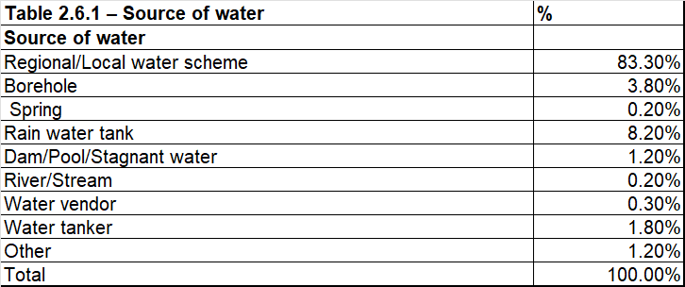

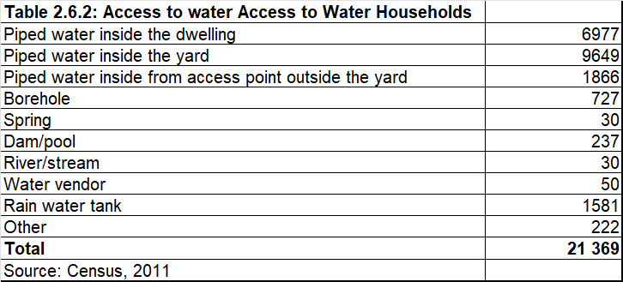

The water quantities where the municipality is paying for bulk water are shown below. This shows an average bulk water purchase cost of R18.64 in 2023/2024 rands, more than the price of the first block water.

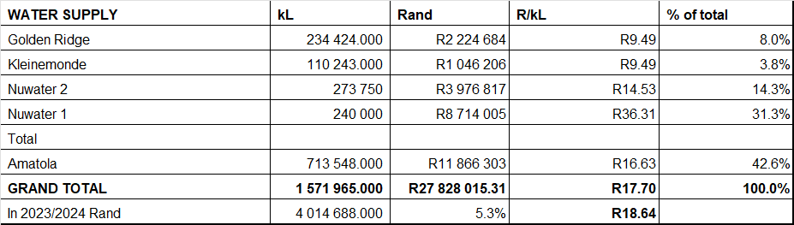

The table below shows the quantities of water obtained in the 2022/2023 financial year from the municipal own facilities. The cost of operating these facilities are included in the financial statements. This comes at a lower cost than the bulk purchase quantities.
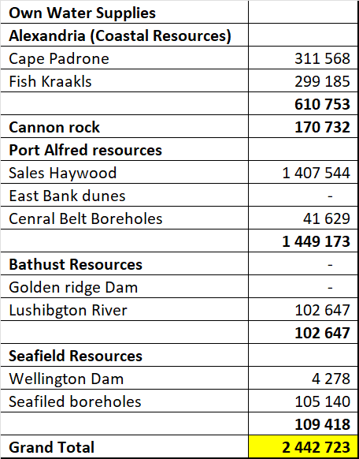

Summary of sales details are shown in table below.

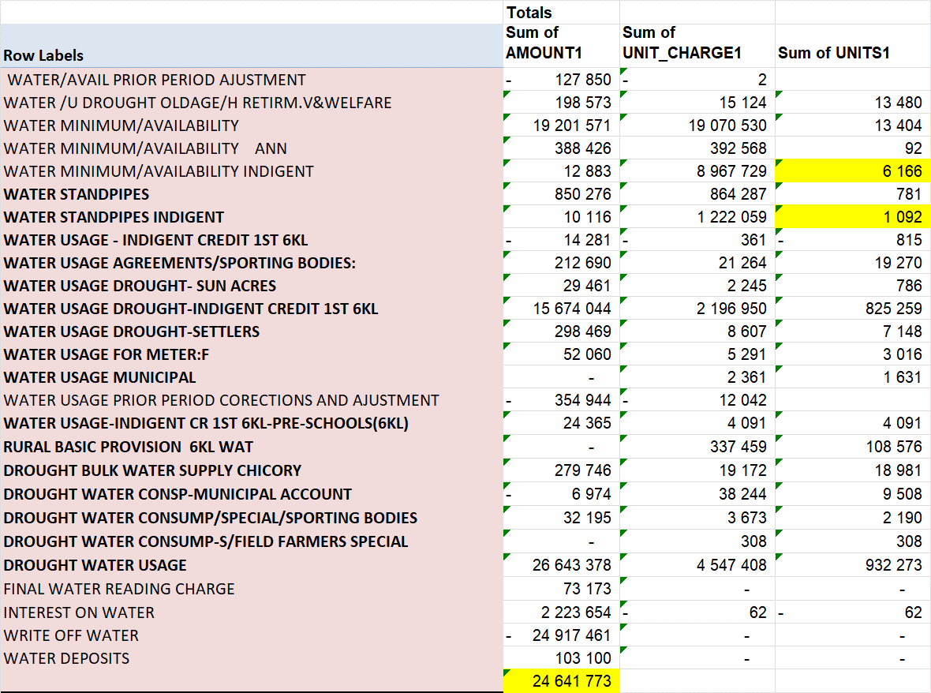

The sales data was analysed and the quantities per block calculated. This is required to do accurate revenue silulations.

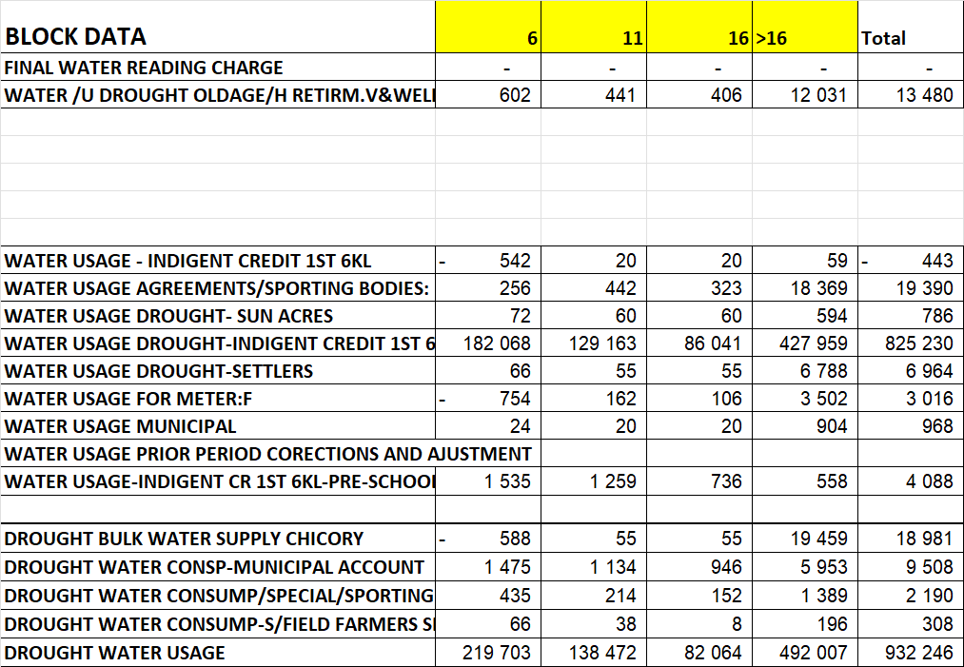

An analysis was undertaken of the pattern of usage by the customers. The table gives the key results and the graphs show firstly the kL of water used by consumption group and then the number of customers who’s average consumption falls within each consumption group. Firstly for normal residential consumers.

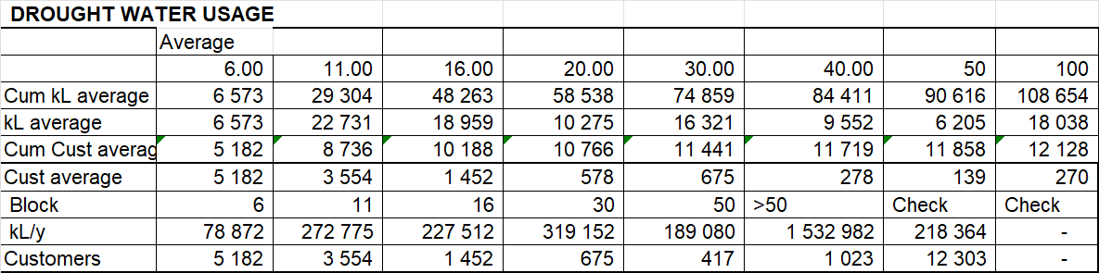

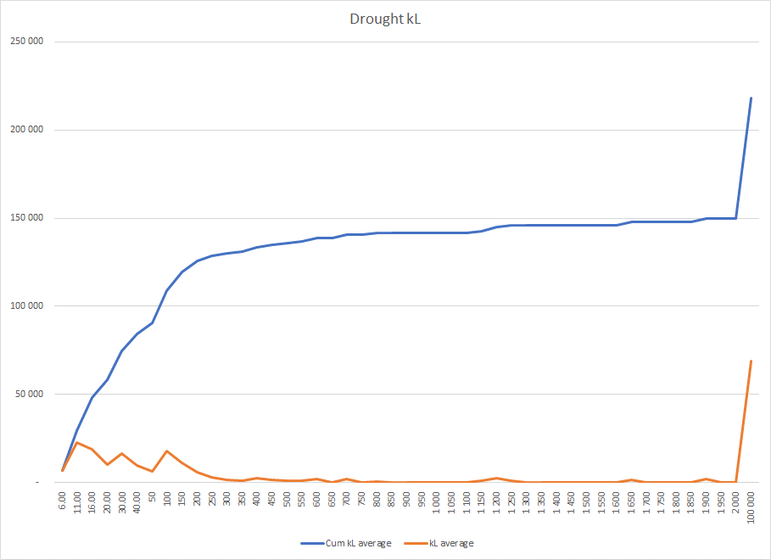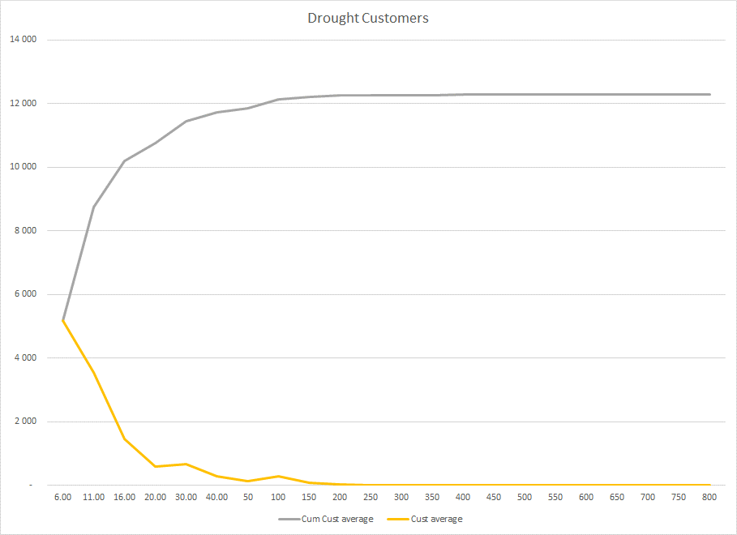

Then for indigent customers.

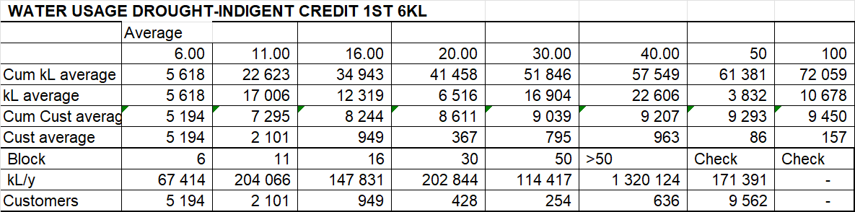

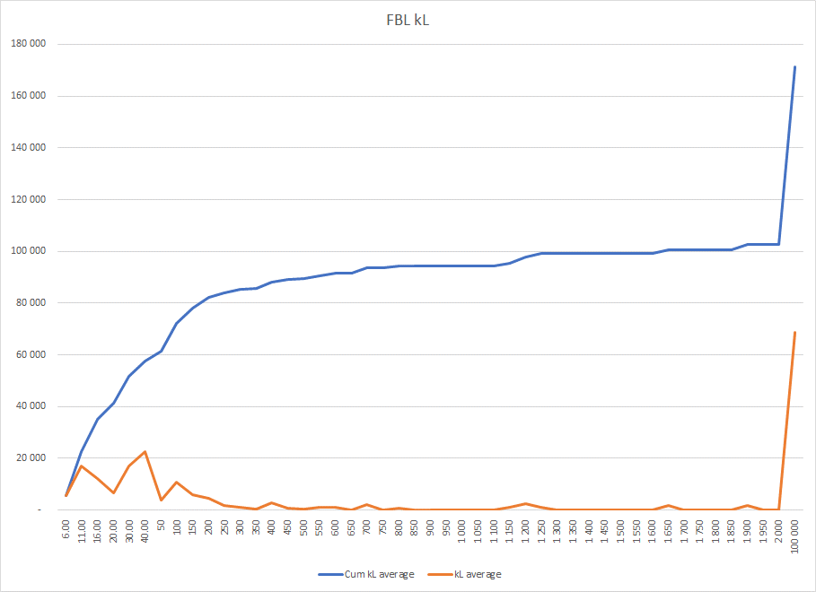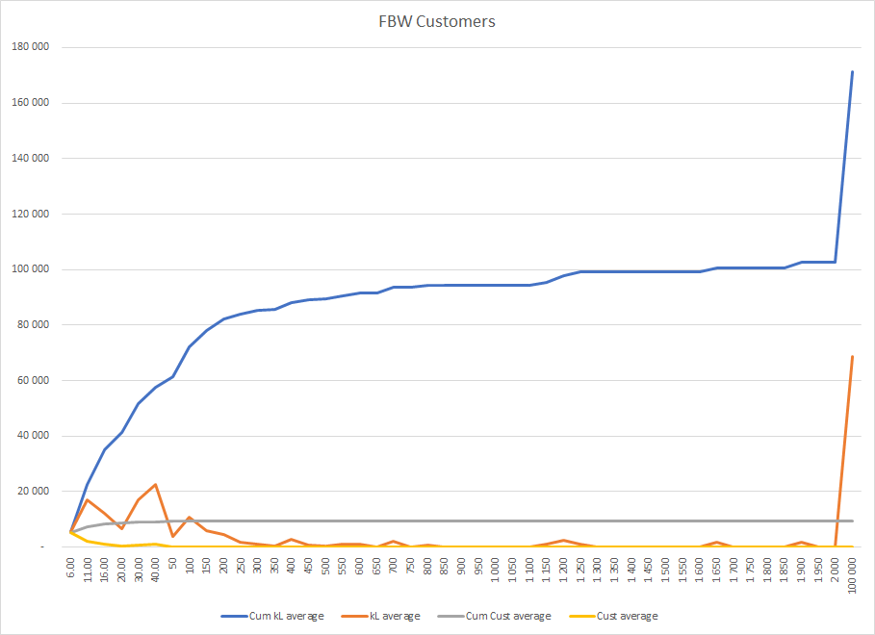

The ringfenced financials for Water is shown in table below:

- The first part shows the allocation factors that will be used.
- The second part shows the actual allocation of costs to the relevant sections.
- The final part shows the calculation of the cost based unit costs.

The following should be noted in this respect:

- The asset register does not show assets separately for the dams and purification and thus these sections’ costs are understated. An adjustment is made to rectify this.
- The allocation of employees to the various sections have been slightly modified as hardly any allocation is made to the final connections to the consumer and the related services.

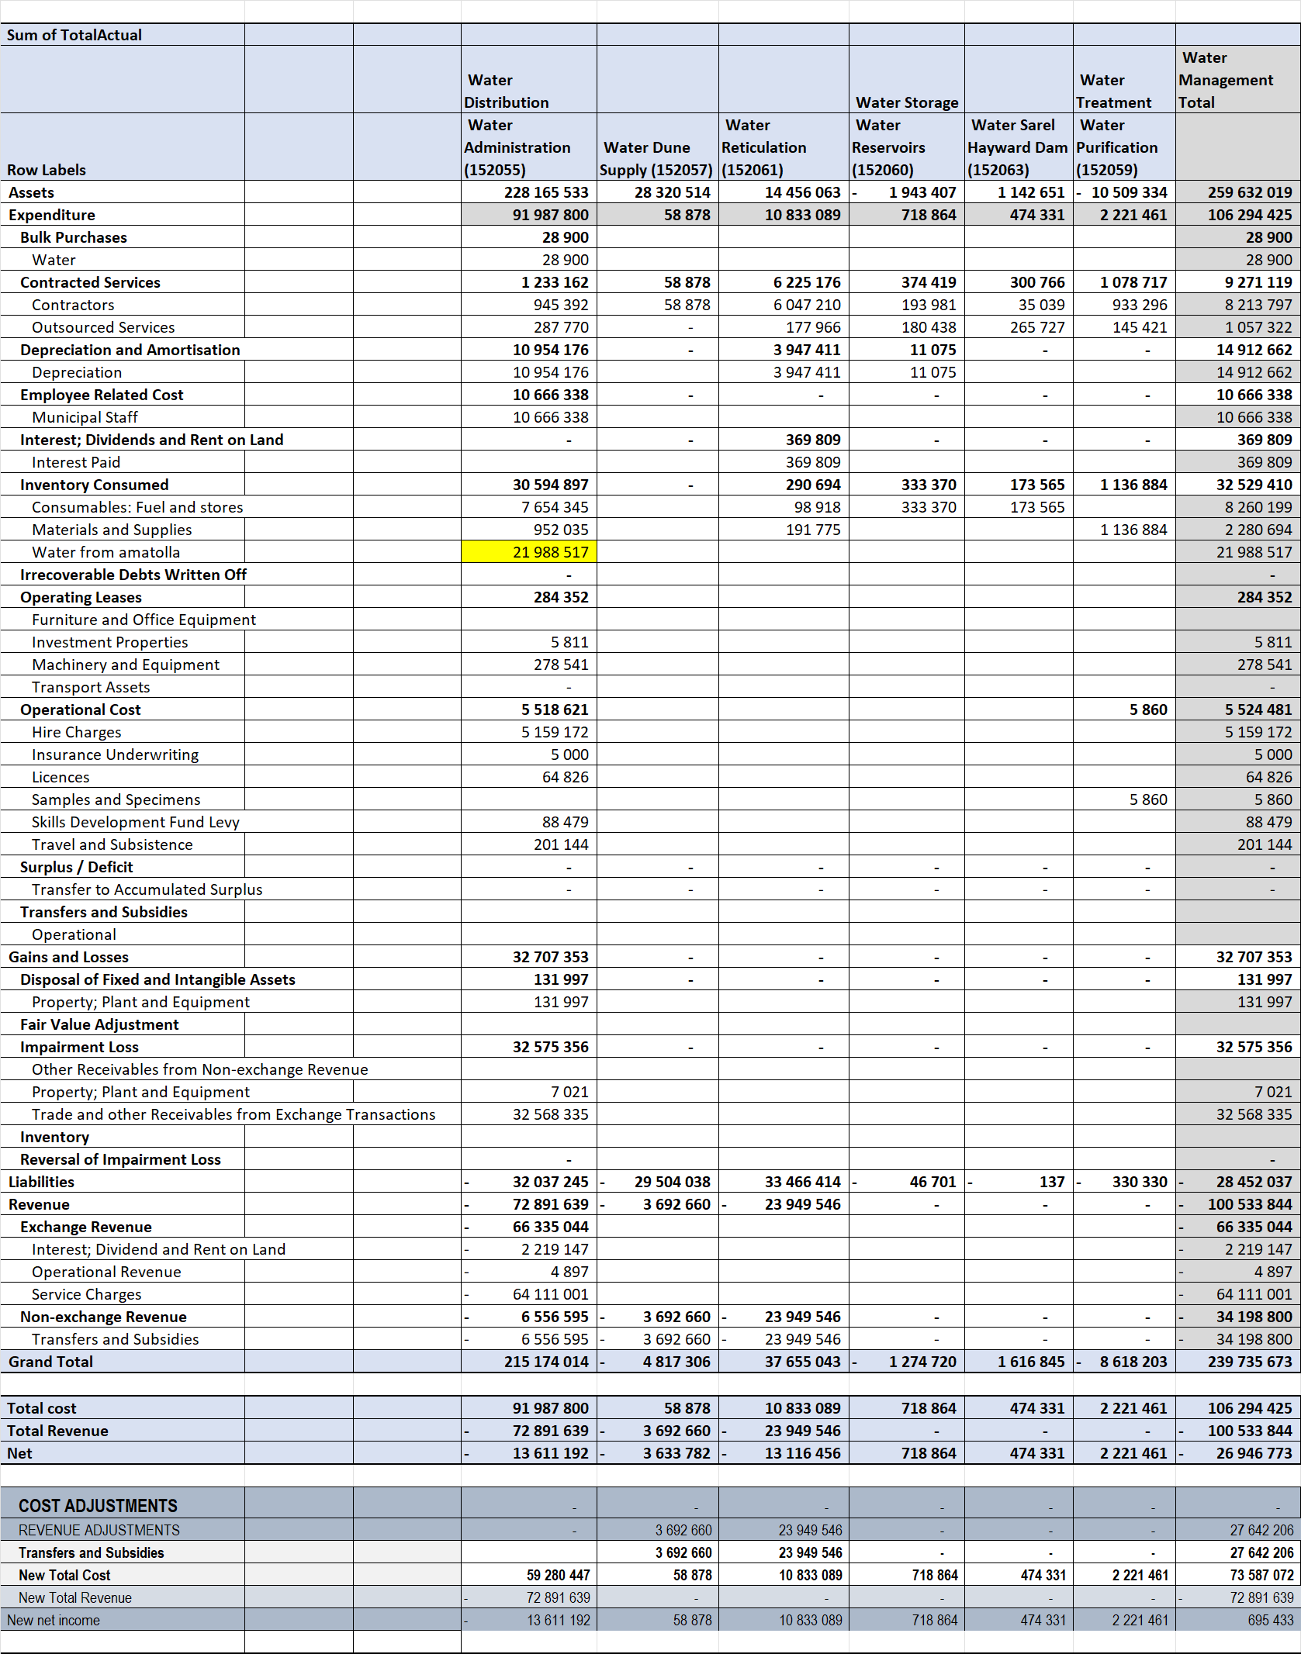

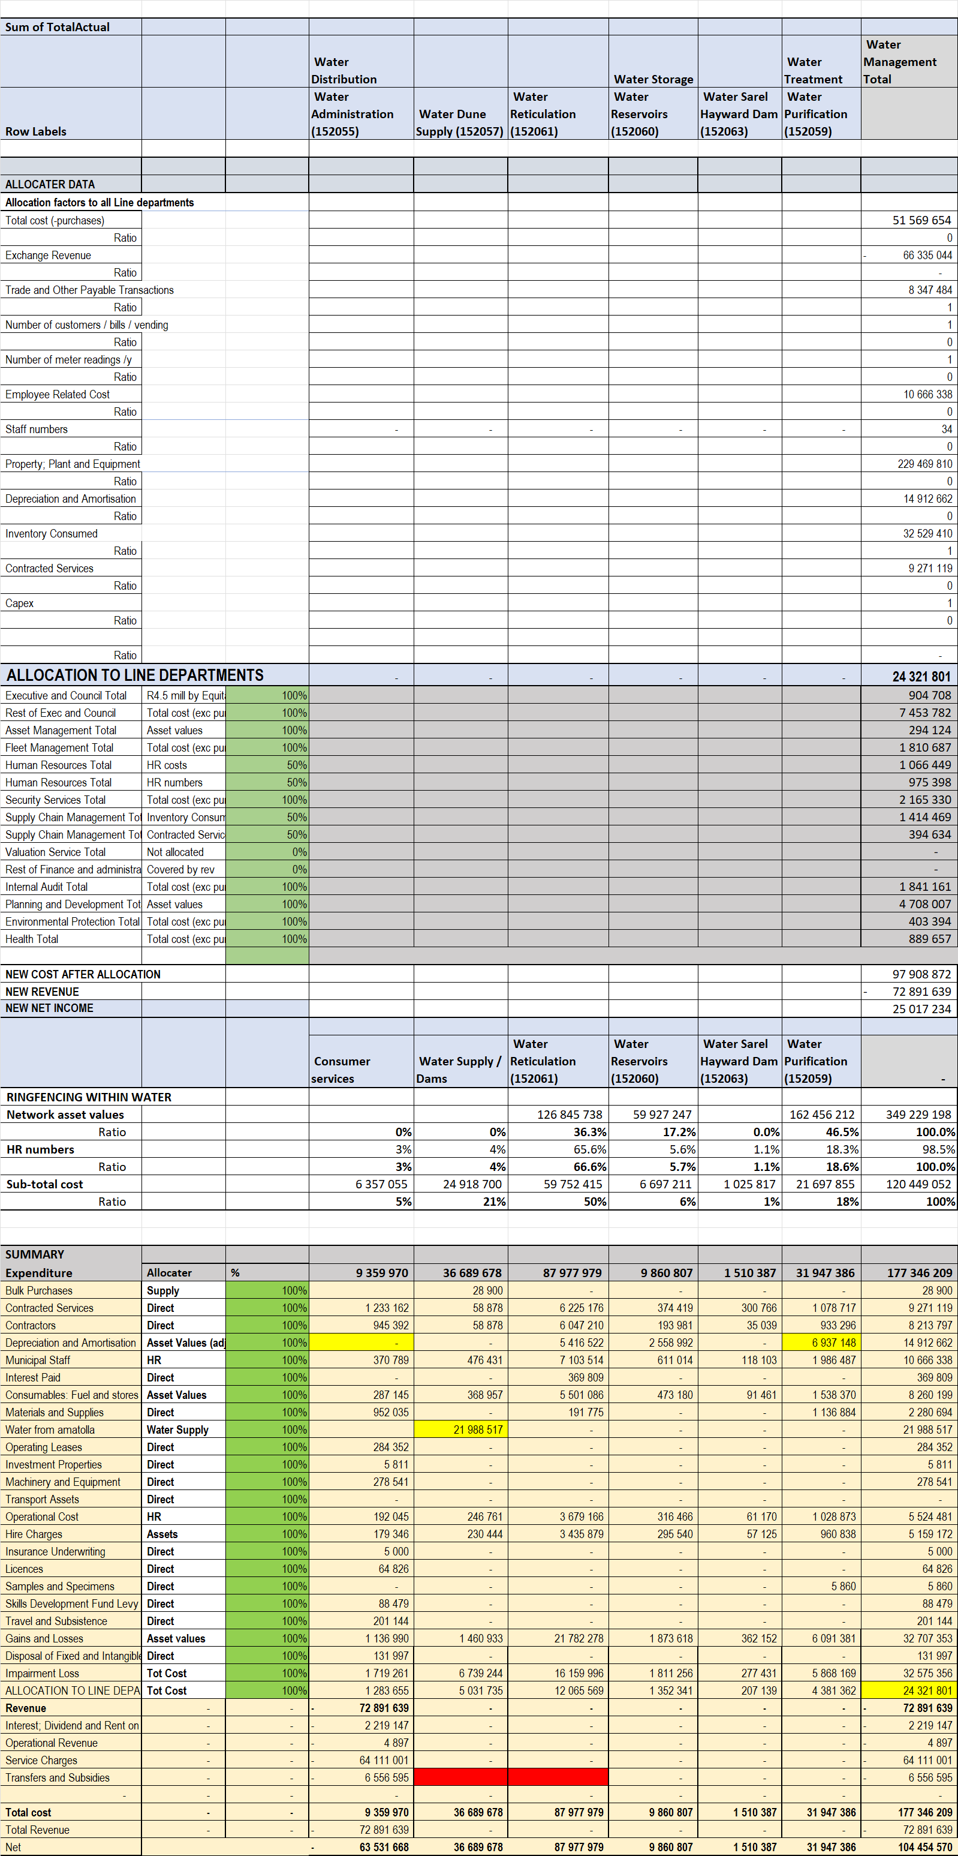

The results are summarised below.

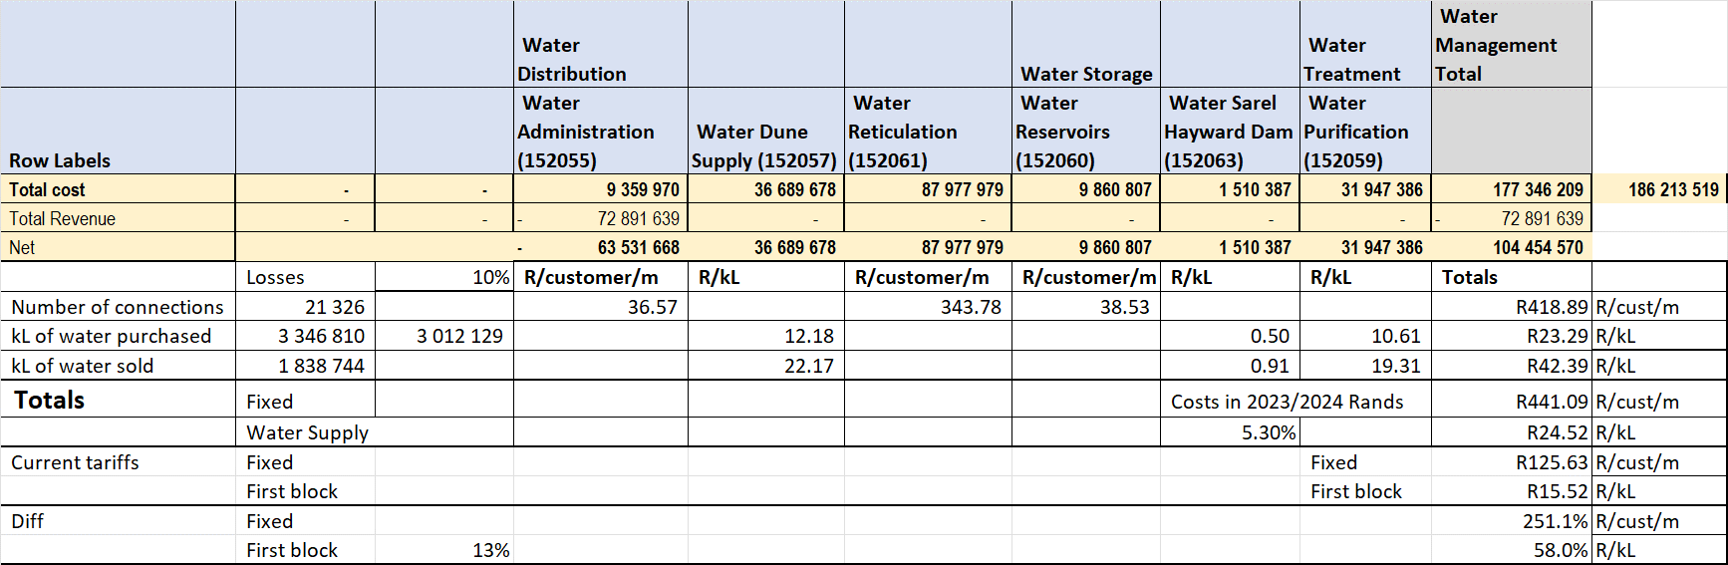

The key functions in water supply are:

Items that impact the cost of the water itself.
- Provision of raw water including:
  - Bulk purchases
  - Own dams.
  - Desalination plants.
  - Boreholes.
  - Etc.
- The costs of water purification.
These costs should be reflected as a R/kL costs.

Items that impact the transport of the water to the consumers.
- The cost of the extended network to get the water to the various consumers including:
  - Main pipe network.
  - The smaller pipe networks.
  - The various pumps and valves.
  - The reservoirs.
- The final connections to consumers:
  - The T-offs from the main line
  - The water meters and valves.
  - The associated services.
These costs are reflected as R/Connection cost. Ideally there should be some differentiation between small connections and big connections but such data is not available:

- Big connections could be supplied from bigger / main networks making it cheaper.
- The actual connection, valve and meter could be more expensive.
- The bigger capacity could place a bigger demand on the network contributing to low pressure problems.

No such differentiation is currently applied. No data has been provided which can be the basis of such differentiation.

One of the critical issues relate to the calculation of unit costs of water:

- If the total cost of the water supplied is divided by the total amount of water sold and is paid for, then the unit cost will be very high. This would mean that good paying consumers are paying for the total losses on the system including all water being stolen, (used but not paid for).
- If the total cost of the water is divided by the total quantity of water purchased, minus normal accepted system losses of say 10%, then the municipality will not cover the full cost of purchasing water.

This does represent some dilemma. The losses should rather be reflected on the shortfall of revenue for the municipality so that they can focus on reducing it, rather than be reflected in the tariff and thus be paid by the paying consumers. Because of this the cost of water is divided by the total water obtained minus 10% losses. The unit costs are then escalated by the previous annual price increase.

It was initially thought that during normal periods, not drought, that due to the increased water sales the unit cost would reduced. Unfortunately not very much as the price paid for water from the majority of sources remain the same in R/kL.

The table below shows the following:

- The various tariff charges per tariff category.
- The sales figures per tariff category.
- The actual revenue per tariff category.
- The calculated revenue using the sales and tariff figures.
- A comparison between the actual and calculated tariffs.

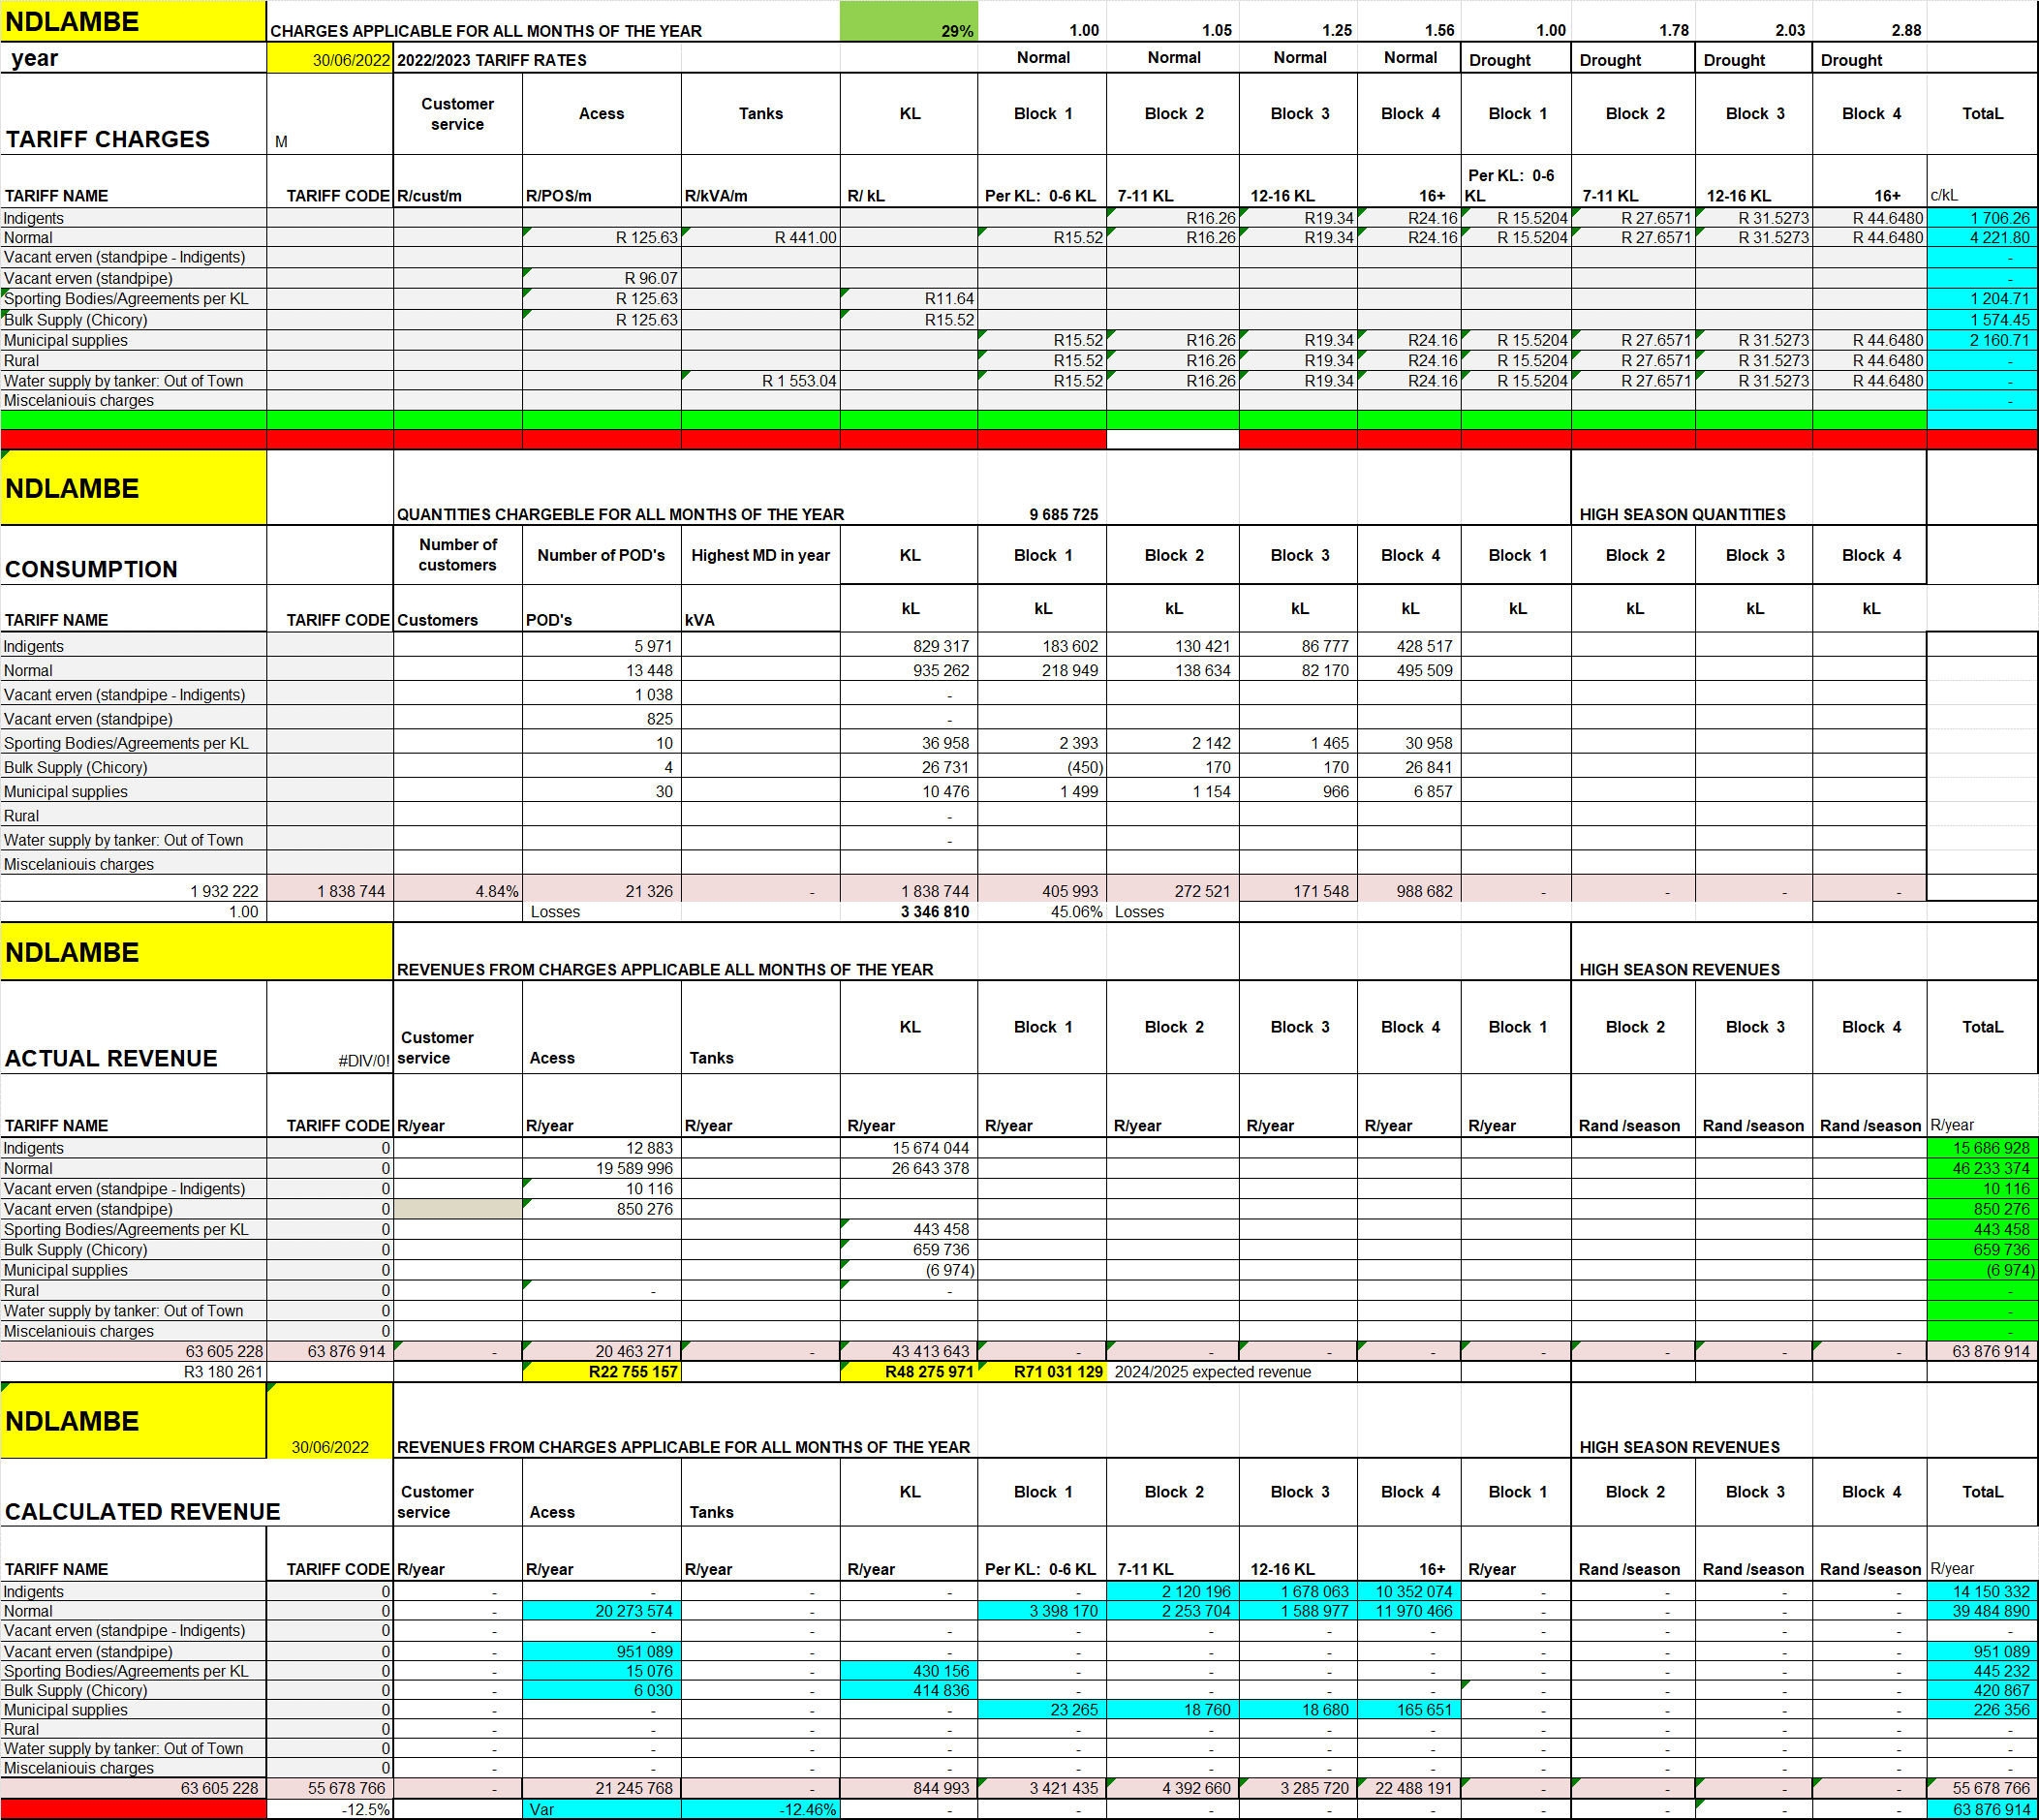

The table below shows a comparison between the calculated and actual revenues.

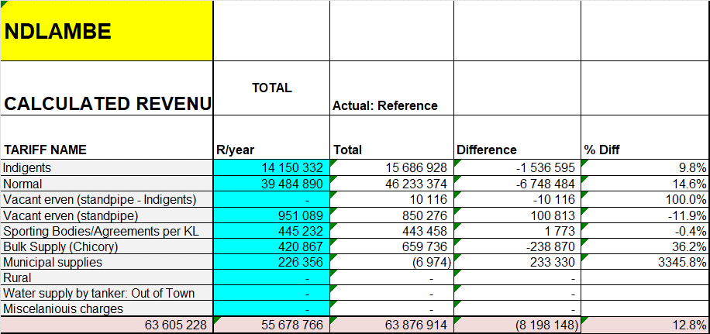

The next table shows the following:

- The cost based unit costs.
- The newly calculated revenue
- A comparison between the current and cost based revenues and thus the subsidies.

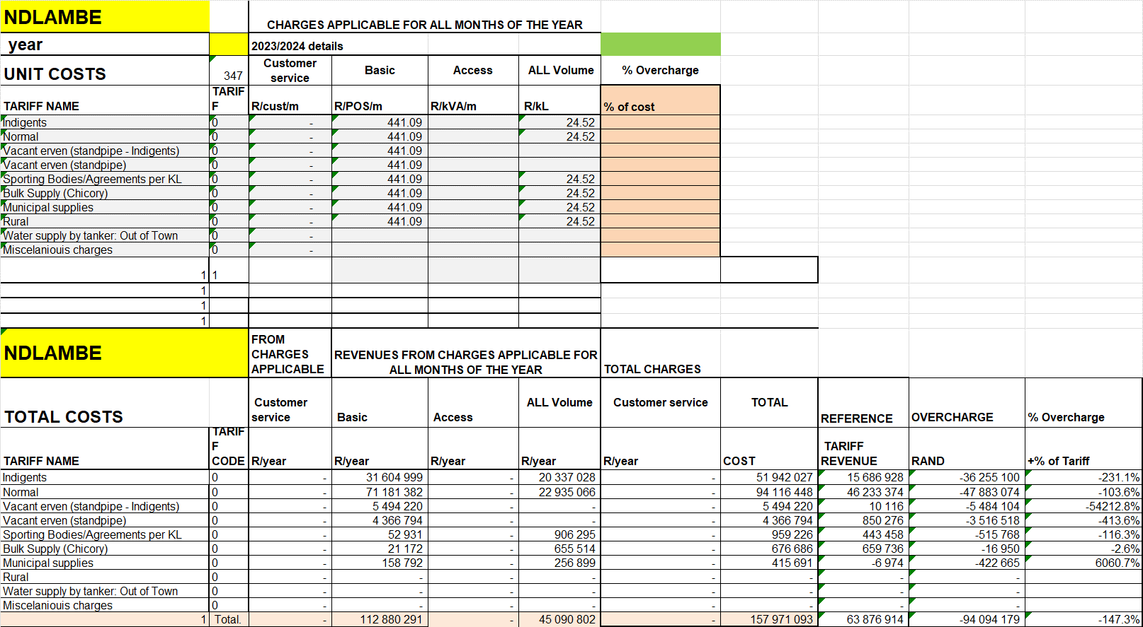

The following can be noted from the above analysis:

- The true subsidy to indigents is R11.8 mill.
- The current equitable share amount is only R6.5 mill.
- The current Basic charge is far too low.
- The current kL charge is too low.

The other issue that needs to be considered relate to the conservation message that need to be given to consumers:

- This is usually done using the inclining block rate tariffs (IBT) where the price increases with increasing consumption.
- Ndlambe water tariffs do provide this message in line with many other municipalities.
- The Ndlambe water tariff differentials are higher during periods of drought which is good. See table below.
- In view of the findings from the study which indicate that the cost of water exceeds the current price of even up to the third block in normal times and only in respect of the first block during drought periods.
- When there is ample water available obviously the municipality want to make the water available so that consumers can use it for various purposes such as own vegetable gardens, normal gardens, beautifying the town, etc. If the water is not sold some of it could just run down to the ocean.

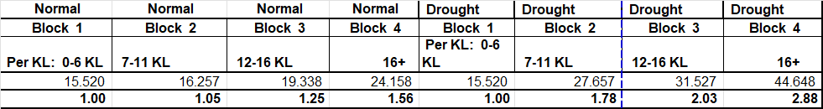

The table below sows that a 27% increase per year for 5 years need to be applied to achieve a cost reflective basic charge. This is obviously severe. The increase in water rates is more complex because of the IBT structure and the high water losses.

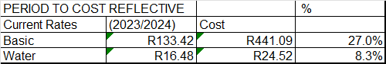

The following is proposed in respect of the proposed tariffs:

- In respect of water supply:
  - That the Water R/kL be increased by 5% above the average inflationary increase.
  - The current IBT structure and differentials be retailed for normal and drought periods.
  - Further increases only be considered as the losses are reduced.
  - It must be noted that because the R/kL rates is calculated using the total amount of water supplied minus 10% losses, instead of the actual volume of water sold, the cost reflective rates will not cover the full cost.
- That the Basic charge (R/connection) be increased by 5% per year for five years and then a new study be done to determine the future direction. It must be noted that this will not year achieve cost reflective rates as an increase of 27% per year is required.
- The expected revenue will thus be 5% more than would otherwise have been the case. The expected revenue including the 5% structure plus 6% inflation increase is shown below. This is calculated using the 2029/2020 sales figures, a non-drought year, times the proposed non-drought tariffs. The result is a lower revenue due to the significantly lower, non-drought tariff. The table below shows the 2019/2020 water quantities used per block.

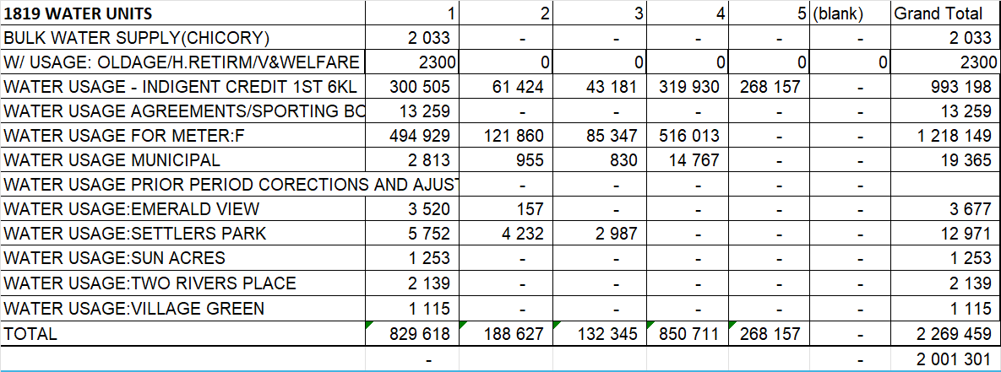

The table below shows the revenue forecast for 2024/2025.
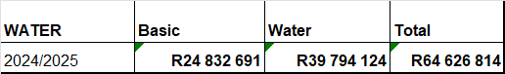

- That the equitable share amount be increased to cover the new tariff revenue shortfall based on the proposed tariffs. The amount is as shown below. It must be remembered that the free water going to indigents that have standpipes are not included as these amounts are not measured.

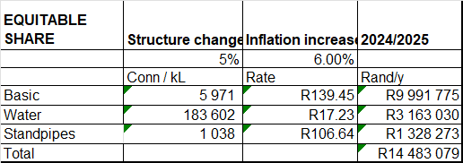

The total expected revenue is thus R79 mill.

SEWERAGE / SANITATION

Details of the current status of Sewerage and Sanitation is shown in the table below.

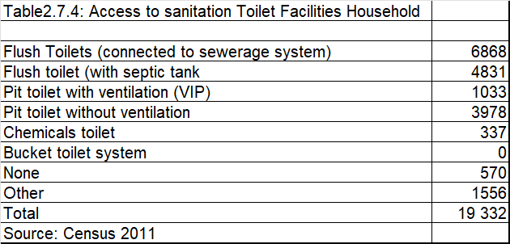

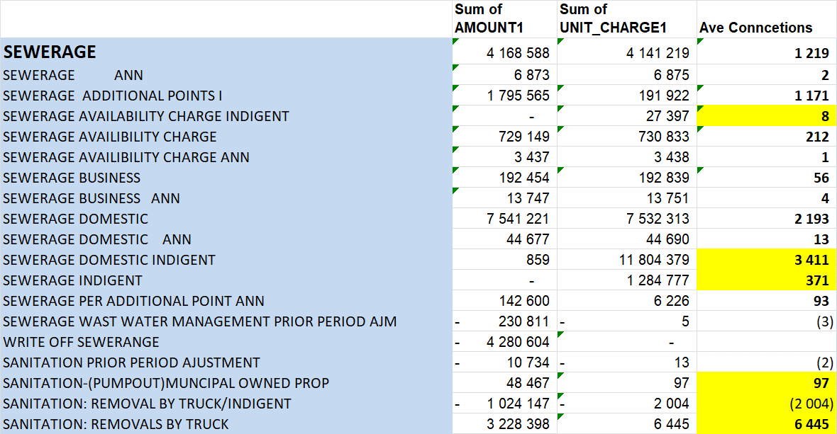

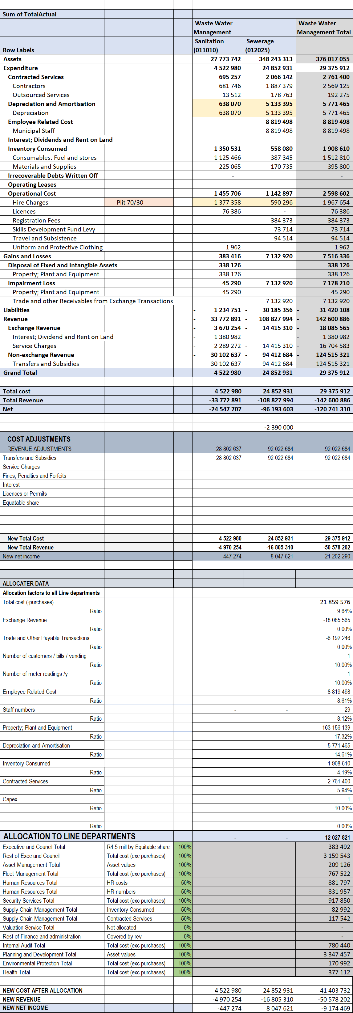
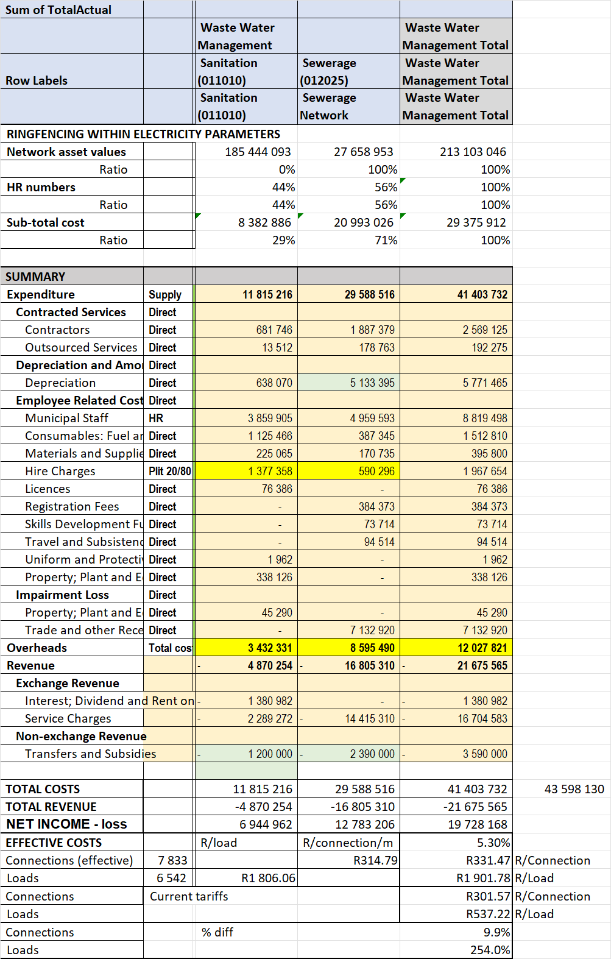

The following should be noted from the above:

- The equitable share values have been adjusted down as the original allocation was incorrect. The service is thus making a loss in respect of both functions.
- The effective number of connections are determined by the number of full connections plus the number of additional connections divided by the ratio of current price differential of full connections divided by additional connections which equals 2.24 times.

The cost reflective rates for 2023/2024 are thus shown. These will now be used for revenue per tariff calculations.

The table below shows the following:

- The consumption per service
- The actual revenue per service
- The calculated revenue per service
- A comparison between the actual and calculated revenues.

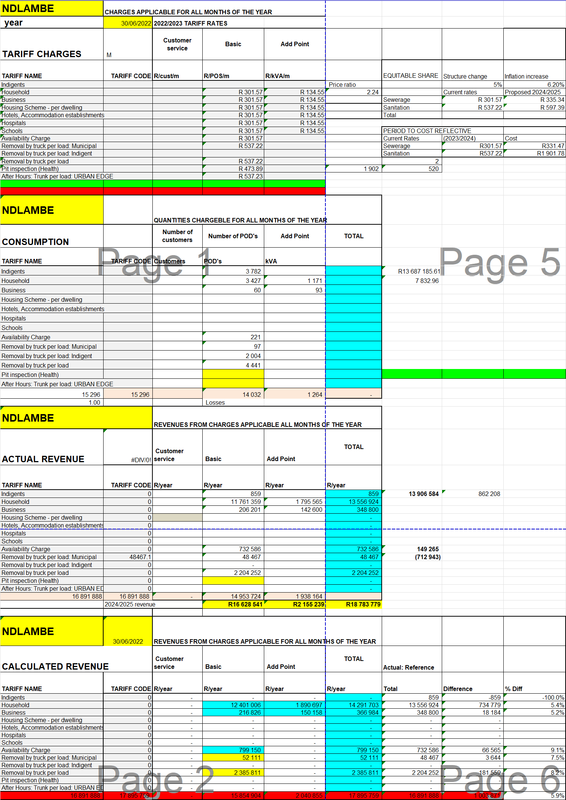

The table below shows the following;

- The newly calculated tariff charges per service.
- The newly calculated revenue per service.
- The comparison between the cost based revenues and actual revenues thus representing the cross subsidies.

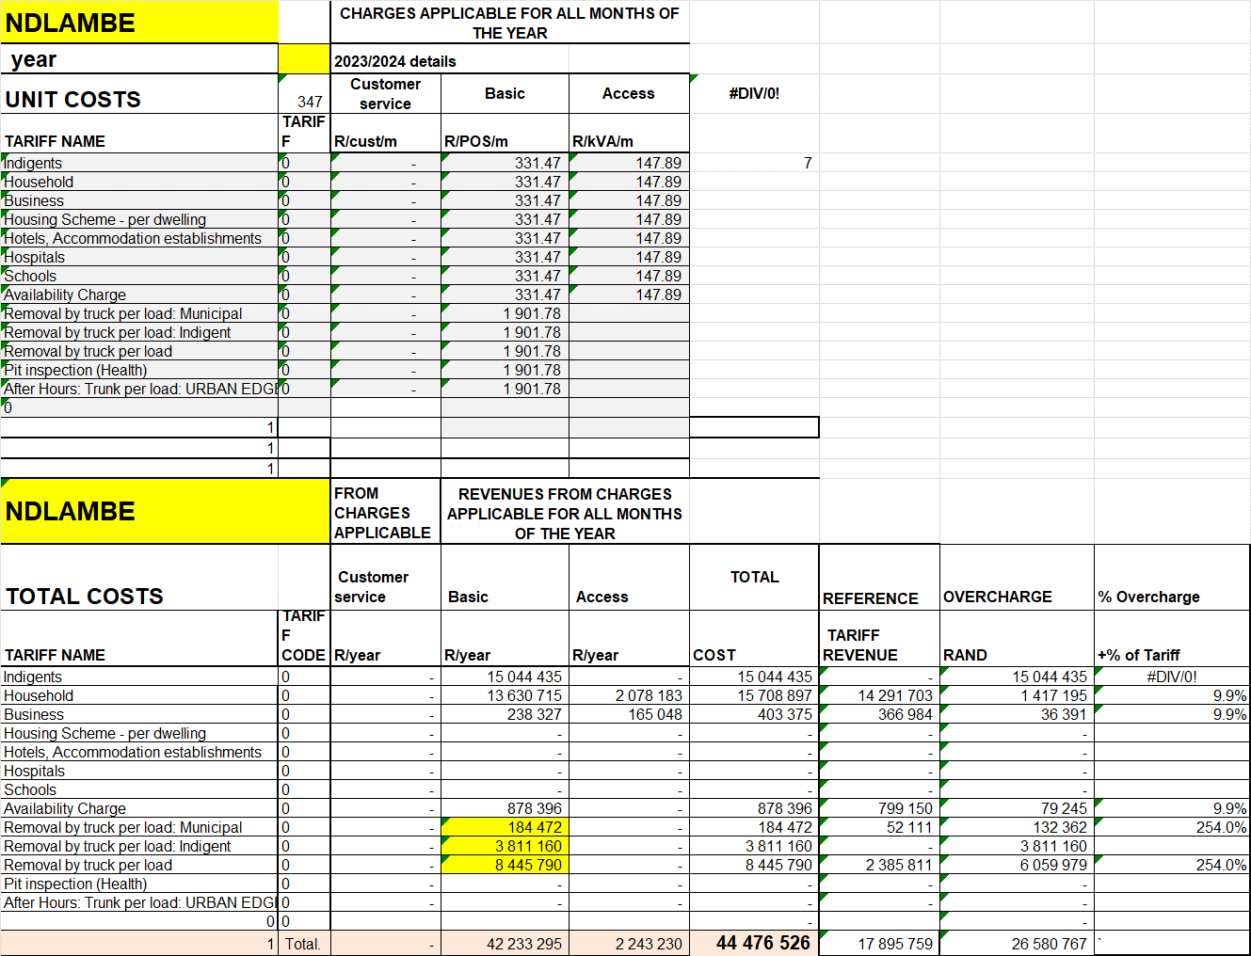

The following should be noted in this respect:

- The sewerage subsidy to the poor is about R13 mill. The equitable share is R2.4 mill.
- The Sanitation subsidy to the poor is about R1.1 mill. The equitable share is R1.2 Mill.

The following should be noted in terms of the current pricing:
“A fixed monthly charge based on the costs of the service per urinal, sewer point/toilet shall be charged to multiple dwelling units, hotels, accommodation establishments, crèche’s, pre-schools and schools.”

The periods to get to cost reflective is shown below.

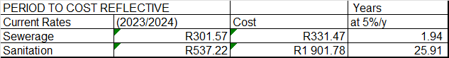

It is thus clear that it is almost impossible to get to cost reflectivity using a 5% per increase.

The following is thus proposed in this respect:

- The equitable share amount to determined at the current rates plus increases and not the cost reflective rates as shown below.

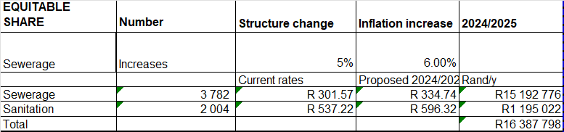

- Currently the additional points are based on the number of A fixed monthly charge based on the costs of the service per urinal, sewer point/toilet shall be charged to multiple dwelling units, hotels, accommodation establishments, crèche’s, pre-schools and schools. This is particularly important in complexes with various homes but could be one property. This practice should be continued in respect of cases where a bulk sewerage point is utilised and the owner provides the network to the individual units.
- That the current sewerage basic / availability charge be increased by 5% above the average increase for two years.
- That the removal by truck fees increase by 5% above inflation increase for a period of 5 years.
- The expected revenue for 2024/2025 is R19.8 mill. This is the 2022/2023 revenue plus the previous price increase, the 5% structure change and the 6% inflation increase.

The following issues need to be addressed for the future:

- Costs and revenues should be allocated accurately.
- The assets and costs for the sewerage treatment part of the business should be ringfenced and the volume of affluent be measured.
- This is firstly so that the sewerage treatment cost not be applied to empty stands / those without connection to the network.
- So that a sewerage treatment fee can be charged to private Sanitation collection companies when dumping the sewerage at the treatment plant.
- Secondly so that the R/kL of sewerage treatment cost can be determined as a good benchmark of efficiency.

Total revenue is thus R36.1 mill.

WASTE MANAGMENT.

Residential household refuse are collected once per week in front of a residential property whereas business refuse is collected twice per week (subject to requests and need for collection). The municipality has 5 refuse compactors. When compactors and trucks that collect refuse is out of commission the municipality appoint private contractors (service providers) to render the service. The municipality have two skip trucks that operate throughout Ndlambe and remove skip bins that are strategically placed within communities. A total of 21 093 households and businesses are serviced once per week (certain businesses serviced twice per week)
In Alexandria, Kenton-on-Sea and Port Alfred Central Business Districts (CBD) cleansing staff is deployed 7 days per week to keep town clean of litter. During the Festive season (December / January period additional contractual staff are appointed to assist with waste and cleansing services to ensure that the town, CBD, recreational facilities, open spaces and beaches are clean. An additional contractual workforce is appointed on New Year’s Day to ensure that the town of Port Alfred and Kenton-on-Sea Blue Flag beaches and beachfront areas are clean from litter. Teams worked from 00h00 on 1st to 18h00 on 2nd January 2023 divided into 8 hours shifts. The municipality has procured 745 wheelie bins that are being rolled out to the communities during first quarter of 2023/2024 so to ensure that litter is placed in a secure container and in so doing keep the communities clean. A large number of households have their refuse removed at least once a week either by the municipality or by a private company. A limited number of towns have their own refuse dump and few households have no rubbish disposal facilities. Statistics suggests that households whose refuse is removed amounts to 100 per cent per week.

The statistics from the IRP plan is shown below.

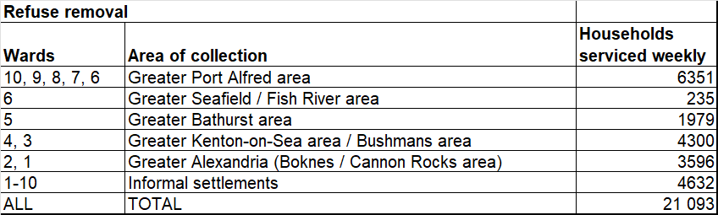

The sales details are shown below.

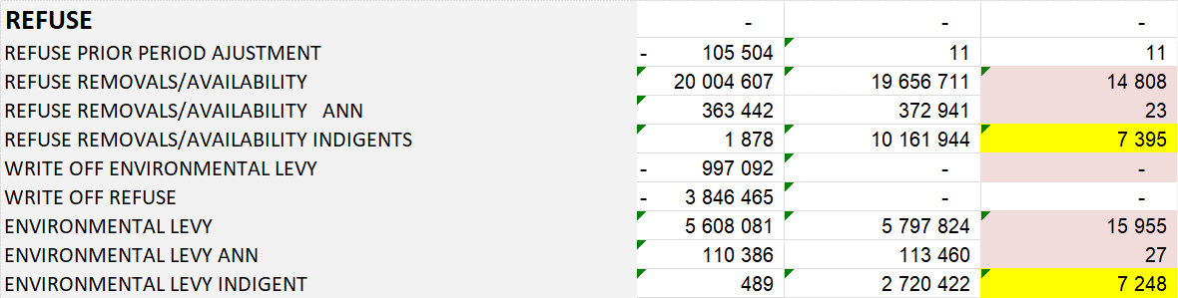

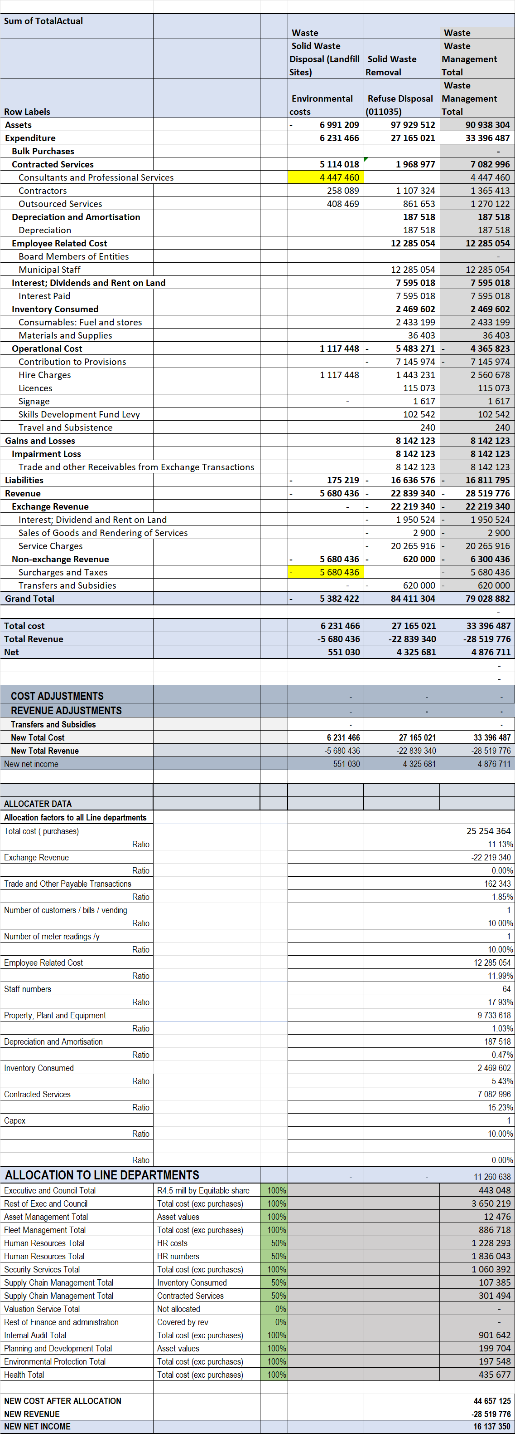

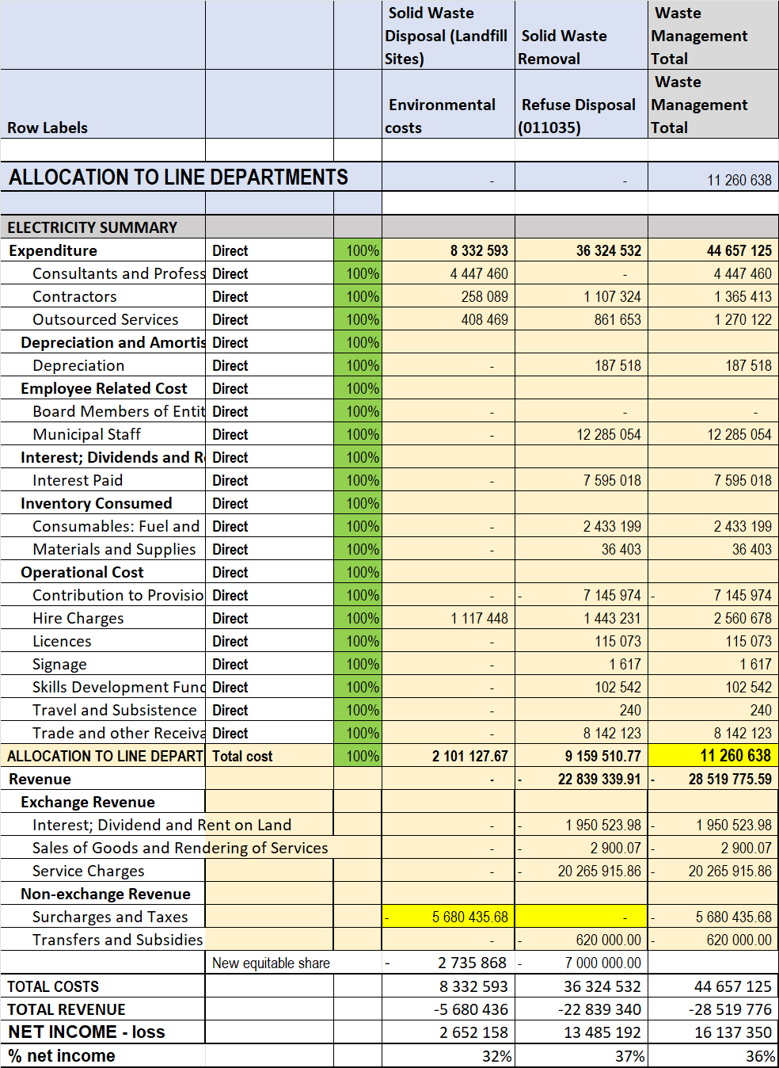

The results are summarised below.

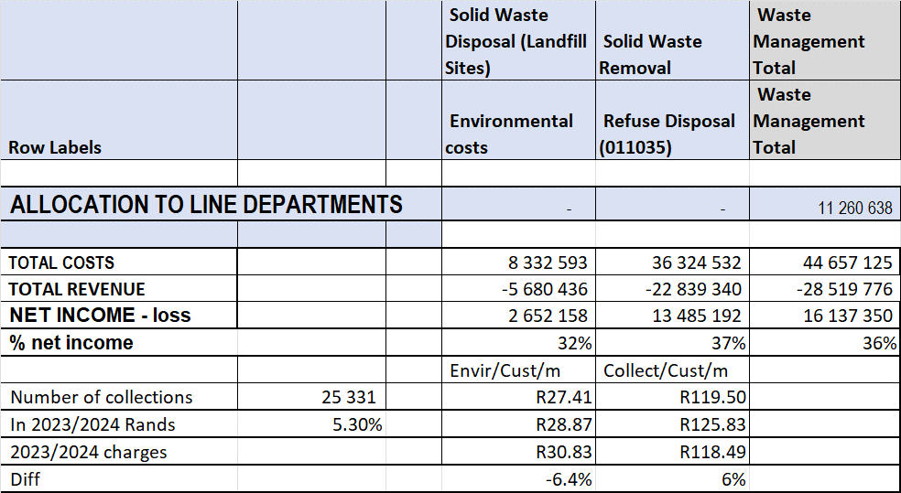

The following should be noted from the above:

- The Surcharges and taxes have been moved from Waste to Environment as it represents the environmental fee revenue.
- The cost of the outsources contract for environmental work including rehabilitation of the landfill site work.
- The Rehabilitation of Landfill Sites is underfunded from the Environmental fee.
- The Refuse disposal is underfunded from the Waste tariff charges plus the Equitable share allocation.
- The volume of waste collected for Commercial and Institutions is more than then for residential. To calculate the effective residential collections the current tariff weight will be used as shown below.

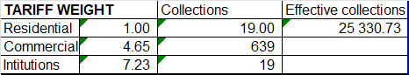

The following should be noted in terms of the current Refuse removal tariffs:

- Ndlambe Municipality currently has differentiated tariffs for domestic, commercial and institutions.
- The latter two with very much higher tariffs.
- These higher tariffs are not levied but the standard domestic charge is levied to all consumers.
- It is a fact that the majority of commercial and institutions leave much more waste for the municipality to remove.
- The question was always how to differentiate between domestic, commercial and institutions.
- The challenge currently is that all rubbish is removed by bags. The bags can be very full or very empty.
- It is this difficult to charge based on number of bags.
- For the calculation purpose the customers will be classified for refuse removal in the same way as the case in electricity:
  - There are domestic consumers
  - Commercial consumers
  - Bulk consumers (TOU-larger that 80 kVA)
- Due to the fact that no data is currently collected relating to the extent of the different waste volumes, the current tariff differentials will be used.
- The effective domestic waste removals is then also calculated based on these ratios.

The numbers as per the electricity tariffs are shown in the table below.

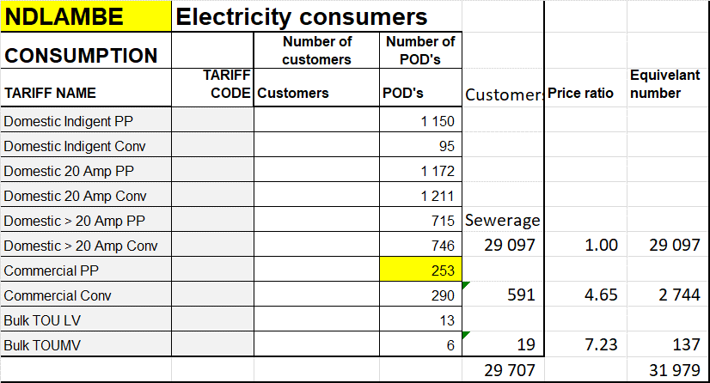

The table below shows the following:

- The consumption per service
- The actual revenue per service
- The calculated revenue per service
- A comparison between the actual and calculated revenues.

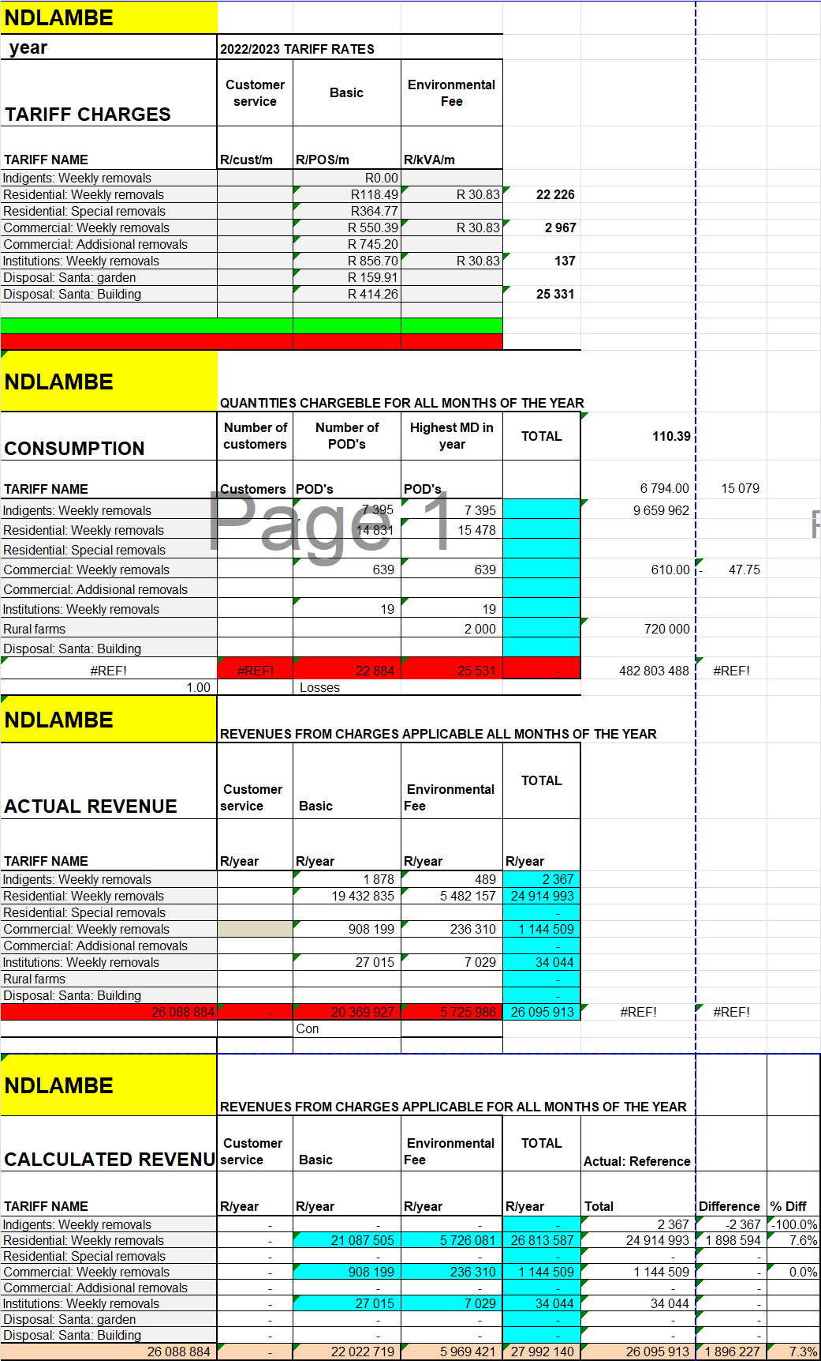
The table below shows the following;

- The proposed tariffs, existing with proposed structure increase.
- The newly calculated revenue per service.
- The additional revenue generated by these changes and the application of the differentiated rates.

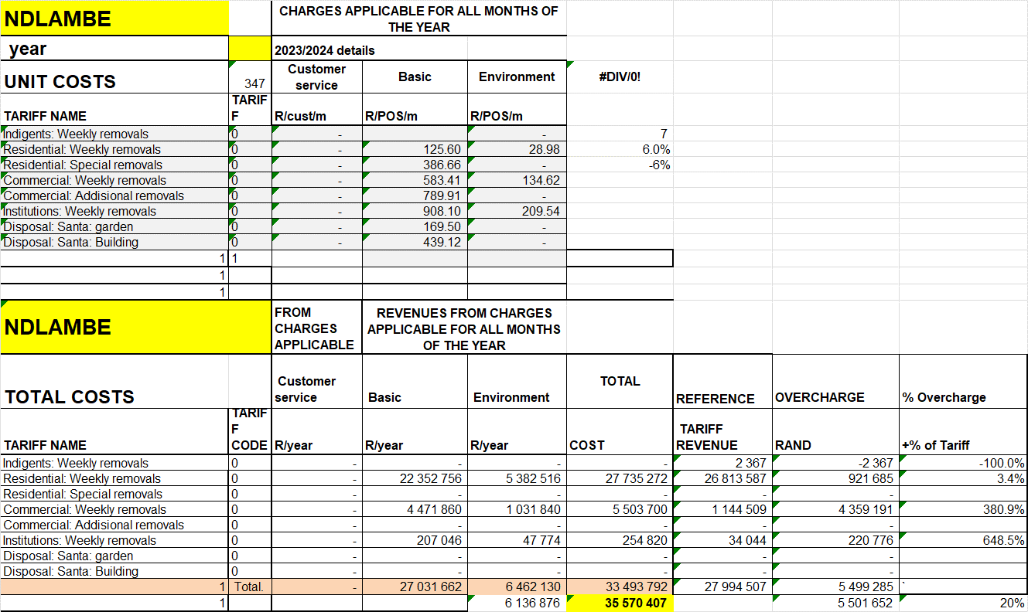

The following is proposed in this respect:

- Refuse removal charge:
  - Apply a 6% once off structure increase to the refuse removal charge for residential consumers.
  - Apply Commercial and Institutions charges with the current tariff differentials.
- The environmental charge:
  - Make no structure change before inflation increase.
  - Apply the same differentials as refuse removal charges in respect of Commercial and Institution consumers.
- These changes would result in the revenue increasing by about R5.9 mill or 20% before normal annual inflation increase.
- Apply the following method to determine who should be on Residential, Commercial and Institution rates:
- All those classified as commercial in the valuation role be charged on Commercial.
- Those on the Bulk TOU electricity tariff be on the Institution rates.
- In time more detailed surveys can be done to determine the estimated amount of refuse to the commercial and institution consumers.
- The expected revenue for 2024/2025 is R35.94 mill.

- The expected equitable share calculation is shown below.

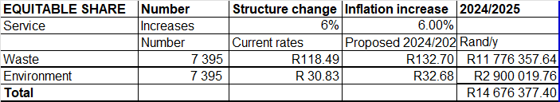

The total revenue for 2024/2025 is thus R50.6 mill.

PROPOSED TARIFFS

In view of the proposed pricing policy the following tariffs are proposed for Ndlambe as shown below:

It shows the following:

- The current tariffs,
- The proposed tariffs including the structure and inflationary increase.

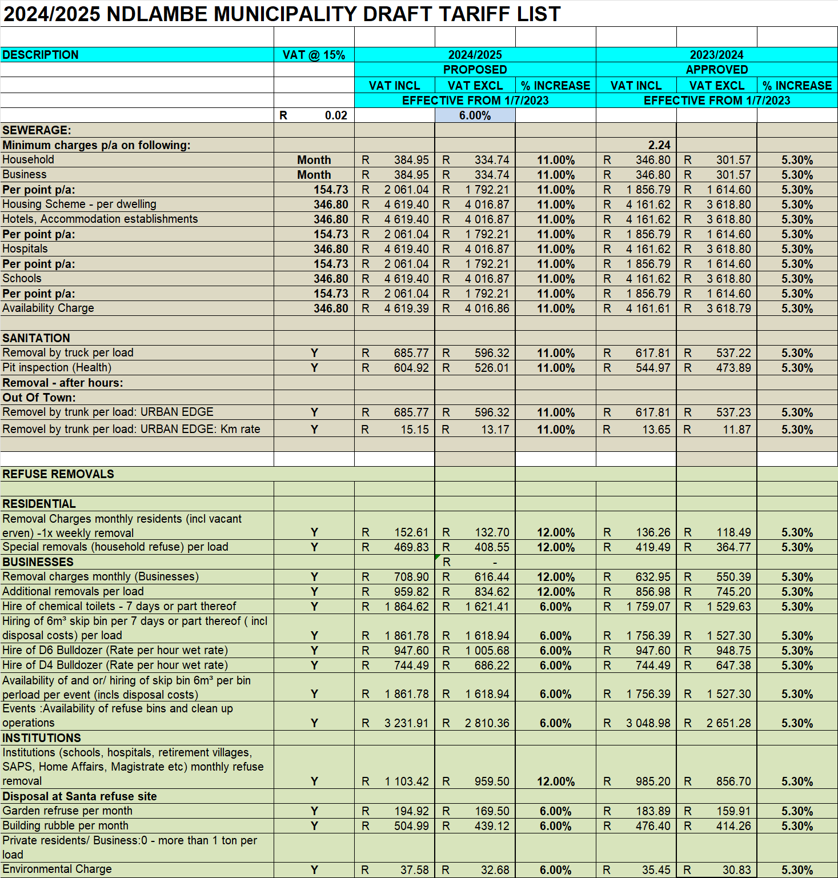

A summary of changes are as follows:

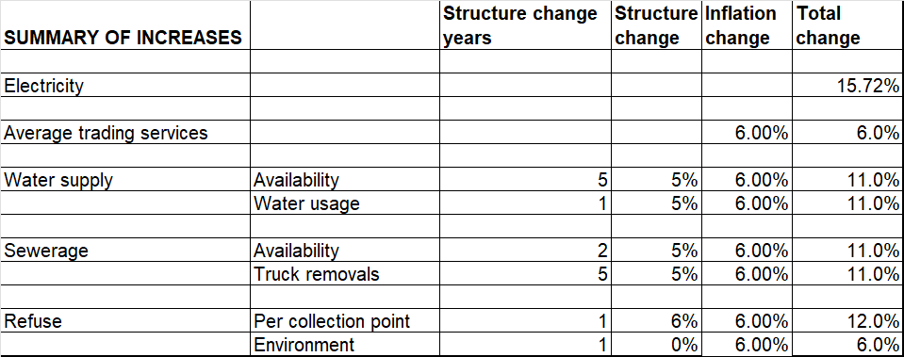

CONCLUSIONS

This detailed Ringfencing, Cost of supply and Pricing study presented many different challenges. All these have been addressed and the results obtained are considered 90% accurate. The current tariffs were found needing major changes.

The COS study must now be workshopped internally and as part of the public participation process and then be approved by Council, which need to make final decisions relating to implementation.

----------------------------------------------------------------------------------

