NDLAMBE ELECTRICITY: RINGFENCING, COST OF SUPPLY AND TARIFF STUDY – 2022/2023 COSTS

Table of contents:

1. INTRODUCTION. 2
2. INITIAL ASSESMENT 2
3. METHODOLOGY SUMMARY 3
4. ESKOM ANALYSIS. 5
5. NETWORK CAPITAL COST ANALYSIS 11
6. CUSTOMER CONSUMPTION PATTERNS. 13
7. CUSTOMER / SALES / REVENUE ANALYSIS. 14
8. NETWORK LOSSES. 25
9. RINGFENCING. 26
9.1. Key focus areas 26
9.2. Methodology applied 27
9.3. Overhead cost allocation 31
10. REVENUE REQUIREMENT. 36
11. REPRESENTATIVE LOAD PROFILE ANALYSIS. 37
11.1. Network profiles. 39
11.2. Profile re-conciliation. 39
11.3. Representative Profile Quantities. 42
11.4. Network Profile Quantities. 43
12. COST OF SUPPLY 43
12.1. Cost Classification 43
12.2. Cost allocation: phase 1 44
12.3. Cost allocation: phase 2 47
12.4. Cost allocation: phase 3 47
12.5. Tariff structure analysis 60
12.6. Key findings 60
13. PRICING STUDY 60
13.1. Pricing Policy Drivers 60
13.2. Pricing policy. 61
13.3. Cross subsidies to the poor. 63
14. PROPOSED TARIFFS 65
15. FINANCIAL IMPACT 67
16. TARIFF IMPACT 67
17. CUSTOMER IMPACT 68
18. BULK TOU TARIFFS 70
18.1. Bulk TOU tariff impact study 71
18.2. TOU tariff recommendations 74
19. AVAILABILITY CHARGES 74
20. BASIC CHARGES 75
21. SMALL SCALE EMBEDDED GENERATION (SSEG) 75
22. PHASE IN 77
23. TARIFF SCHEDULE 79
24. CONCLUSIONS 82
25. ANNEXURE 83
25.1. Allocation of network costs to tariff categories. 83
25.2. Definitions. 85
25.3. Abbreviations 87

INTRODUCTION.

Ndlambe Municipality (Ndlambe) sanctioned a comprehensive electricity pricing study which contains 3 main components, more than that required by NERSA:

- Ringfencing electricity. The key objective of this part of the study is to establish the true cost and revenue of electricity supply in the municipality.
- The Cost of Supply study. The objective of the cost of supply study is to know the cost of supplying customers on each tariff and to compare this with the revenue from current tariffs and thus the cross-subsidies.
- Tariff study. The final step is to analyse the structure of the tariffs and how it differs from the cost structures and identify the cross subsidies within the tariffs and then to propose new tariffs.

This paper describes the details relating to all three components of the study undertaken for Ndlambe Municipality. It contains the detailed results for the whole area.

INITIAL ASSESMENT

This section summarises the findings in terms of the existing tariffs and related issues. This was determined through analysis of the existing tariffs and discussions with electricity staff:

Domestic tariffs: Normal, indigent; conventional and PP

- The basic charge is not capacity differentiated and thus is too high for small consumers.
- Energy charges
  - The first block rate is below the Eskom purchase costs.
  - The second block very close to the Eskom costs.
  - The fourth and fifth blocks exceed the Eskom costs.
This probably means low usage consumers are overcharged.
- In some areas the basic charge is not being levied, RDP, houses.

Indigent.

- The same tariff as for other domestic consumers is applied.
- The basic charge and 50 kWh of FBE is not levied.
- This income foregone is supposed to be covered by the equitable share.
- There are about 900 consumers in poor areas for whom the basic charges have been waived. This does not comply with the rules for any tariff.

Commercial Tariffs: Conventional and pre-paid
- Fixed charge not capacity differentiated.
- High energy charges.

TOU for Bulk: LV and MV
- Slightly high basic charge: Should have difference between MV and LV
- No access charges
- Demand charges at a reasonable level.
- No reactive energy charge
- Voltage differentiation: MV/ LV – exceeding cost difference
- Tariff surcharge: HV / MV - irregular

Availability:
- The standard basic charge is applied.

SSEG tariff.
  - No provision

Wheeling charges
  - No provision

METHODOLOGY SUMMARY

The NERSA cost of supply Framework describes the steps as shown in Figure 1. It is considered to be an oversimplification and does not cover all aspects.

Figure 1
NRS058, the National Standard Specification “Cost of Supply Methodology for application in the Electrical
Distribution Industry”, which was developed many years ago but never received final approval due to a legal dispute, shows the framework as in the Figure 2.

Figure 2

Later in the NRS058 standard, a procedure diagram is provided as is shown in Figure 3. The NERSA framework does not feature any of these very important steps.
Figure 3

This report will thus follow the NERSA framework, but it must be realised that it is an over implication of a much more complex process and thus feature many more steps. It must also be remembered that NRS058 was developed largely by an Eskom employee who only undertook cost of supply in Eskom. The issues of ring-fencing of electricity from the rest of the municipality do thus not feature in NRS058. For a proper study, Ringfencing must be done.

It is however proposed that anybody who really wants to appreciate the complexity of this cost of supply study should read the Interim NRS058 before reading this report.

Before starting with the ringfencing study, some background calculations need to be done as detailed in the next few sections.

ESKOM ANALYSIS.

Ndlambe receives its electricity from Eskom from 2 points of supply. These are shown in Table 1 as well as the tariff and the % on TOU.

Table 1
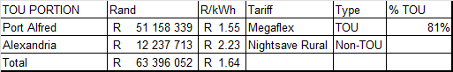

These actual kWh and Rand values are summarised to represent the total purchase costs for Ndlambe as shown in Table 2. During February 2023 a big adjustment was made in the Eskom bills. This involved an increase in maximum demand and decrease in kWh.

Table 2
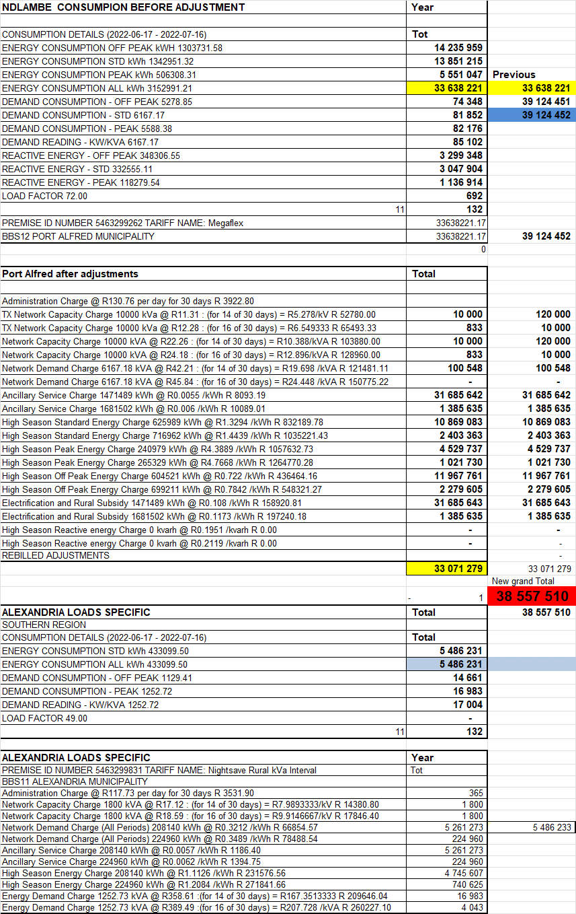
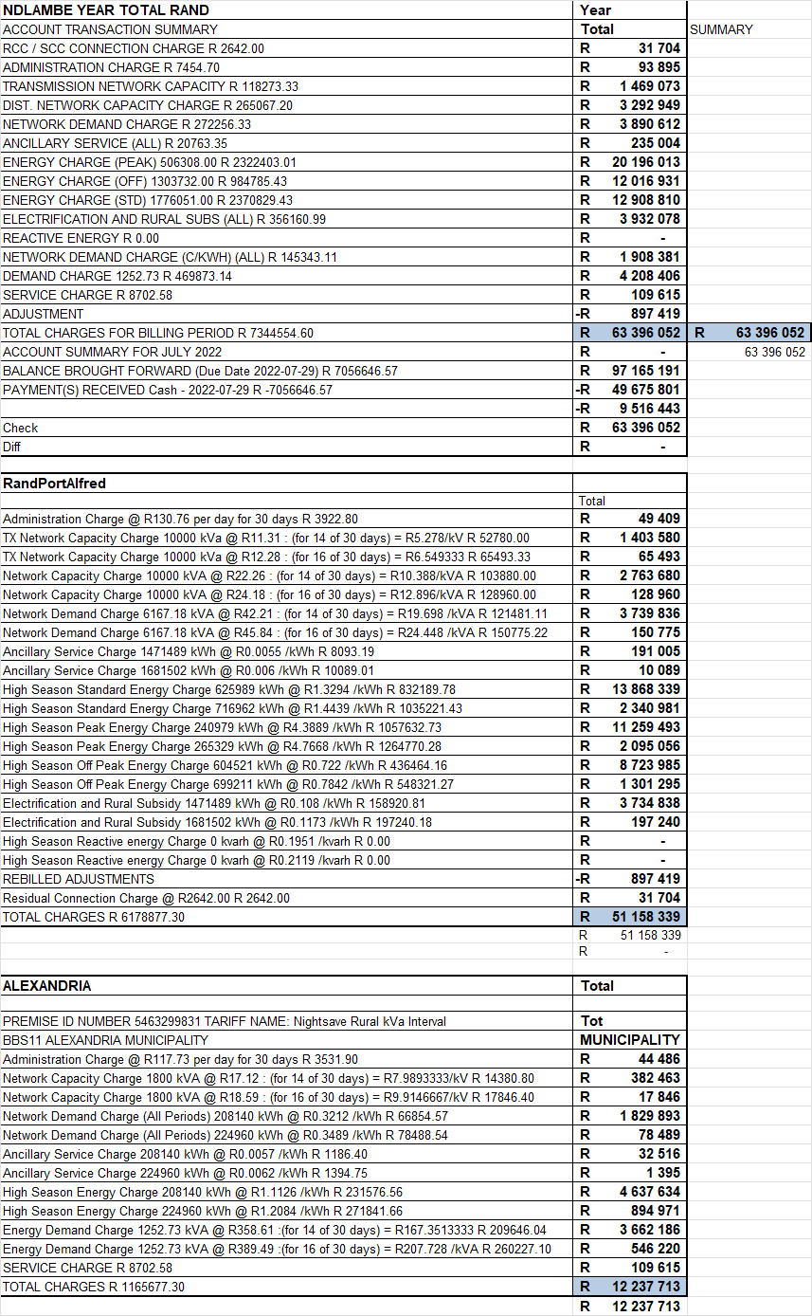

Next is to analyse the load profiles of the supplies from Eskom. The ½ hourly profiles for the last financial year were obtained from Eskom for each of the points of supply.

Figure 5 shows the total ½ hourly KVA purchases (Y-Axis) for Ndlambe over the 12 months (X-Axis).

Figure 5 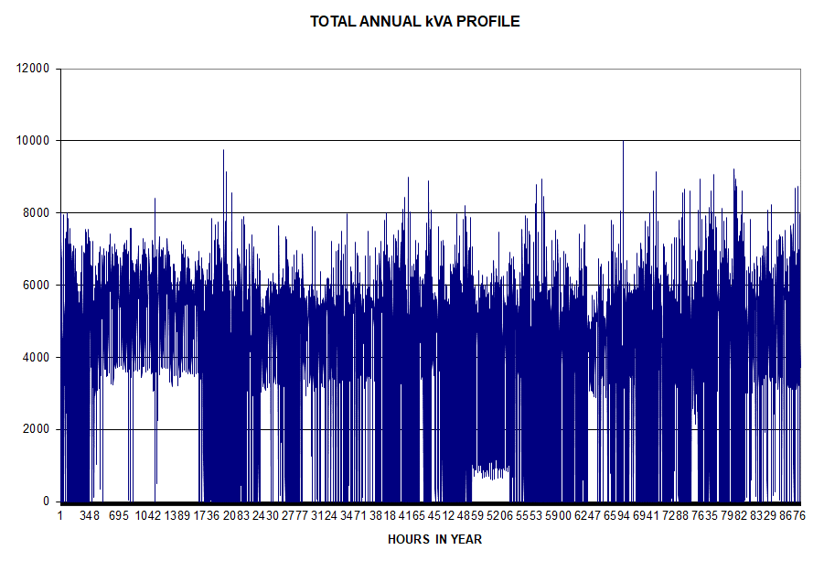
The following observations can be made from this:

- The municipality has a generally flat load throughout the year.
- It shows very sharp peaks which probably could be accounted to the cold load pickup after load shedding.

Figure 6 shows the annual load duration curve. This shows the highest to the lowest ½ hourly kVA (Y-axis) for all the ½ hours of the year (x-axis) and gives an indication of the potential to reduce the peak demand.

Figure 6
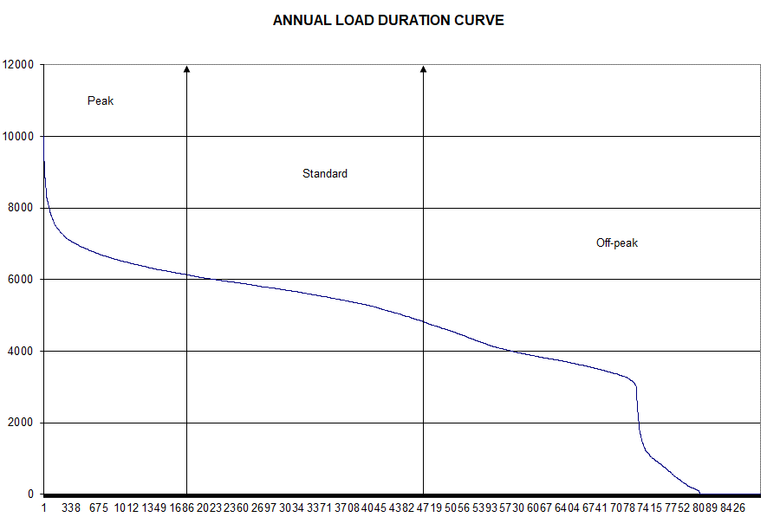

Table 3

This shows that there is limited opportunity to save on maximum demand charges by only cutting out the peaks for a few hours in the year. Although the potential looks limited for the combined load, it will become clear that there are great opportunities to reduce peaks at each individual Eskom point of supply. Analysis shows that close to 5 MW can be further reduced by managing less than 100 peak hours in the year. This shows the importance of applying demand side management in the pricing signal to customers.

Figure 7 shows the ½ hourly kVA values (Y-axis) for the following average weeks (7 day ½ hours per week = x-axis) of the total Eskom supply in the year:
- Average for whole year.
- Average for high-demand period
- Average for low-demand period.

Figure 7 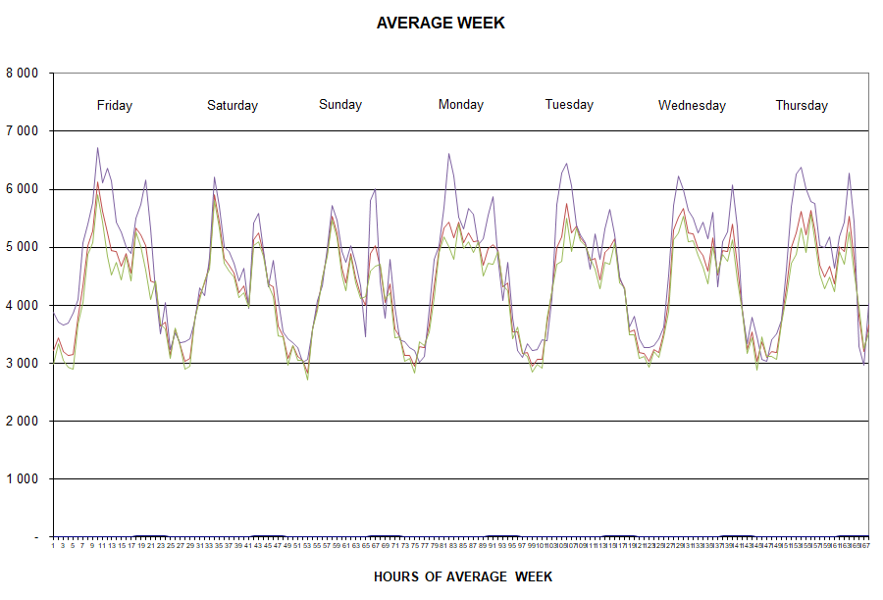

The following can be said in this respect:

- This is similar to other town profiles.
- It shows the very high evening peak especially in the High demand period (mainly from domestic customers).
- With the hot summers there is also a lower peak during the late mornings.
- It shows lower consumption on Saturdays and Sundays but late morning peaks on Sundays.
- Very low levels of consumption during the night.

Figure 8 shows the ½ hourly kVA values (Y-axis) for every week of the year (7 day ½ hours per week = x-axis). This is a very important graph as the previous average graph easily hides very important information.

Figure 8
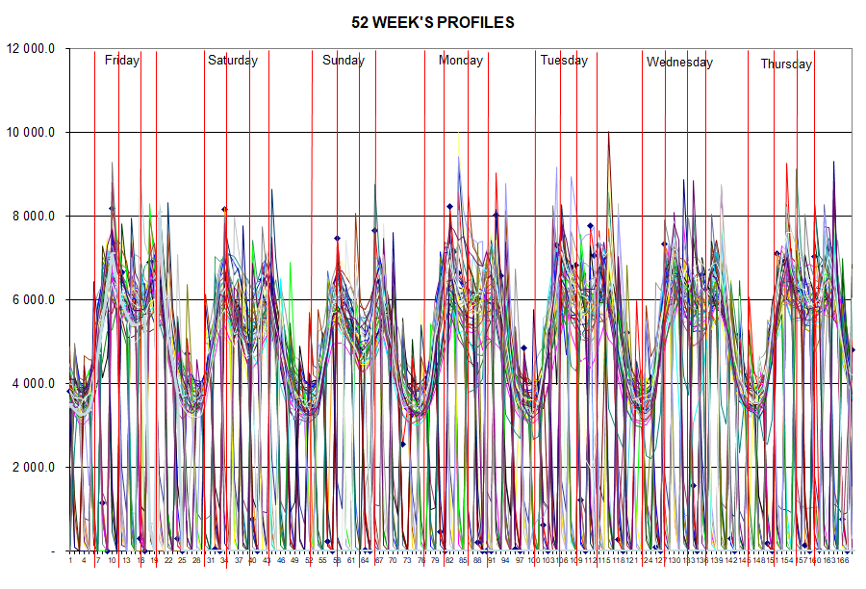

The following can be seen from this:

- There are high peaks during the mornings and evenings although the highest peak was during the late afternoon.
- It also shows that there are only a few days in the year where the demand actually exceeds 8 MW. That leaves massive opportunity to save more than 2 MW with very limited effort.
- This is a clear message that the key focus for demand reduction must be on domestic evening peaks but the rising morning peaks cannot be ignored.

NETWORK CAPITAL COST ANALYSIS

The first step in analysing network assets is to develop a Reduced network diagram (RND). Figure 4 illustrates this for the Ndlambe network. Most rural supplies in the area are provided by Eskom.

Figure 4

Table 4 shows the RND in table form. All costs and customers will be linked to these networks in the cost of supply study.

Table 4
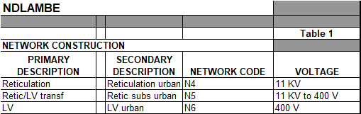

The following comments in this respect:

The summary of electrical assets in the financial assets register was studied and the following found:

- The asset descriptions are not detailed enough: cable and line lengths not shown.
- No replacement values provided.

The technical asset register was then obtained and studied.

The summary of the technical asset register with replacement values are shown in Table 5.

Table 5
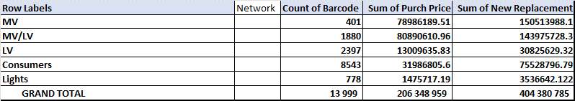

The replacement per units values were tested and found to be too low. The CRC values were thus doubled to obtain more reasonable values.

The depreciation and ROA making up the total Capital revenue requirement is shown in Table 6.

Table 6
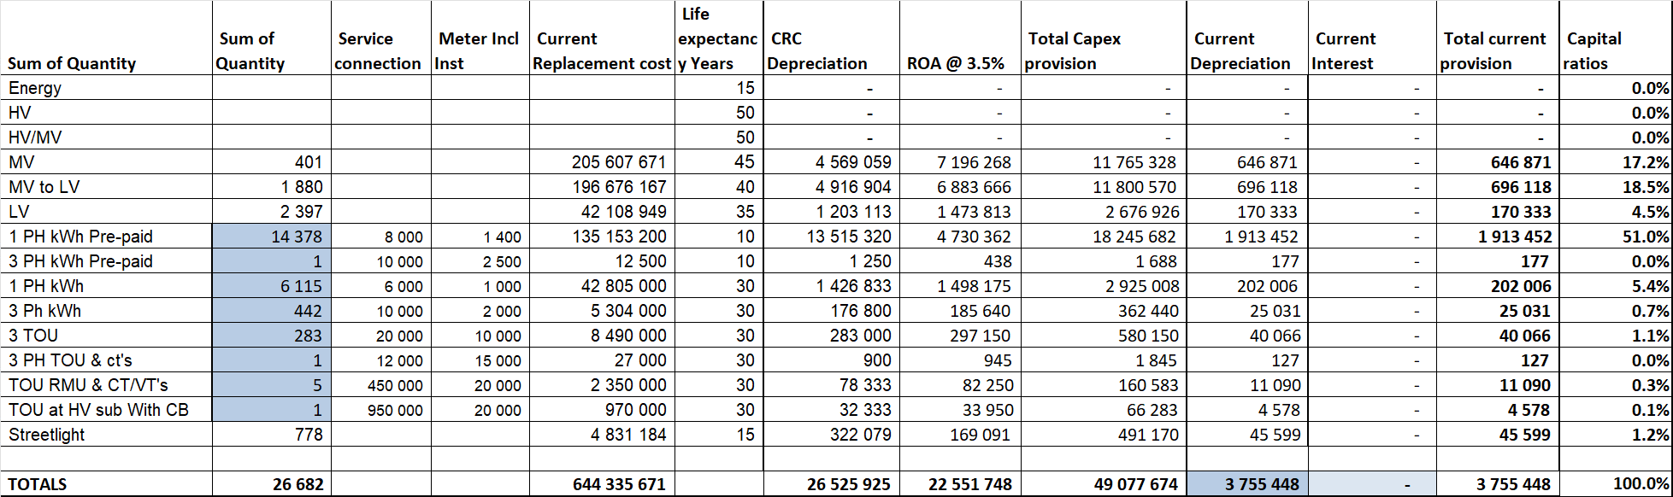

The following in this respect:

- CRC depreciation – Calculated using the NERSA prescribed life expectancy.
- ROA - Return on Assets. The 3.5% is a real rate return considered internationally acceptable. This component is to cover the average cost of capital, including interest and return.

The process followed is to calculate the total capital provision as by international standards (depreciation plus ROA also called levelised cost) and then the ratio of these provisions relative to the total provision. Then apportion the current total provision (depreciation and interest) to the various asset categories using these ratios. These values will be used as a basis for the cost of supply analysis.

CUSTOMER CONSUMPTION PATTERNS.

The sales are then analysed even further to determine the number of consumers per consumption block. This is important when deliberating about categorising consumers and developing appropriate tariff structures and consumer impact. The tables and graphs below show a section of the analysis for each of the small consumer tariffs. In case of each tariff the graphs after each table illustrates this graphically:

- The first graphs show:
  - the cumulative kWh vs each kWh block. (vertical axis)
  - the kWh per kWh block (horizontal axis)
- The second graphs show:
  - the cumulative consumers vs each kWh block. (vertical axis)
  - the consumers per kWh block. (horizontal axis)

Domestic consumers.

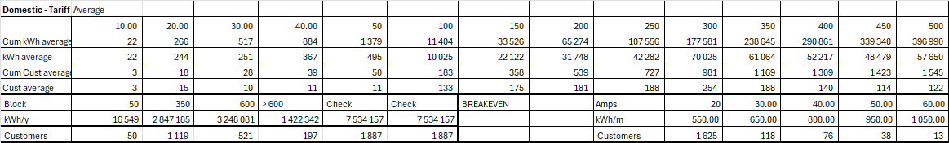

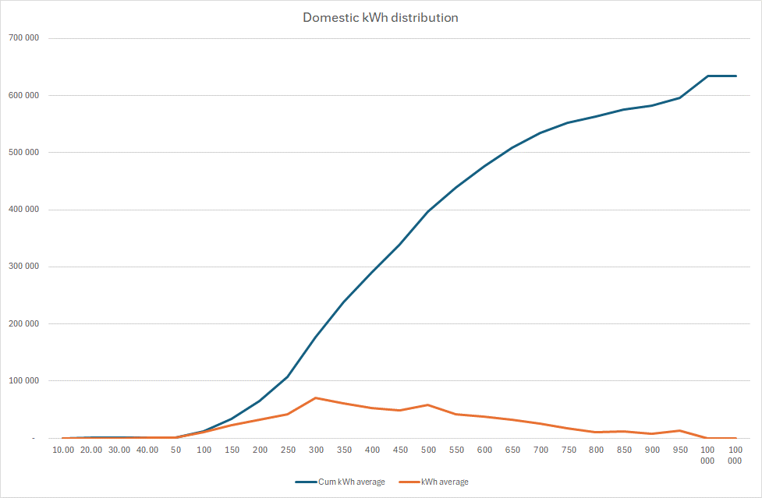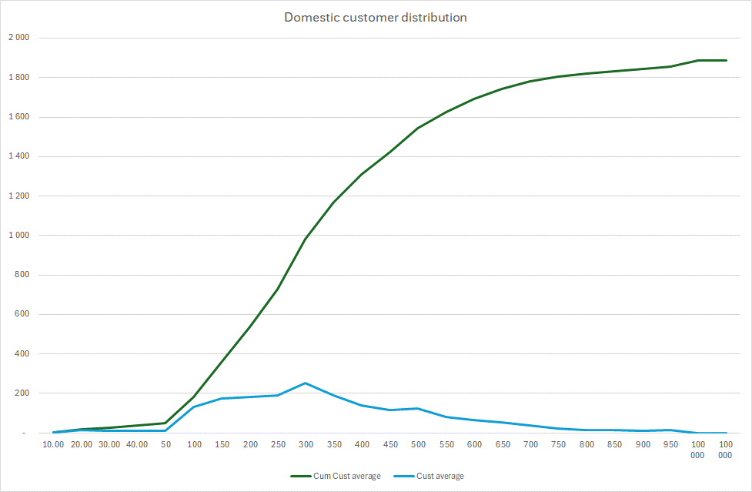

Indigent consumers
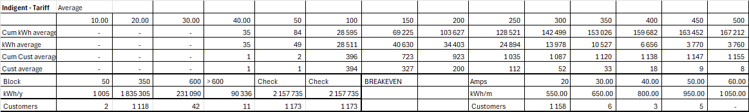

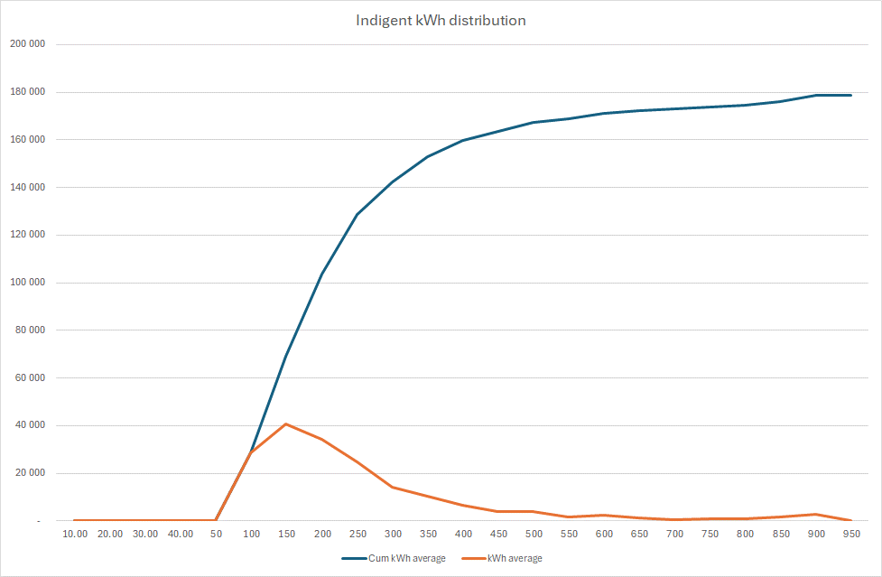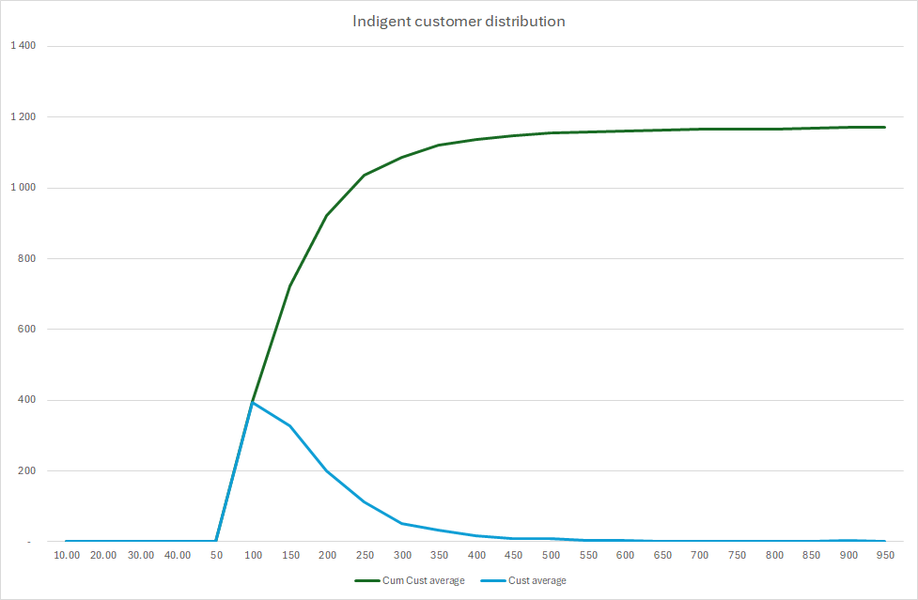

This information is critical for the following:

- The fact that sales is already collected by Amp size makes this very useful.
- Determination of different tariff categories
- Determination of a subsidy tariff for the poor that are not indigent.
- Selecting consumers on appropriate tariffs.

This clearly shows that there are many poor consumers that use very little and probably can’t afford more even if they are not indigent.

CUSTOMER / SALES / REVENUE ANALYSIS.

Before one can start classifying costs, some calculations need to be done which will be used in the classification process. It starts off with the analysis of customers, tariffs and revenue.

Table 7 shows the 2022/2023 and 2023/2024 tariffs. The current tariffs are used to ensure that any restructuring that was done during the last tariff change is incorporated.

Table 7
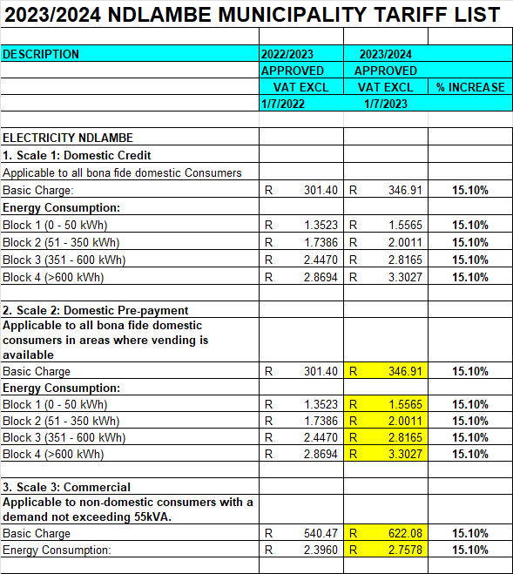
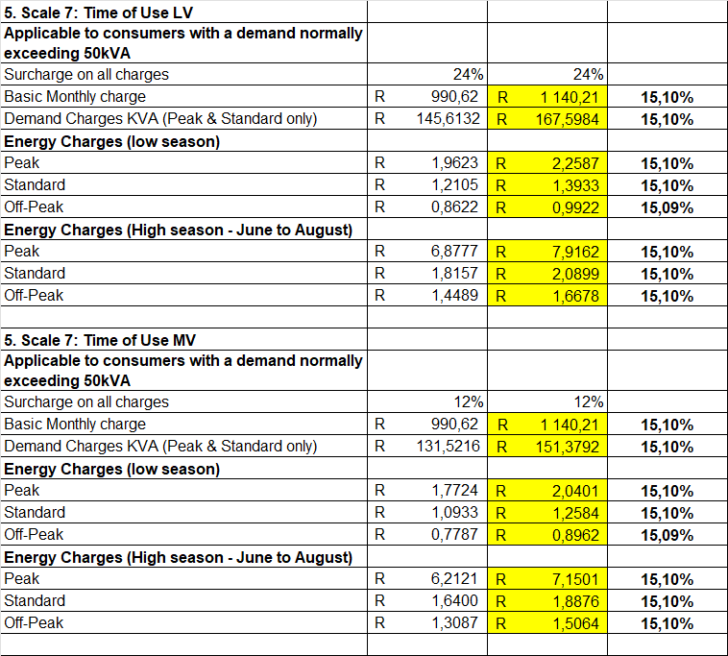

Table 8 shows the 2023/2024 tariff charges for purpose of calculations and assessment.

Table 9 shows the 2022/2023 consumptions details.

Table 10 shows the 2022/2023 consumption statistics.

Table 8 Table 9 Table 10
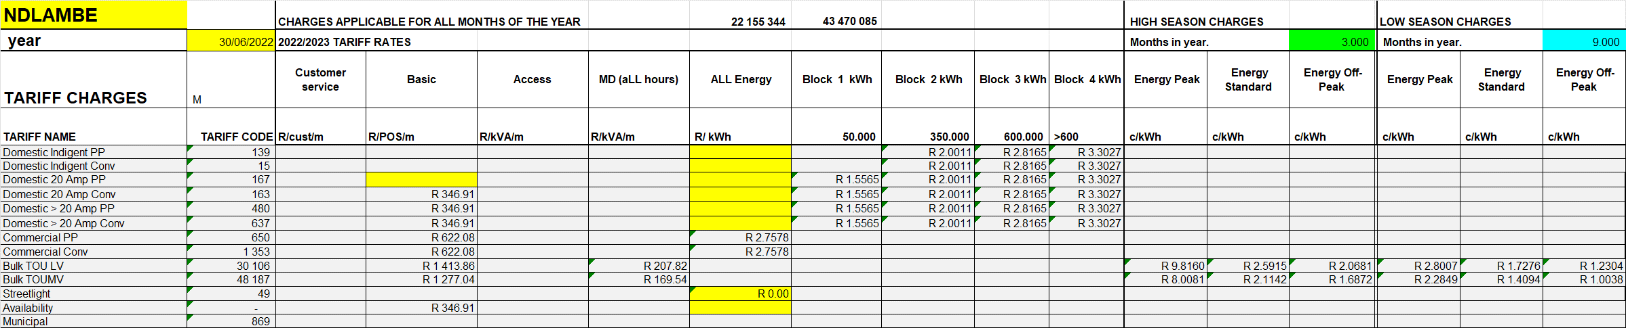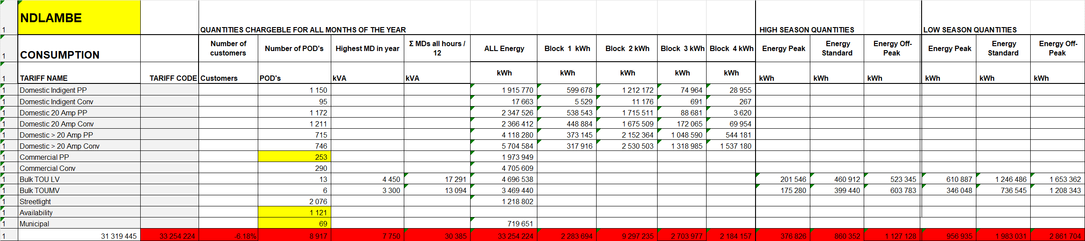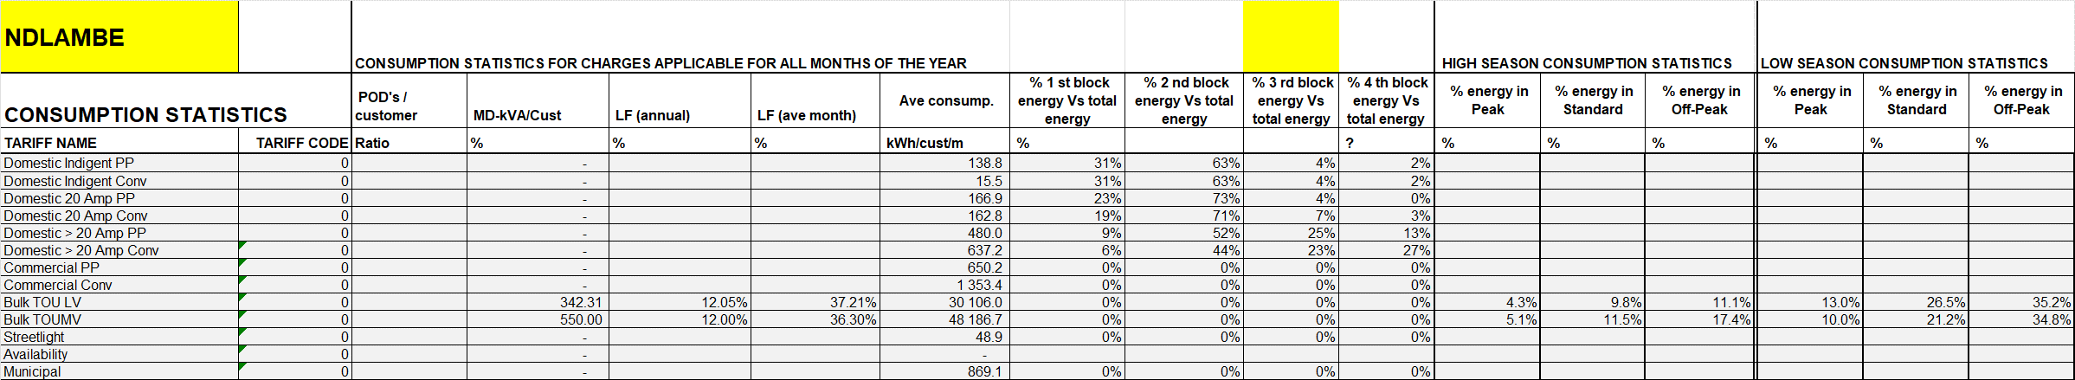

These values all makes sense and will thus be used as such.

Various reports had to be used to determine the sales per tariff. Table 10 shows the sales for pre-payment consumers. Table 11 shows the consumption per tariff block. This is obtained by calculation of the individual consumer monthly data.

Table 10 Table 11

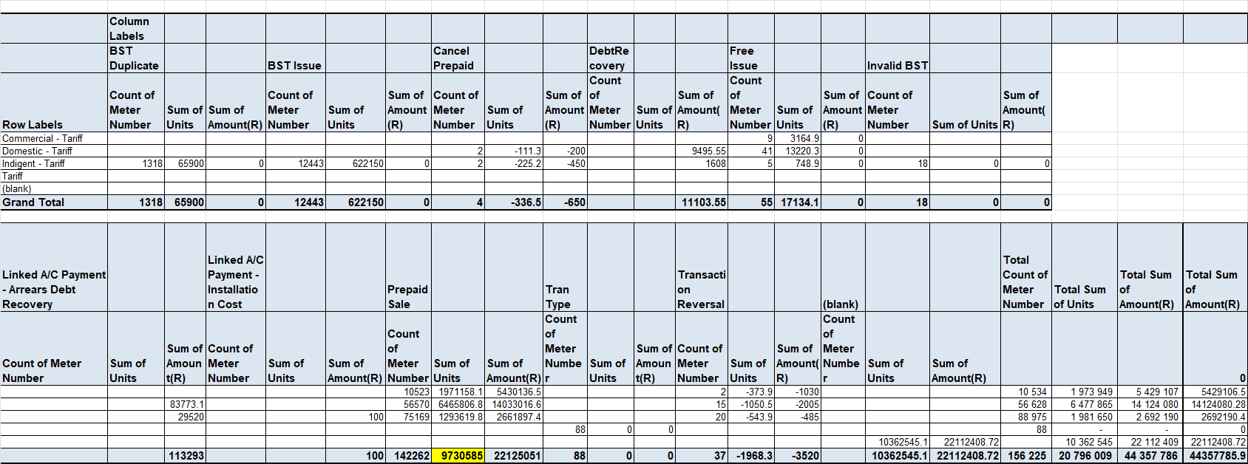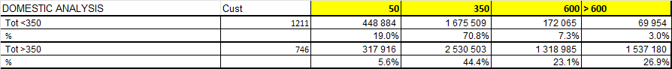

Table 12 shows the conventional consumer sales data excluding basic charges.

Table 12
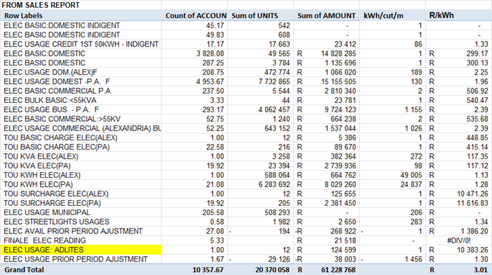

The domestic tariffs feature block rate and thus the quantities per block is required. This is not provided in summary form. The sales per block was then calculated from the individual consumer monthly data. A summary of these ratios are shown in Table 13 below.

Table 13
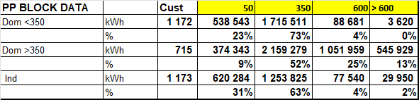

Table 14 provides details of the non-metered loads including public lighting. The following should be noted in this respect:

- The municipality provides the energy to all the other public lights.
- The municipality provides maintenance to all the public lights.

Table 14
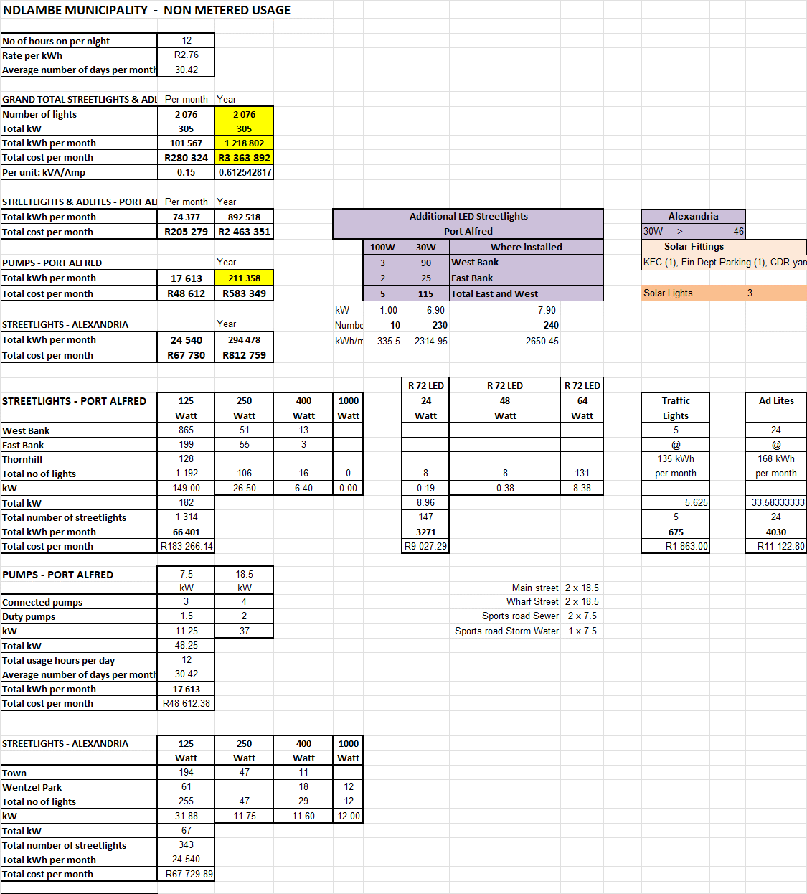

Table 15 shows a comparison of the data from the various sales reports, that summarised in N-1 and the NERSA D-form. It is clear that some adjustments need to be made in this respect.

Table 15
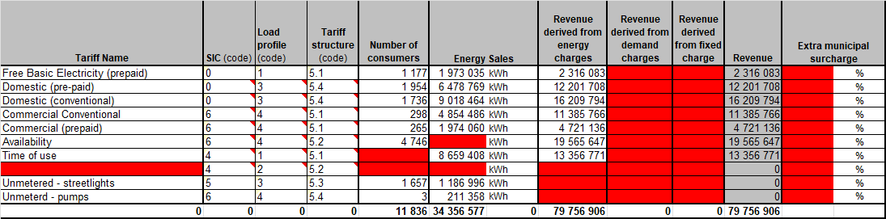

Table 16 shows a summary of the 2022/2023 actual revenue from the sales reports.

Table 16
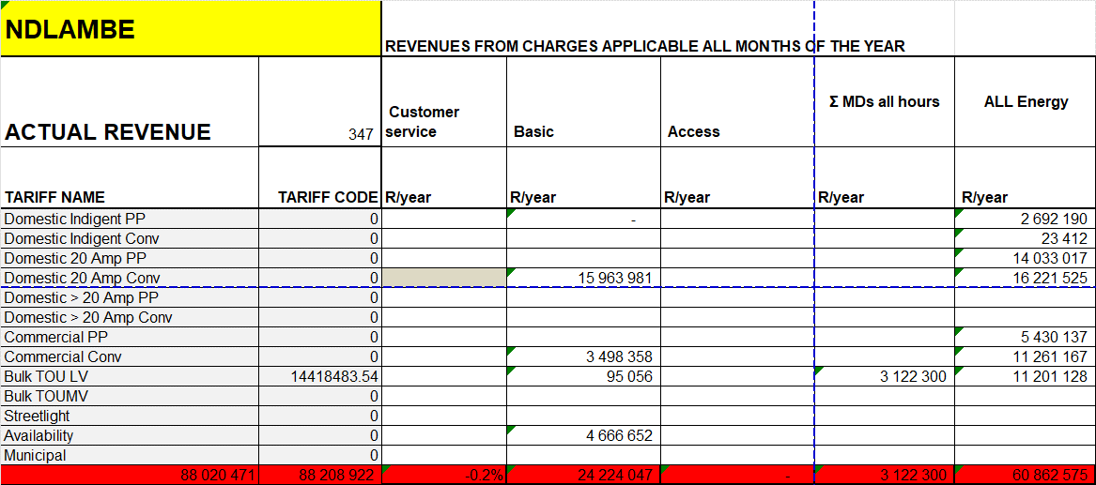

Table 17 shows the calculated revenue by multiplying the 2022/2023 consumption by the 2023/2024 tariffs.

Table 17

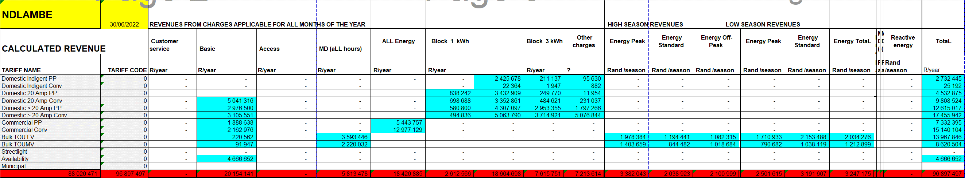

Table 18 shows a summary of the newly calculated revenue compared with the actual revenue.

Table 18
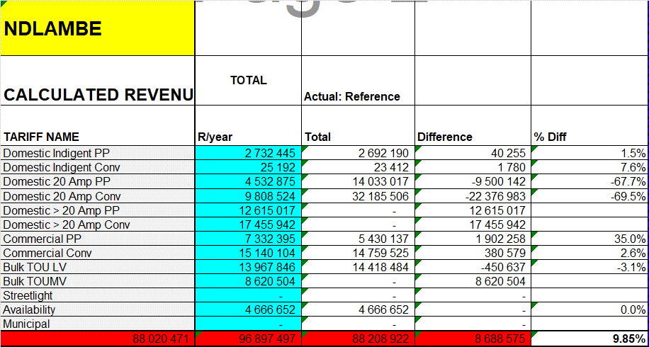

This shows a total increase of 9.85% which is less than the average price increase of 14.59%.

Because the losses are much higher than the normal expected technical losses, 13.5% compared with 8%, some adjustment is required. If the lower consumption levels are used it would yield R/kWh and R/kVA unit costs that are inflated because the divider is understated. For that reason the following adjustment will be made.

- The number of consumers are not changed as it is assumed that all consumers are on record. There may be some illegal connections but these will be ignored.
- The KVA values are not going to be changed.
- The kWh values are going to be changed on all consumer categories. It may be that t should only be done on residential consumers but experiences elsewhere have shown that losses are incurred on all consumer categories.
- The kwh will thus be increased by the same % to achieve losses of 8%.

The adjusted consumptions figures are shown in Table 19 below.

Table 19
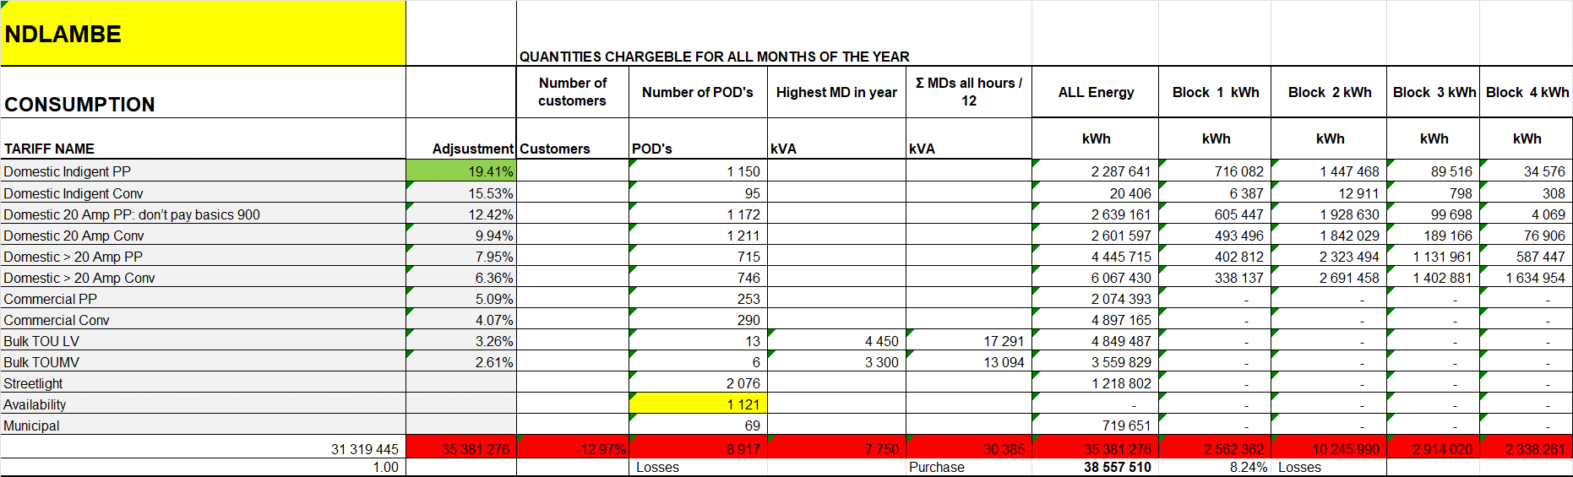

The adjusted calculation of revenue is shown in Table 20 below. This will also be used as a basis for calculation of the revenue requirement.

Table 20
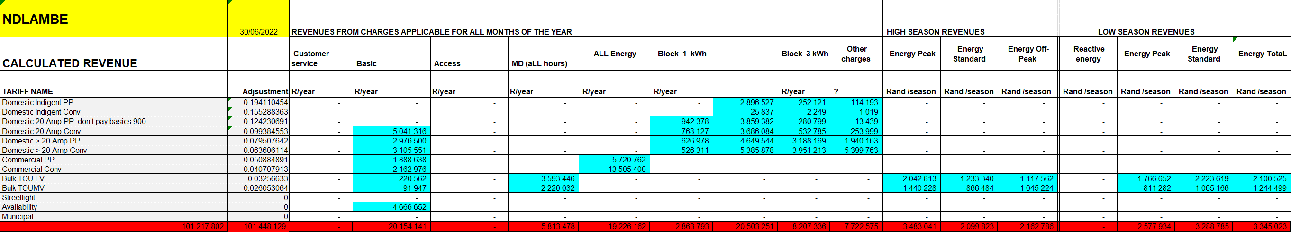

These values will be used to calculate various cost of supply factors.

NETWORK LOSSES.

The losses in the network are required in various instances. The first step is to determine the amount of energy flowing through each of the networks for each representative load profile. This is done by obtaining the kWh from each customer category from the actual consumption table and allocating it to the relevant point on the network. The result is shown in Table 21.

Table 21
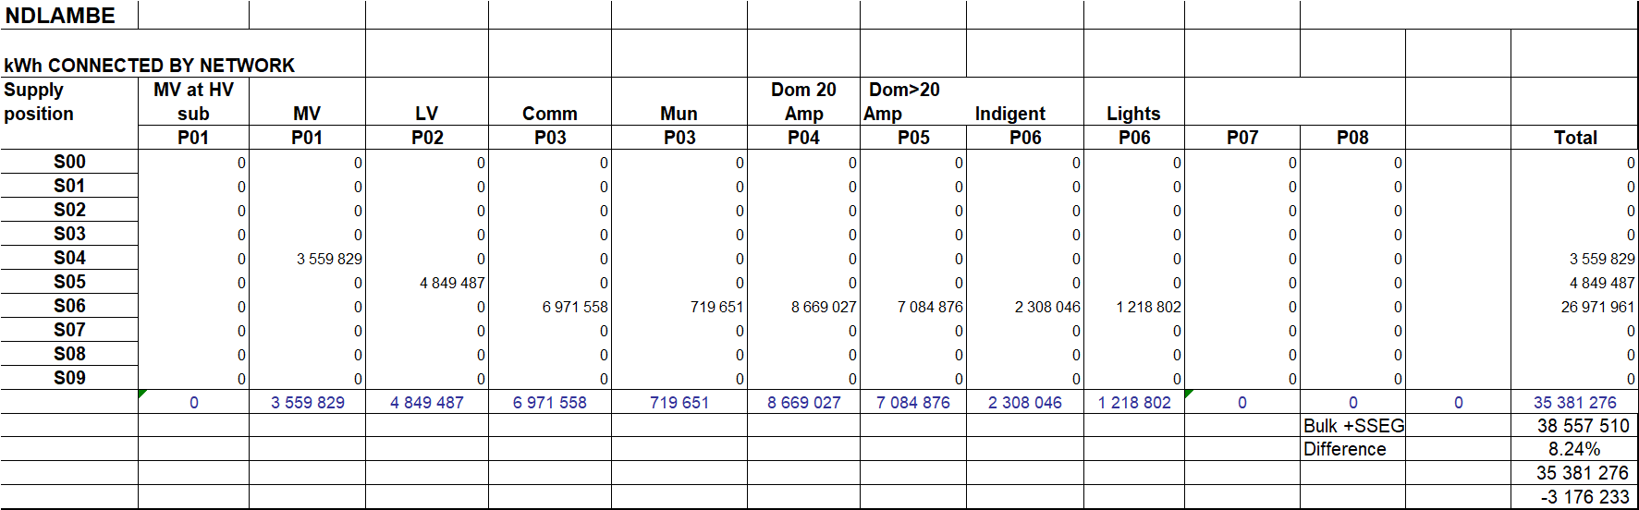

The next step in the process, to calculate the losses of every network component, is as follows:

- An estimate is made about the loss % for every network component. This is done by considering the impedances of individual network components, the numbers involved and the loads flowing through it.
- The total infeed loads are then added to the relevant losses for every network through which it flows and are then added to the loads through all other networks to yield the total load.
- The loss factors are then modified until the total load, as calculated, is equal to the total load supplied in bulk. This is done by modifying the first pass estimation loss factors by the loss adjustment factor.

The resultant calculations are shown in Table 22 and Table 23.

Table 22
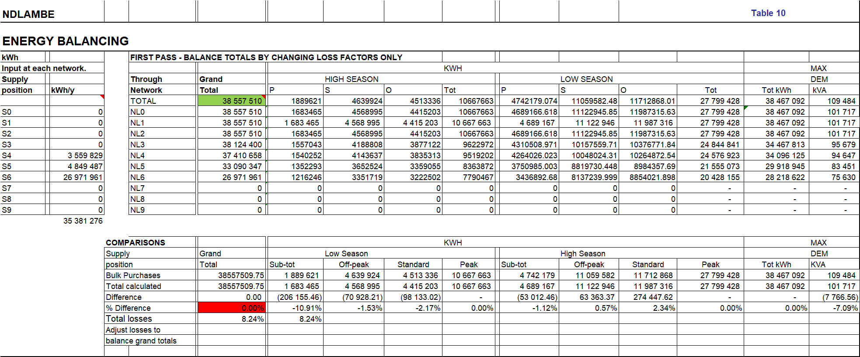

It is important to note that the losses refer to all losses from the Eskom infeed points right down to the customers connected on the LV network and include non-technical losses.

Table 23

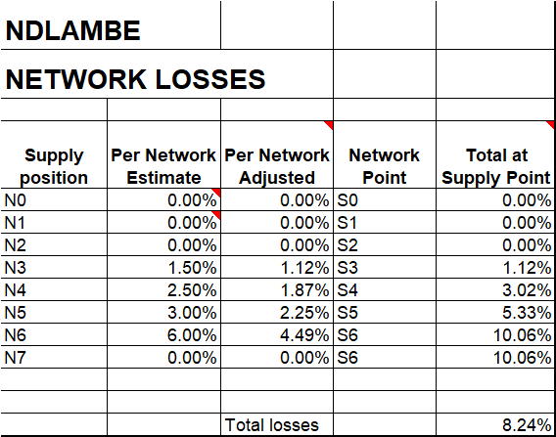

These load loss factors will be used in calculating the costs per tariff cost category.

RINGFENCING.

Before one can calculate the revenue requirement, a ringfencing study needs to be completed to determine the true costs and revenues and specifically overheads that should be charged to Electricity by the municipality. This means that the trial balance of the municipality and the NERSA D-form figures will be different due to a proper ringfencing process being followed.

Because it is best to do cost functionalization as early as possible in the process, it is done as part of the ringfencing study. In other words, the costs within electricity are identified and then costs are allocated from the various support functions in the municipality towards each of the various functions in electricity.

Key focus areas

There are a host of practices that affect the accuracy of the cost and revenue of current LG electricity distributors. The following ones will take the key attention:

The focus will firstly be on the larger items and thus the 20% of items that have 80% of the impact.

Services being supplied by Electricity to the rest of the LG where no charge is levied to cover the cost of supplying such service. The services involved here include the following: Electrical maintenance of LG facilities such as water works, sewerage works, buildings, houses etc.

Electricity equipment and other resources being used by the rest of the LG with no charge. This typically includes the following: Heavy vehicles, large machinery, meter readers etc.

Public lighting including streetlights, high mast lights, robots, parking lot lights, etc. This service is considered a LG service and not part of electricity supply although the service is provided by Electricity.

Electricity for own use by LG. Many municipalities have a different set of tariffs for the supply of electricity for use by its own facilities, such as municipal buildings, stores, sewerage supplies, water pumping and sometimes also for staff. If these tariffs are not cost reflective it has the effect of distorting the true electricity supply cost/revenue and thus surplus. In some cases, an overcharge is made to the LG in the tariff and in other cases an undercharge.

Services provided to Electricity by the LG. Typical services include the following: Meter reading and billing, revenue collection, general accounting and administration, telephones, stores, etc. The extent to which this is done, differs significantly between various distributors. The big problem here is the extent of allocation of these costs made to the electricity department:
- Administration and overheads are allocated in terms of turnover instead of more realistic allocation factors, such as the number of staff, the own costs, area of office space etc. The problem with this is that the purchase cost of electricity is close to 70% of the revenue and the tax (surplus) being levied by the LG on electricity makes up a further approximately 20%. This method overstates the true share of the cost by the electricity department by more than 50%.
- Metering and billing costs should typically be allocated according to the share of the cost of the billing system with the number of transactions or actual processing time. Where the revenue is used as a basis, a misallocation is again made.
- A wide range of other methods are being used to allocate the other costs. There are internationally accepted methods that should be used to allocate the costs to ensure a fair burden on the electricity department.

Funding of capital expenditure. Assets in municipalities are mainly funded directly from profits / retained income and various grants received by the municipality. Some assets are still funded from external loans. The capital expenditure does not form part of the income statement, except in subsequent years when it appears as depreciation.

Government Grant funding. A large portion of LG income is from Government Grants. These are used to subsidise charges to residents but also to fund operating and capital costs. This distorts the normal profitability of departments and complicates the fair allocation of costs and revenues. Proposals will however be made in this respect.

There are a host of practices that affect the accuracy of the cost and revenue of current LG electricity distributors. The focus will firstly be on the larger items and thus the 20% of items that have 80% of the impact. It is one matter to develop a generic methodology to be applied. Things are always different because of the following:

- The way the municipality operates and is structured.
- The availability of data in the required format / level of detail.
- The need to focus on big values that have a significant impact.

Methodology applied

The process starts with an analysis of the Total Municipal Trial Balance for the completed financial year. These are the figures that are used as the basis for the compilation of the Annual Financial statements.

In analysing the Ndlambe data the following key steps were followed to achieve accurate ringfencing:

- The data was ordered as follows:
  - The head office, support and administrative functions. These are not considered primary service delivery but act as support to the various line functions and as such the line departments should cover their costs.
  - Community services, the economic services trading services. These are considered the primary service delivery to the community and need to carry all costs of the overheads and service departments.
- The various sub-departments and cost categories are grouped to make viewing practical.

This process is illustrated graphically in Figure 10 below.

Figure 10
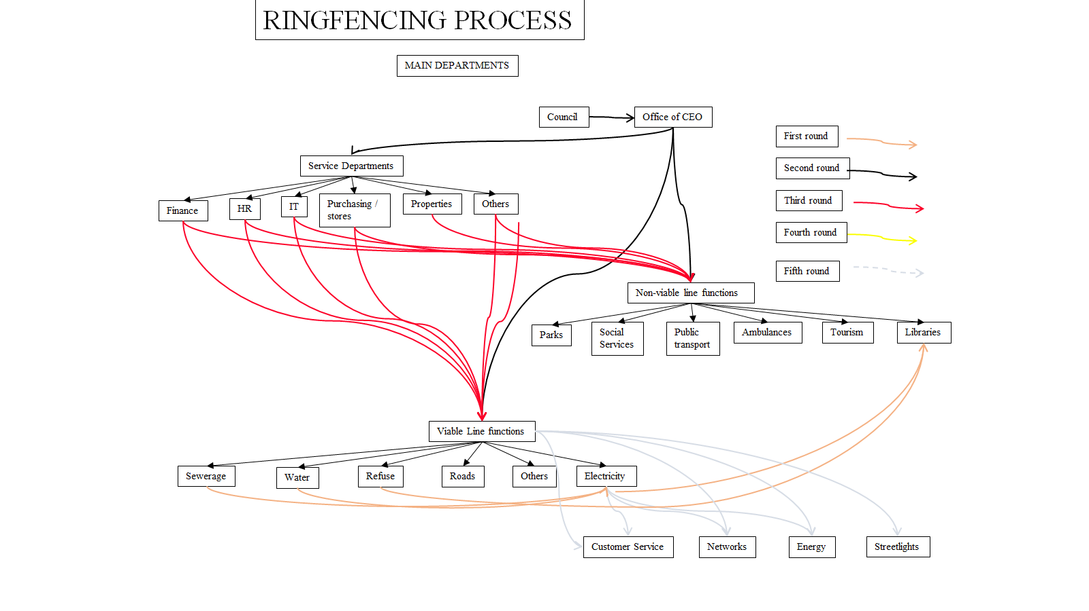

Table 24 shows the trial balance per group before any adjustments.

Table 24
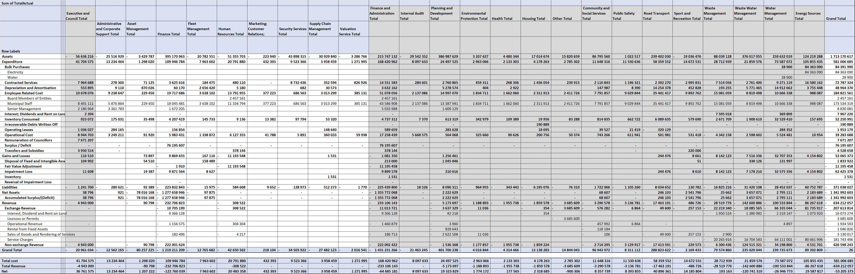
All the main transactions were analysed and any area where costs / revenues were not transacted correctly were identified. These were checked with the municipality and the required adjustments were made. The trial balance was found to represent the true picture accurately. The positive amounts refer to charges to electricity and negative amounts refer to amounts charged by electricity to the various departments and detailed in the fourth column.

Some adjustments have however been made to represent the data more accurately for tariff making purposes as shown in Table 25.

Table 25
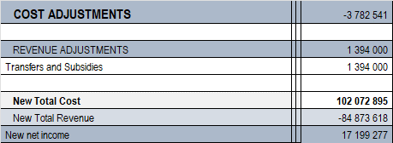

The only adjustment done is to remove the capital grant income as this must cover capital costs not operating costs.

Overhead cost allocation

The next step is to calculate the fair portion of the municipal overheads that should be covered by the electricity department. It was previously stated that no overhead costs have been allocated to Electricity. The next section does a calculation of a fair amount which should be allocated to all the line functions in the municipality by overhead and service departments. The first step is to calculate the ratios of various possible allocation factors using actual data.

Various ratios were analysed. The problem found was that in many cases the data required was inadequate in terms if not reflecting the required departments or in many cases were all grouped together. It is however believed that these ratios provide a fair means of allocating overhead costs.

The table below then shows the following:

ALLOCATER DATA.
- This refers to the various allocation bases which are to be used.
- The first line shows the data used
- The second line shows the ratio which will be applied in allocating the service department costs to that line department.
- This is calculated by dividing the line department units by the total units of all line departments.

ALLOCATION TO LINE DEPARTMENTS
- This shows the amounts allocated from each service department to the various line departments.
- The first column shows the name of the Service department.
- The second column shows the basis for allocation of the cost. Various basis were considered and inputs from staff was obtained at the workshops. Unfortunately, only those where data was provided could be used.
- The third column shows the percentage of the service department costs to be allocated on the basis.
- The cells in yellow shows the amounts allocated from the service department as a (_).
- The other cells show the amounts allocated to each line department.
- The last column shows that the net amounts sum to zero.

NEW NET INCOME
- This shows the new costs / revenue per department after the cost allocations.
- The subsequent new net income.

The following should also be noted:

- The cost for the Councillors and admin is not allocated to line departments. This will be offset against Account surplus.
- The Municipal and General is a problematic cost centre because:
  - The majority of grant funding is collected under this account. This will not be off-set against line department costs.
  - Various very big costs which belong to line departments are also collected here. The following is proposed in this respect:
    - Only the big cost items minus the small, related incomes will be allocated to the line departments.
    - Bad debt written off. This mainly relates to rates income thus based on total line depart cost.
    - Depreciation. This is only on common assets. Total line depart cost.
    - Inventory and consumables. Total line depart cost.
    - Interest costs relating to retirement benefits. Line department labour cost.
    - Leave pay. Line department labour cost.
    - Various operational costs. Total line depart cost.
- Municipal manager. All costs allocated to Line departments based on total own costs.
- Financial services.
  - Asset and risk based on asset values.
  - Billing finance based on number of bills per service.
  - Debt collection based on outstanding debt per service.
  - Supply chain based on inventory.
  - Remainder based on total cost. Net amount minus property rates income.
- Corporate services. Total net amount.
  - All HR functions according to staff numbers.
  - Remainder based on total cost.
- Strategy and Economic development. Net amount all based on total cost.

The allocation factors and allocations to line departments are shown in Table 26.

The actual allocations from the various departments are shown in Table 27.

The next step is to allocate the costs between the various sections within electricity. The allocation factors and the actual allocation of the various cost items to the various departments within electricity are shown in Table 28.

Table 26
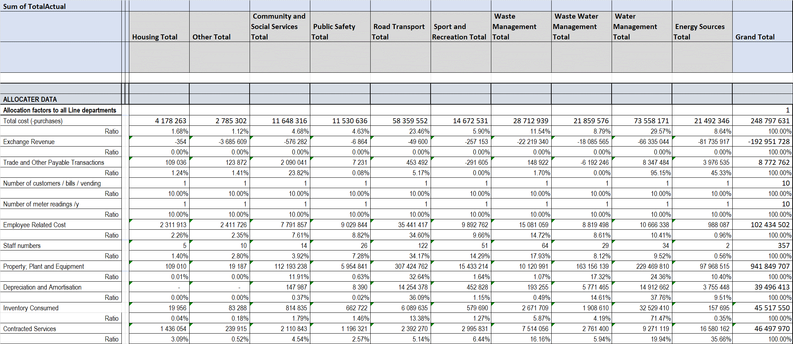

Table 27 Table 28
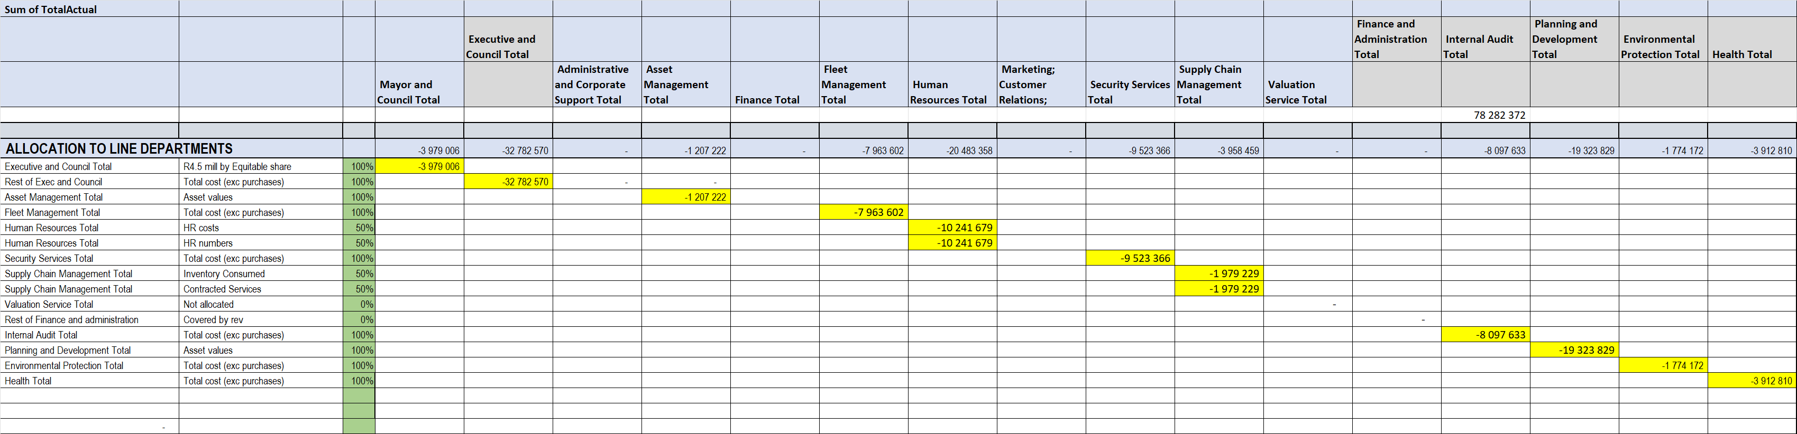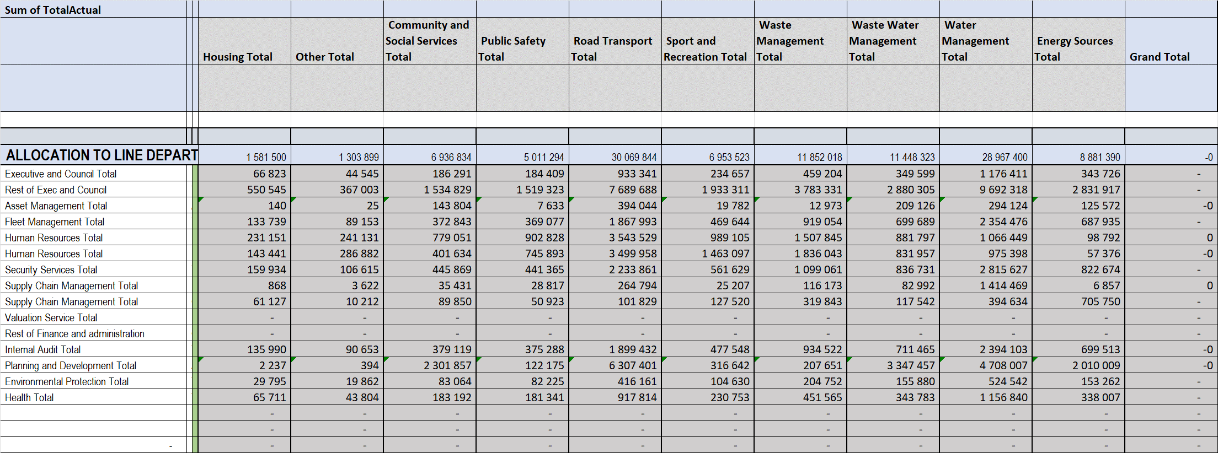

The costs and revenues per individual account is shown in Table 29 below.

Table 29

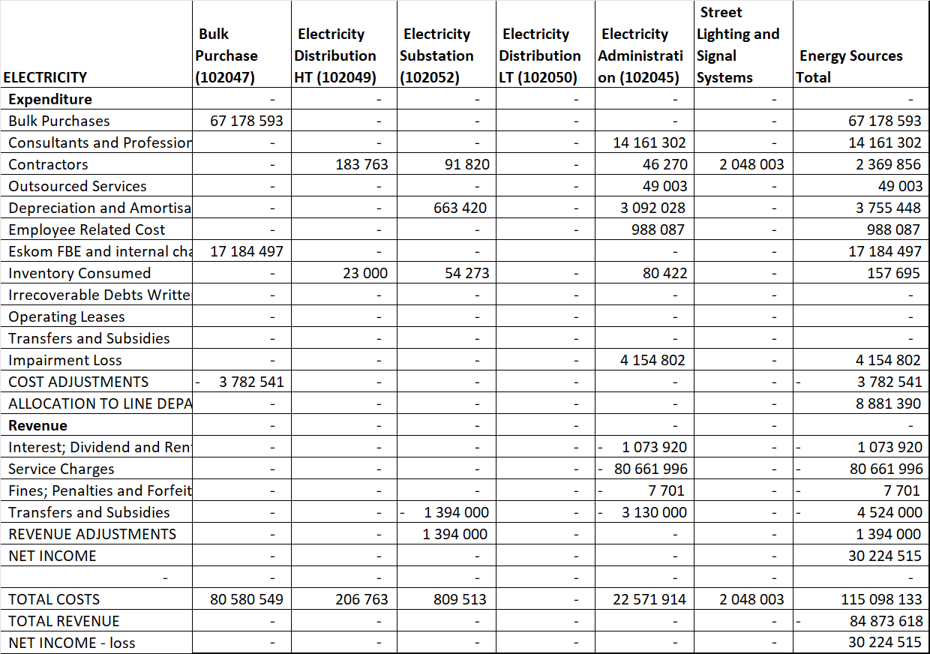

The costs are then allocated to the various functions within electricity. The allocations factors to be used are shown in Table 30.

Table 30
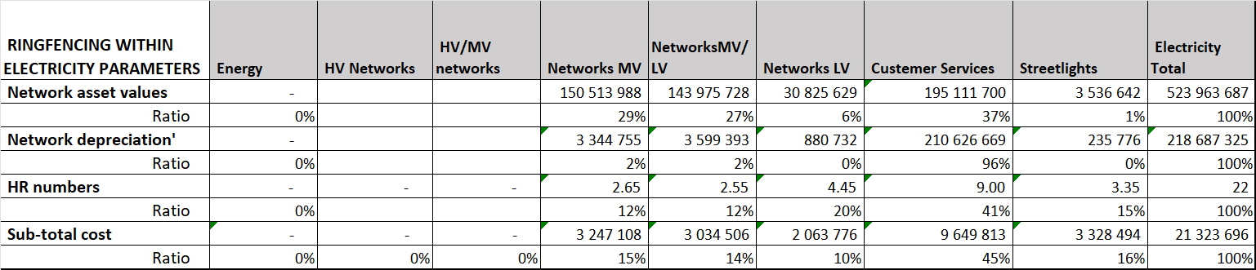

The actual allocations are shown in Table 31

Table 31
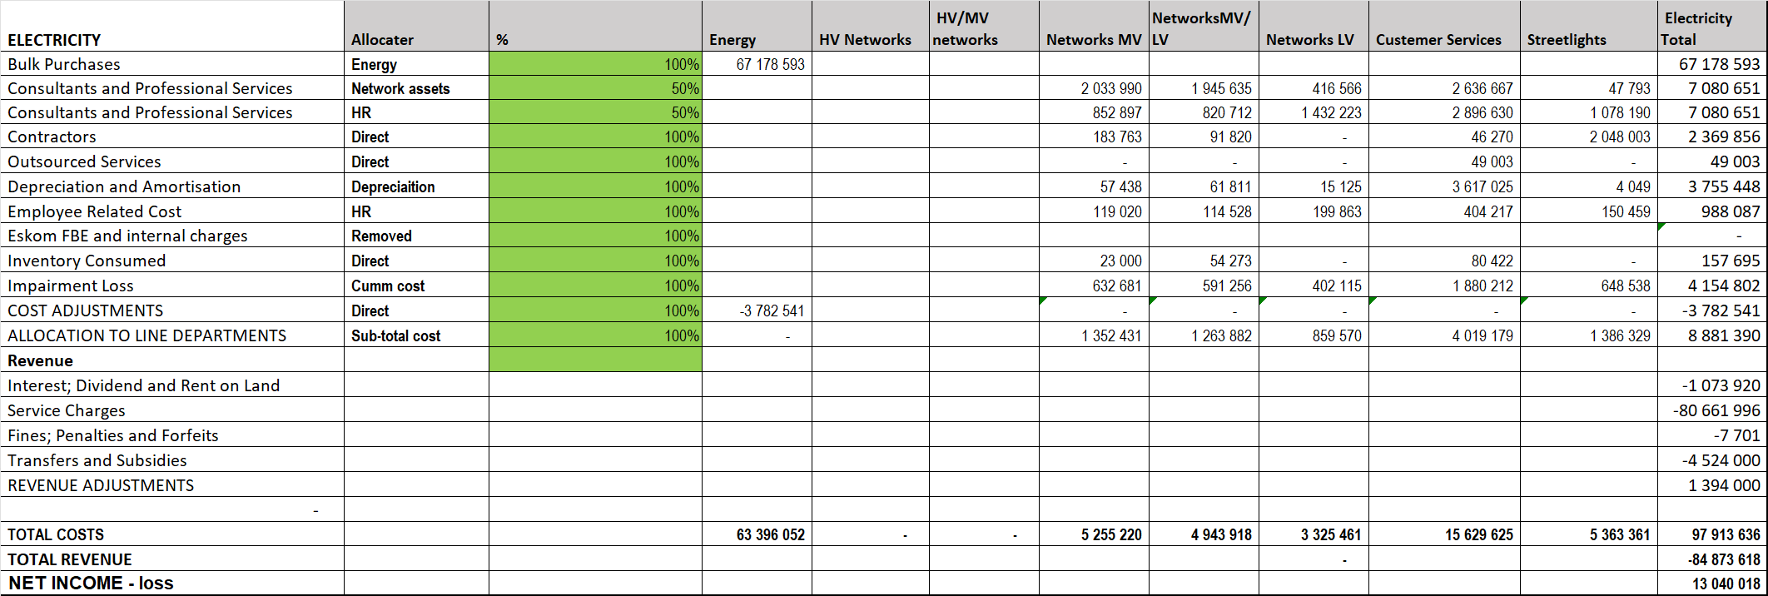

REVENUE REQUIREMENT.

This section calculates the revenue requirement for Ndlambe using the NERSA method. The items are then grouped as per the NERSA method. The calculation of the revenue requirement is shown in Table 32.

Table 32
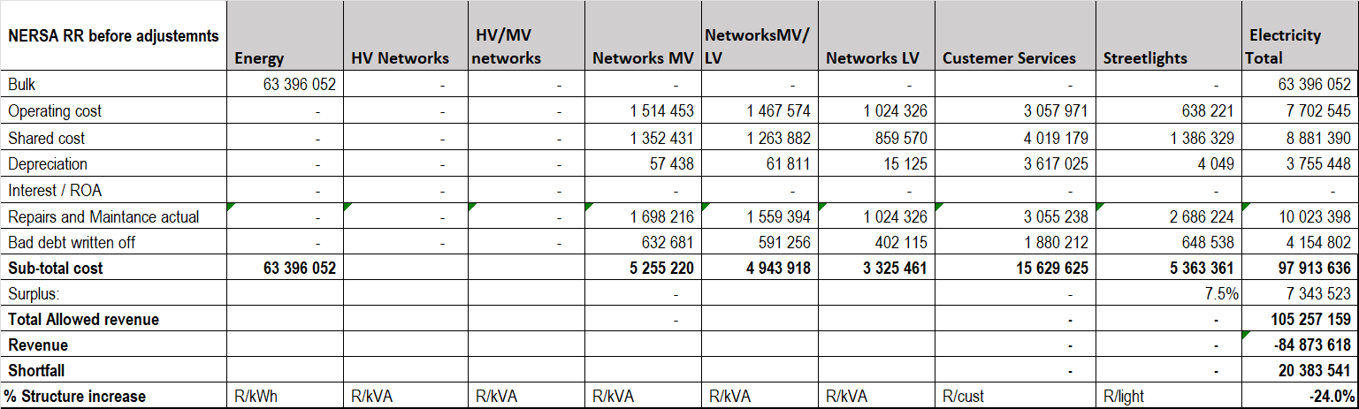

This shows the situation before any adjustments. The buildup of revenue is shown in Table 33 below.

Table 33
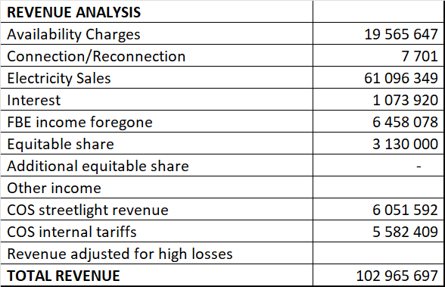

The proposed adjustments to remove non prudent items are shown in Table 34 below.

Table 34
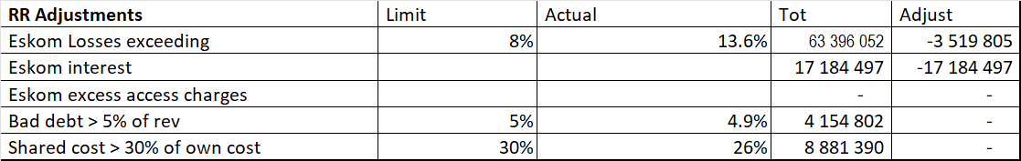

After doing these adjustments the revenue requirement is shown in Table 35 below.

Table 35
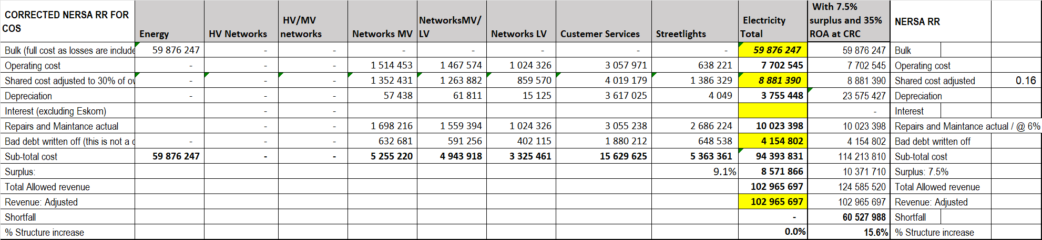

The problem with adjusting the bulk purchase cost to reflect the losses at an acceptable level is that the actual sales and consumers now have to carry still carry all the network costs.

The Support costs (operations, maintenance and admin) and capital costs (depreciation and interest) are split by function in Table 36 below.

Table 36
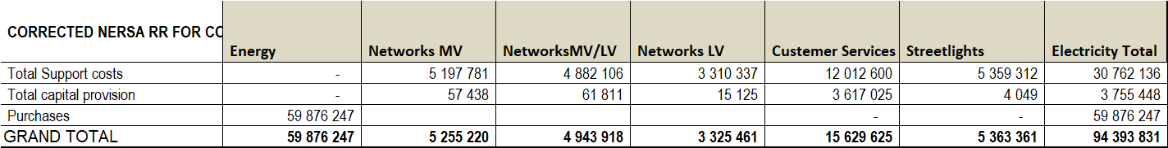

The following very important facts need to be noted:

- A surplus of 15% after allocation of overhead costs is considered high as the NERSA benchmarks (10 to 20%) were developed assuming no overhead costs. The actual surplus of 9.1% is thus used..
- The calculated Head Office / Service department allocation (admin charge) to electricity is less than 30% own costs excluding Eskom. This can be considered to be reasonable.
- The current replacement value (CRV) annual depreciation is equal to R26 mill. The surplus must at least cover this amount to ensure long term sustainability. At 9.1% the surplus is equal to R8.5 mill and actual depreciation R3.7 mill. Although these together is less than the CRC depreciation significant financial support is obtain from various grant sources.

REPRESENTATIVE LOAD PROFILE ANALYSIS.

Extensive work is required in respect of load profiles. This refers to the way electricity is used by different customer categories and through different networks. The data used is 12 months of ½ hourly data.

The representative load profiles refer to the typical load profile of customers in a tariff category. The typical profiles that have been accepted nationwide and for which data is separately available include the following:

- Commercial
- Municipal
- Domestic
- Res Poor
- Streetlights.

The municipality provided 30 customer load profiles. These were provided by Cigicell. The profiles were for a whole year and of good quality.

Details of the customers and the type of profile of each type is indicated in Table 37.

Table 37
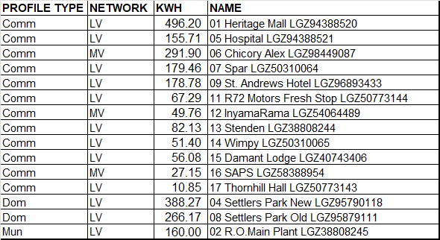

These profiles were then analysed and the resultant representatives profiles calculated.

Figure 11 shows the ½ hourly kVA values (Y-axis) for the average week (7 day ½ hours per week = x-axis) for each of the representative load profiles.

Figure 11

These profiles are then used to simulate the load profiles at each of the representative networks.

Network profiles.

To be able to calculate the load on a particular network one firstly has to calculate the profile at every infeed point on the network. This is calculated by:

- Multiplying the total load for every representative load profile being fed in at that point with the representative load profile ratio to establish the total load of every profile.
- The values for every representative profile are then added together.

The next step is to calculate the loads going through every network component.

- Calculate the load being taken at the infeed point of every network by adding the losses to the load being taken from the outgoing side of that network.
- Calculate the load through each individual network by adding the load infeed at the outgoing side of that network to the load going through the next network.
- This is an integrated process starting with the last points on the networks from where loads are taken and working upwards towards the main supply point to the distributor.
- This should be done for every half hour of the year, yielding an annual half hourly profile going through every network.

The result is an annual profile at N2 (the Eskom supply point).

Profile re-conciliation.

It is essential that an assessment be made of the accuracy of the representative load profiles used. This is done by

- calculating the annual load profile from the LV network up to HV network:
- multiplying consumption at each point on the network times the per unit representative load profile at that point.
- adding up from the LV network up to the highest voltage network including losses at each point up calculations
- and comparing that with the annual purchase load profile.

Table 38 below shows the maximum demand with date and time for the actual purchase profile and the N2 profile. The maximum demand occurs at a very different time of the year.

Table 38
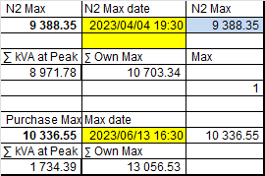

Figure 12 shows the Eskom and N2 profile for the Eskom peak day. One of the challenges with this analysis relate to the Eskom load shedding which disports all the profiles. This is clear from this graph.

Figure 12
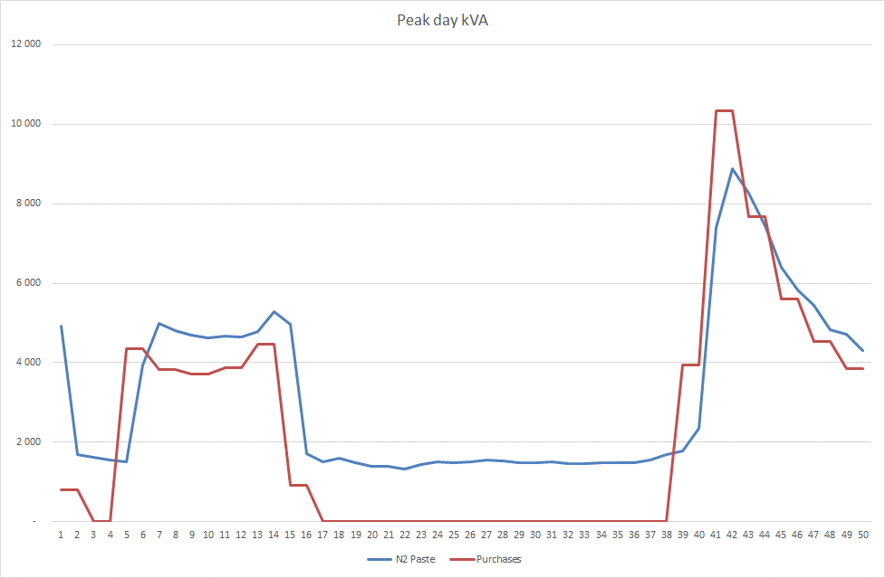

Figure 13 below shows the Eskom and N2 profile for the Eskom peak week. The same problem as for the peak day is apparent here as well.

Figure 13
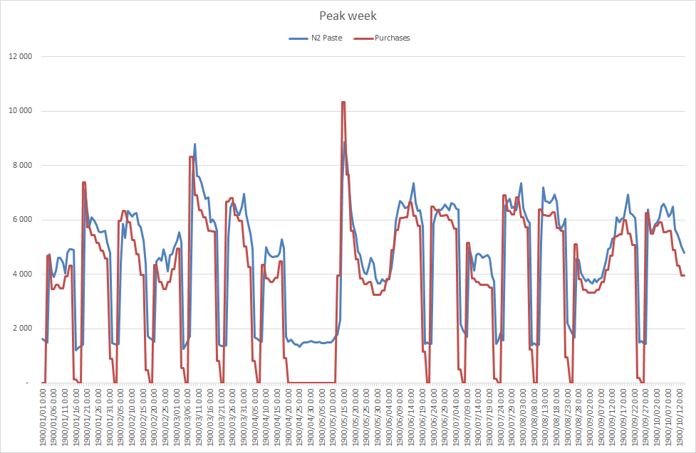

Figure 14 below shows the average week for Eskom and N2. Here it is clear that there is a very good correlation.

Figure 14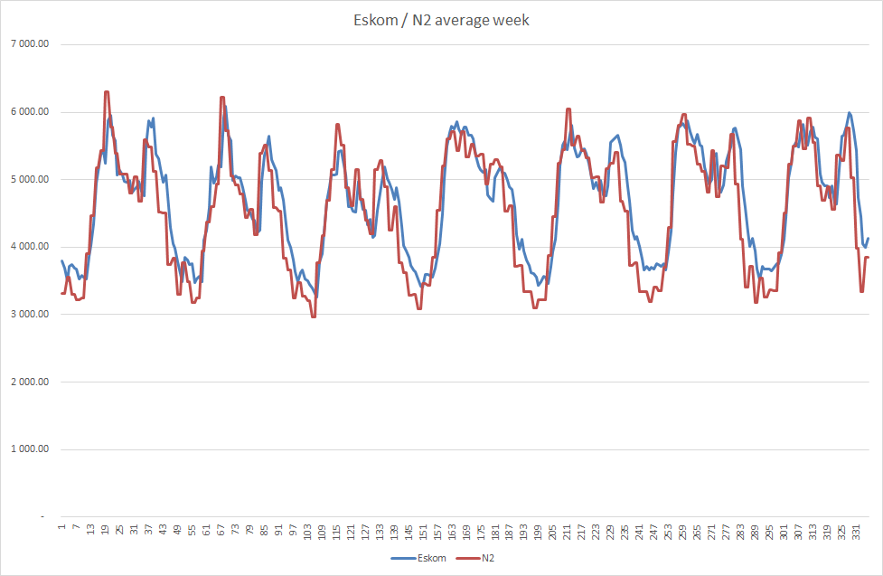

This concludes the analysis of load profiles. These results will be used later on specifically as basis for the kVA units per network.

Representative Profile Quantities.

The TOU quantities for each of the representative load profiles were then calculated. The per unit representative load profile quantities for the year are then multiplied by the total kWh for each representative load profile. The results are shown in Table 39:

The process followed in the model can be described briefly as follows:

- The ½ hourly kWh and kvarh per unit figures as calculated for each annual profile from above is used as starting point. The per unit value means that each actual half hourly value is divided by the total number of half hours in a year (365 days x 24 hours = 8760).
- In other words, if the total number of kWh used by this profile of customers are multiplied by the per unit values and then again divided by 8760, the full picture for this profile is obtained.
- For each profile the kVA values are then calculated. This is done by calculating the square rout of the 1/2 hourly kWh and kvarh and multiplying by 2.
- For each half hour the excess kvarh are then calculated by obtaining the amount of kvarh exceeding the kvarh associated with the kW peak for than ½ hour with a power factor of 0.85.
- The ½ hourly kWh, kvarh and kVA figures are then sorted and summed by:
  - For each month.
  - Season: High and Low.
  - TOU period: Peak, Standard and Off-peak.
  - Excess kvarh during peak and standard periods only.
- The sum of the maximum demands incurred during each month is then calculated as well as the highest maximum demand during the whole year.
- From these the Annual Load Factor (LF) and Excess kvarh % of total kWh are calculated.
- These values are then calculated for each profile.

Table 39
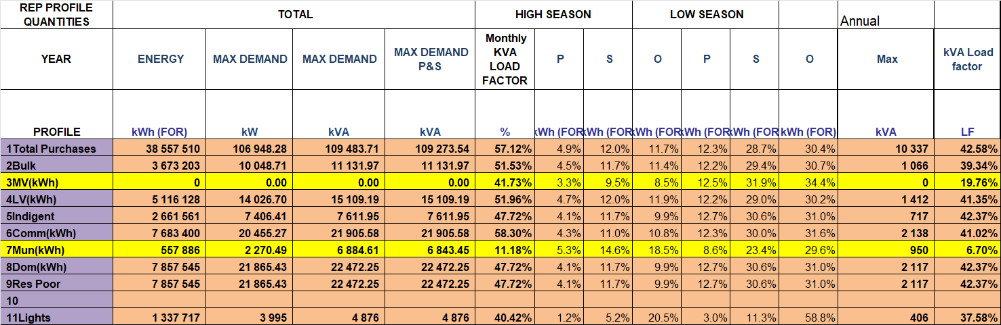

The following should be noted in this respect:

- The average Load factor refers to the total kWh per year divided by the sum of the monthly maximum demand in the year times the total hours in the year. (Total kWh for year) ÷ (Sum 12 kVA maximum demands x hours in year).
- The Annual LF refers to the total kWh per year divided by the highest maximum demand in the year times 12 times the total hours in the year. (Total kWh for year) ÷ (Highest maximum demand in year x 12 x hours in year).
- The % values in each of the TOU periods refer to the % of consumption relative to the total consumption.
- The reactive energy refers to the kvarh as calculated in the Eskom Megaflex tariff. (Sum of: kvarh – 30% of kWh for each ½ hour in peak and standard periods).

This data will be used to calculate the load demands of each profile and the kWh’s used in the different time periods.

Network Profile Quantities.

The network profiles calculated above are now further processed. The maximum demand and TOU ratios are required for further analyses and the results obtained are shown in Table 40. Once again it is clear that there is a good correlation.

Table 40
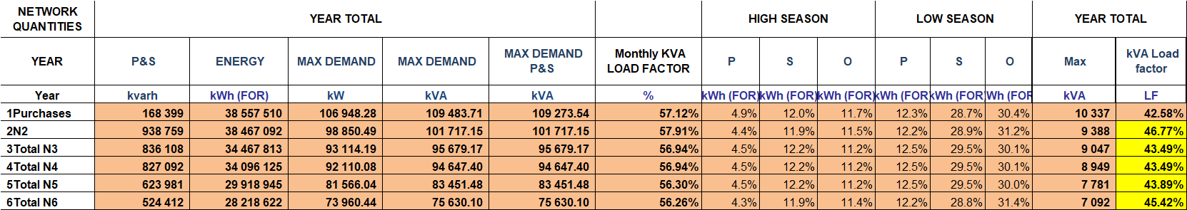

These values will be used to calculate the peak demands at every point on the network and thus to calculate the per unit R/kVA for each network.

COST OF SUPPLY

The next step is to allocate the electricity costs between the various cost functions. The table below firstly shows the cost adjustments and then the method used and the actual allocation of cost per function.
The next step is to functionalise the various costs between the various cost drivers. The 4 types of functions in electricity namely:

- Purchases
- Networks and
- Customer services.
- Streetlights.

The steps to be followed to do this are as follows:

- The costs, as per the trial balance, are firstly allocated directly to the relevant function as prescribed by the particular activity.
- The common costs are then allocated based on various relevant ratio’s such as number of staff or asset values.

These calculations were already done in the Ringfencing part of the study.

Cost Classification

The next step is to classify these costs into the different cost types / drivers. The electricity costs, from a tariff point of view are classified as one of the types below:

- R/kWh in terms of the different TOU periods namely, peak, standard and off-Peak.
- R/kVA costs also separated by dedicated and shared per network.
- R/customer as per customer category.
- Rand / light in the case of streetlight maintenance costs.

The way in which these costs are functionalised / classified is shown in Table 41.

Table 41

The actual functionalisation/ classification of costs is shown in Table 42.

Table 42
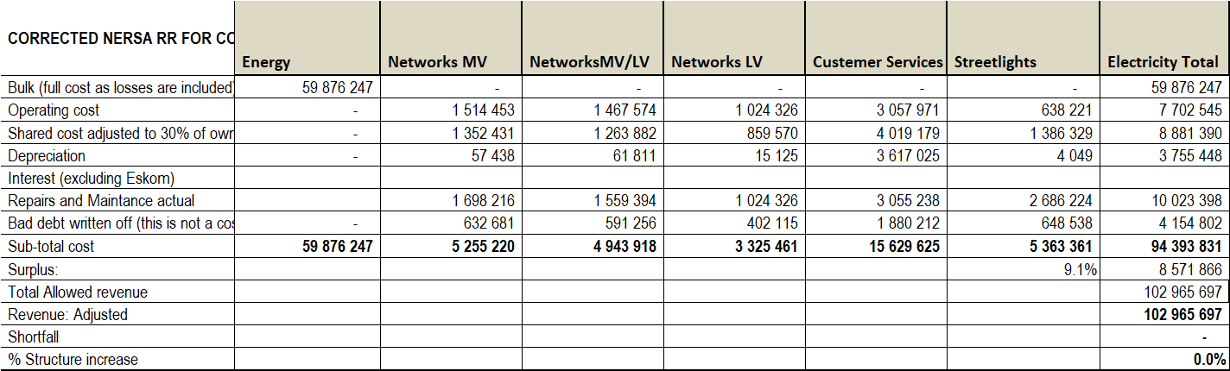

The following points are of note:

- There is a small portion of customer services costs which can be classified in R/kWh. The problem is that the true cost really depends on the number of customers and not the amount of kWh purchased. All customer services costs are therefore classified as R/Customer.
- A portion of the Eskom costs relate to the demand or maximum capacity taken from the network. This will be classified as such later on in the process of detailed cost calculations.

These costs will now be used as a basis for the detailed cost calculations to follow.

Cost allocation: phase 1

The next step is to allocate the various costs per the different cost categories. This is shown in Table 43 in respect of the capital portion of the network and customer connections. It also allows for adjustment to reflect the pricing policy of the municipality. In other words, where customers pay outside of the tariff (by way of connection fees, capital contributions, subdivision fees or developer contributions), the full capital provision must not come from the tariff. In this respect staff indicated that all capital costs for new customers / capacity are covered outside of the tariff and thus no adjustment is made.

Table 43

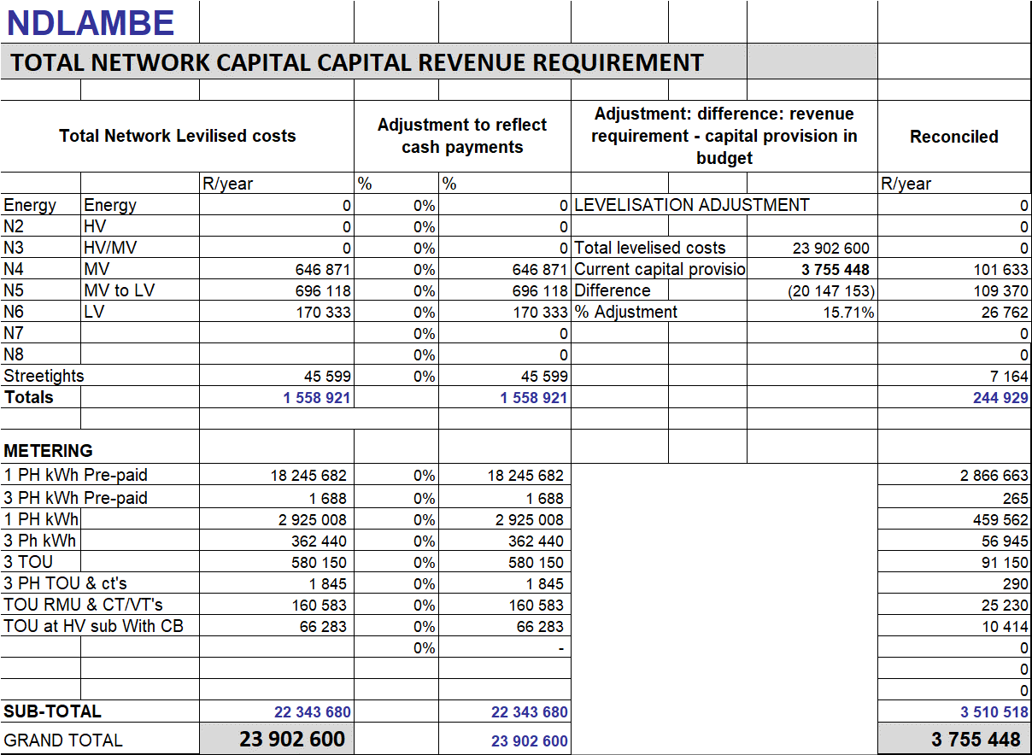

The next step is to allocate the support costs (operations, maintenance and administration) relating to the networks and technical customer services. The operating costs per different cost type, network and customer category are shown in Table 44.

Table 44
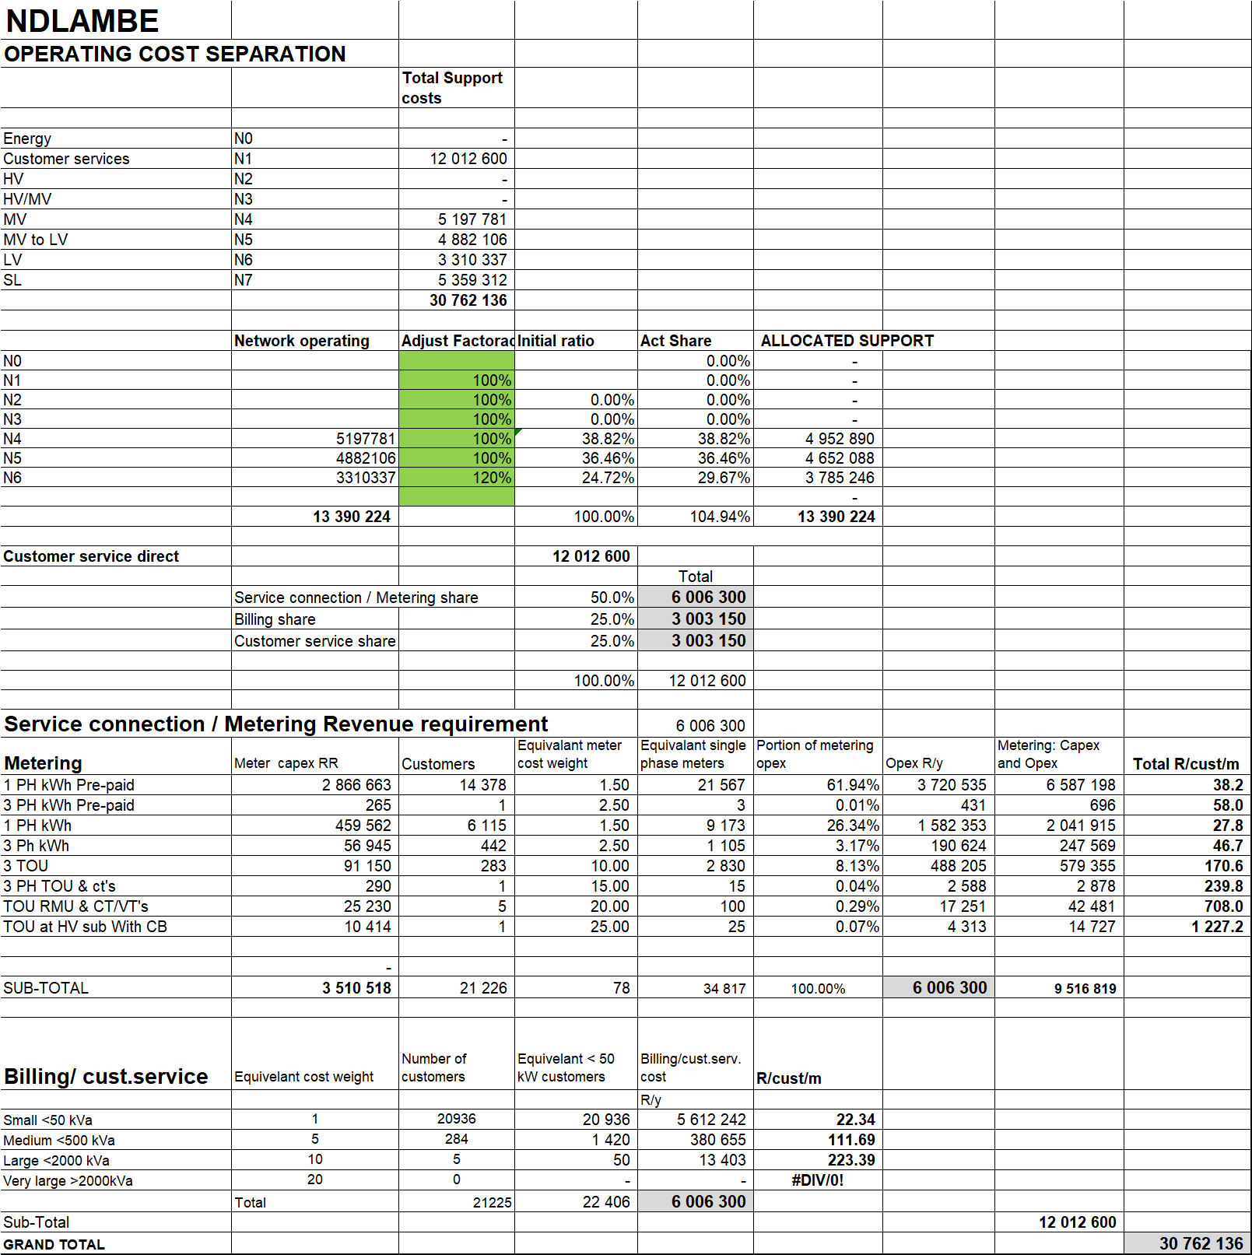

The following should be noted in this respect:

- The operating costs are as per the ringfenced trial balance.
- The network costs are then allocated as follows:
  - According to the Network capital revenue requirement at first pass.
  - These figures are then adjusted based on inputs from staff to reflect the real case of support costs per network.
- The customer services costs are then split between:
  - Metering according to different connections and metering.
    - This is done by giving a weighting to each of the types of connections. The following in this respect:
      - This is a difficult number to determine because records are not kept of difference in these costs.
      - This has been done based on experiences elsewhere and inputs from staff.
      - An example is the amount of come backs that have been experienced with pre-payment meters compared with conventional 1 phase meters.
      - Another example is that the Bulk meters are not read by normal meter readers but by the Distribution staff.
    - The effective cost per meter is thus calculated.
  - Billing and customer services according to size of customer.
    - This is again done by giving a weighting to each size of customer. The following should be noted in this respect:
      - This is one of the most difficult assumptions because records are not kept of customer service costs per size of customer.
      - This has been done based on experiences elsewhere and inputs from staff.
      - An example is that a customer > 50 kVA is a 3 phase customer which means there is a more sophisticated meter or 3 single phase meters that need to read and thus 3 readings to be entered into the billing system compared with only one for a customer < 50 kVA which are mostly 1 phase customers.
      - Staff also indicated that bigger customers have more queries on their electricity bills and they thus spend more time on them.
      - These assumptions are subjective but the best available considering the staff inputs.
    - The effective cost per size of customer is then calculated.

Cost allocation: phase 2

Ndlambe purchases all its energy from Eskom on TOU at Megaflex.

For these reasons the Megaflex tariff will be used as a basis to calculate the cost of supply and specifically the energy costs and unit rates.

The summary of Megaflex LG rates is shown in Table 45.

Table 45
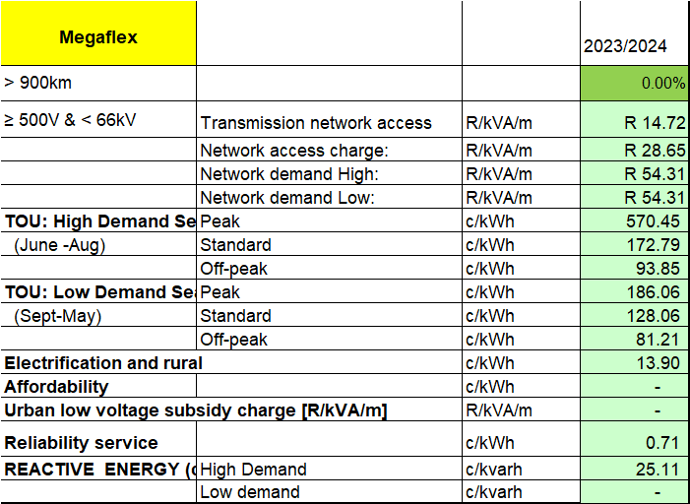

These values will be used as the initial per unit energy and Demand / Access charges.

Cost allocation: phase 3

The next step is to add the capital cost to the operating costs and then allocating it to the various cost drivers as is shown in Table 46. The cost of the actual streetlights plus overheads is allocated on a per light basis.

Table 46
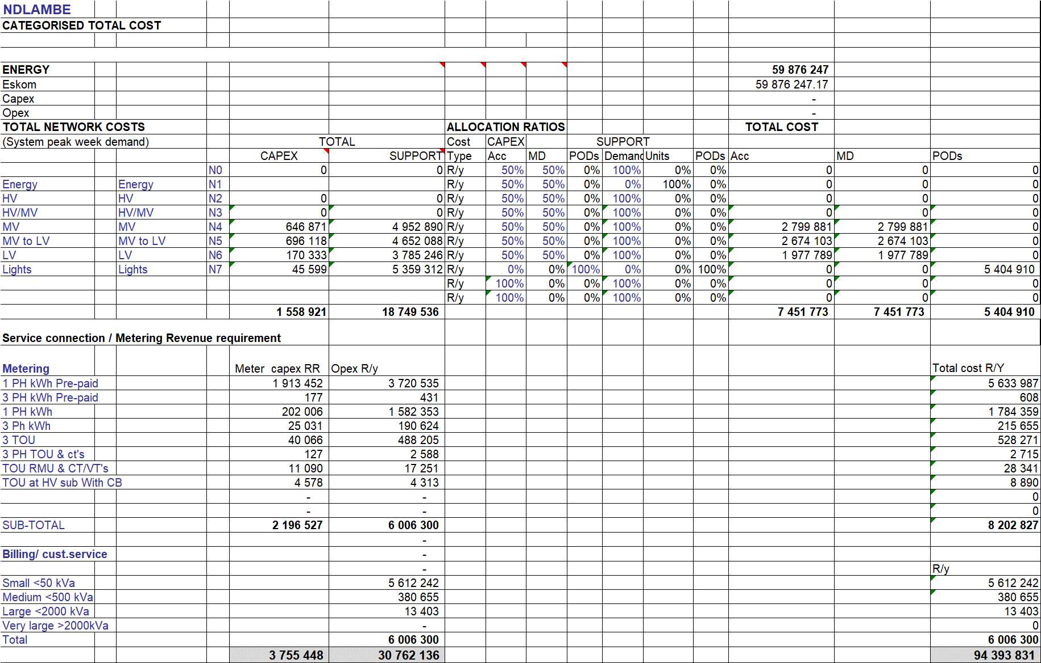

The following should be noted in this respect:

- The streetlight maintenance costs are allocated per streetlight.
- All network costs are allocated on the R/kVA basis.
- All customer costs are allocated on the R/customer/month basis.

Based on experience the non-co-incidental peak demand method was used as basis to allocate all network costs to customer categories.

The total costs have to be divided by the total number of units applicable to that cost. The units required for this purpose should be derived from the network load and customer details.

To be able to allocate the network costs as a per unit cost (R/kVA), the kVA for each network is required. This was calculated by building up the total load profile of each network starting at LV and working up to the high voltages. It must be noted that the Purchase values differ from the billing data as it is calculated from the load profile data.

The allocation units to be used are shown in Table 47. The network kVA and kWh quantities were obtained from the Quantities tables. The sales data was obtained from the sales data.

Table 47
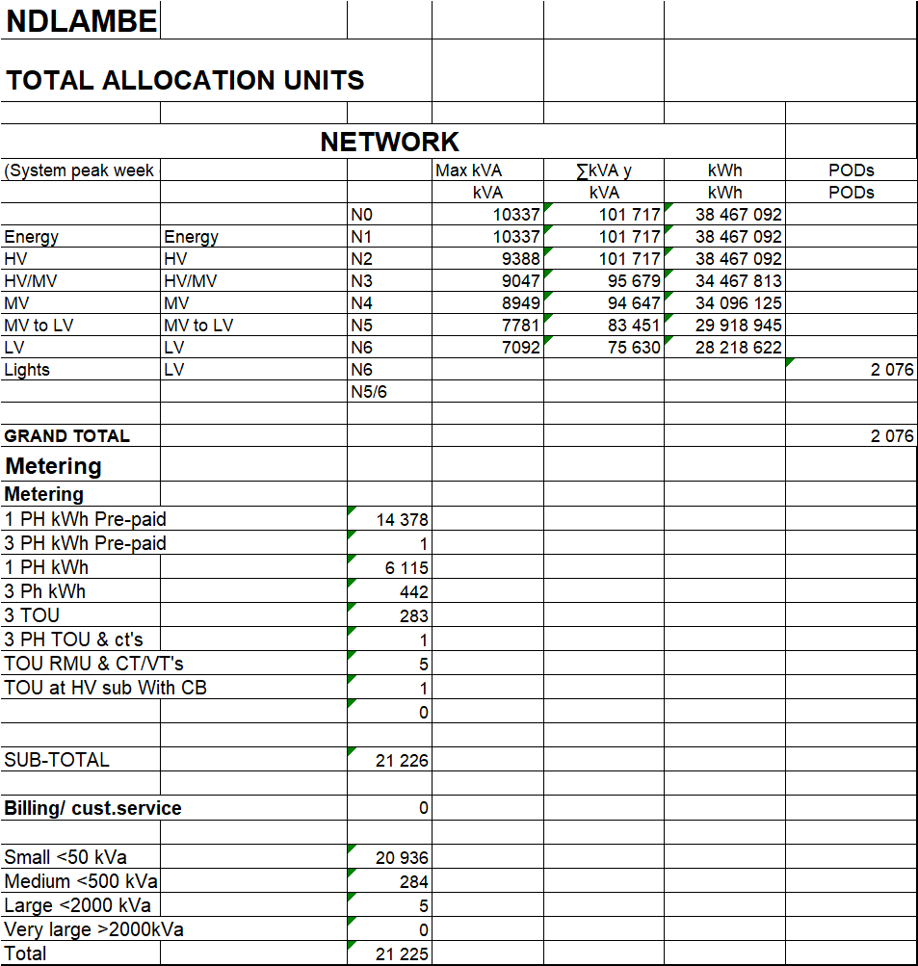

The next step is to calculate the unit costs. This is done by dividing the total cost per category by the relevant units. The results are shown in Table 48.
Table 48
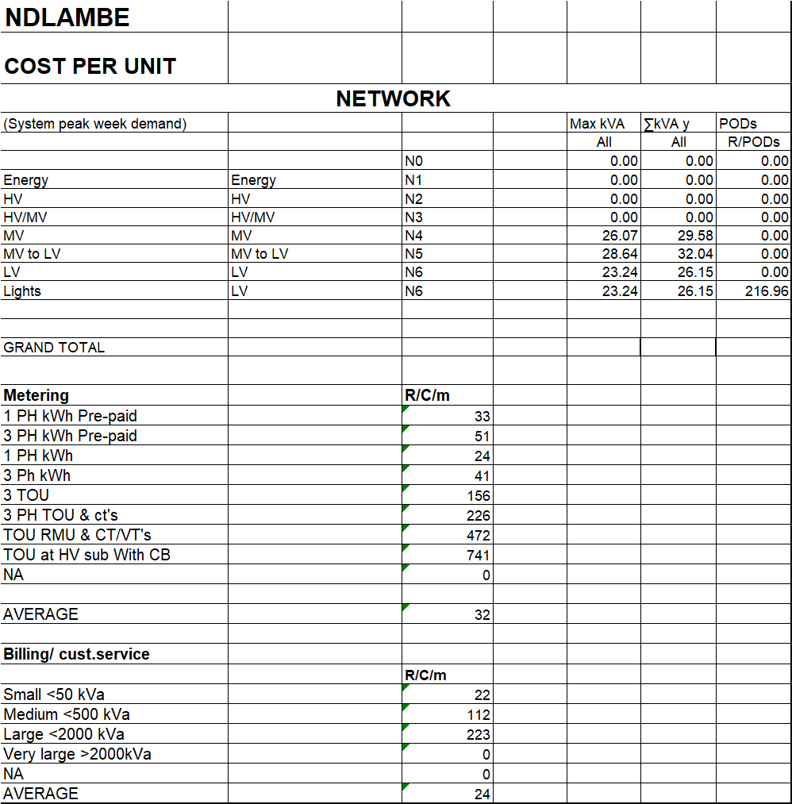

The costs obtained up to now reflect the cost of every separate network segment. To have a more practical set of charges these must be set for every network supply position stating the total charges at each point. This involves the network cost closest to the supply position plus all the networks up to that point plus the losses incurred in the networks up to that point. The values stated therefore reflect the total per unit cost of supply at that network supply point. The resultant costs are shown in Table 49.

Table 49
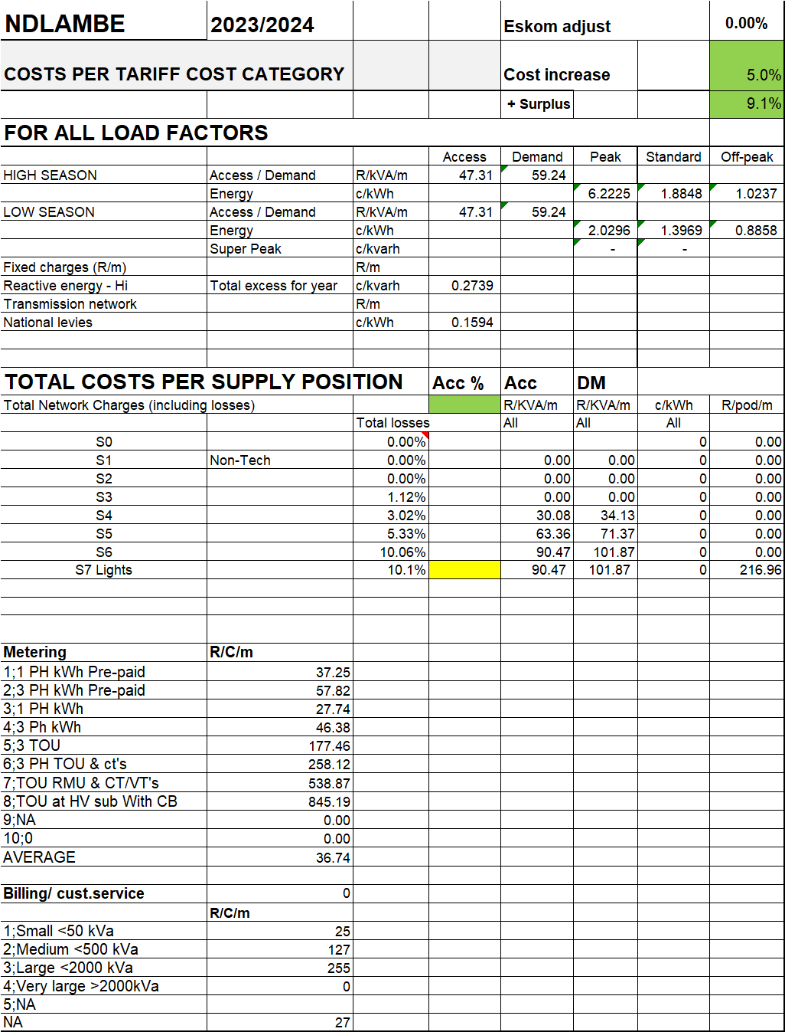

The following should be noted in this respect:

- Own costs increase by CPI.
- The surplus is the actual surplus.
- The surplus reflects the current surplus which NERSA would allow under normal circumstances.
- The R/kVA costs are split here between the dedicated and shared portion as follows:
  - Dedicated refers to networks which cannot really be shared with other customers. For example, if a development is done based on a particular after diversity maximum demand (ADMD) and supplies to various small and large customers are installed, if customers change their loads the costs do not change, and these networks cannot be used to supply other customers and thus are considered dedicated.
  - Assumptions about this is subjective but also reflects the realities in each municipality. Where there is ongoing growth and customers continue to use the power installed this is not a problem.
  - In areas where economic growth is bad and customers reduce their demands, the risk of revenue loss is higher to municipalities as there are less customers to share the unused capacity with.
- These values show the total network costs at each position on the network including the costs and losses of all higher voltage networks up to that point. In other words when a demand of say 10 kVA is incurred at a LV point of supply, the demand at the point of purchase which is increased by the total losses up to that point. Losses thus effect the network and energy costs.
- It is important to note that these are per unit values. For example, the energy costs for each profile will be calculated by using the Eskom energy rates, plus the losses up to each relevant network multiplied by the % of kWh in each TOU period multiplied by the total number of kWh for that profile.
- The Eskom and own network costs are calculated by:
  - Multiplying the sum of the monthly maximum demands by that profile by the Eskom maximum demand and own maximum demand per unit costs.
  - Multiplying the highest annual maximum demand by the Eskom access charge plus losses and the own Access costs.

Before one can go from the costs per tariff cost category to costs per tariff, we need to know the statistics of the loads associated with the various tariffs. Representative load profiles were calculated from available data. These were then analysed and the necessary details calculated under the load profile section.

The following comments in this respect:
- The quantities shown represents the quantities associated with each representative load profile at the relevant network where it is supplied from.
- For example, the kWh represents the kWh used by streetlights supplied from the LV network. The Sum of maximum demands represents the sum of the sum of the 12 highest maximum demands incurred on the network, the Annual maximum demands is the highest maximum demand that Streetlight supplies placed on the network in the year.
- Because the individual maximum demand method is used, the maximum demand values of each profile are used irrespective of when it was incurred.
- These quantities will be used to calculate the per unit charges.

The next step is to now calculate the various per unit charges which should apply in respect of the different customer, network and energy charges relevant to the various periods. This makes use of:

- The position at which the customer is supplied to determine:
  - the R/kVA network costs plus R/kVA Eskom costs.
  - the losses % to be added to Energy and Eskom Demand/Access.
- The type of metering and size of supply to determine the metering and billing / customer service costs.

This is shown in Table 50.

Table 50
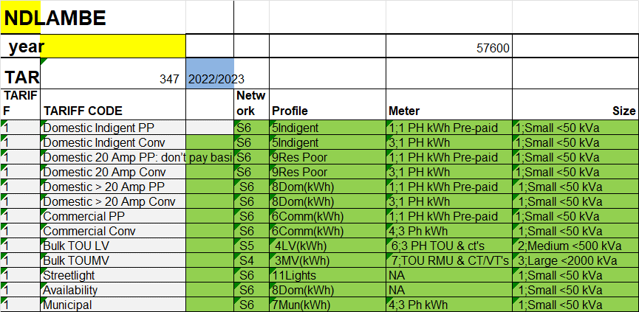

The resultant costs per tariff broken up in all the different components are shown in Table 51.

The consumption values of the various customer categories were previously calculated. These quantities are broken up into the detailed cost categories and not billing quantities. This is done by using the representative load profile, load factor and consumption per TOU period.

- The ratio of consumption Peak, Standard, Off-peak
- and the load factors of the different representative load profiles
- are obtained from the representative load profile quantities.

The consumption quantities per TOU period are shown in Table 52.

Table 51 Table 52
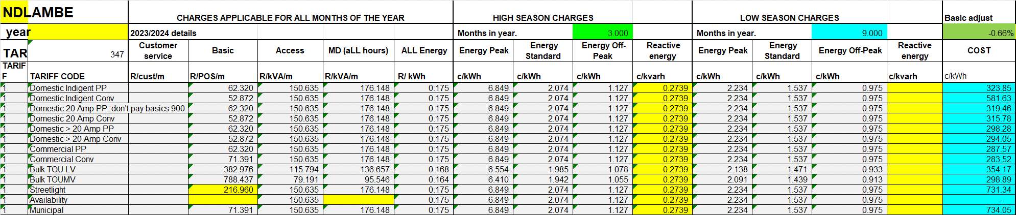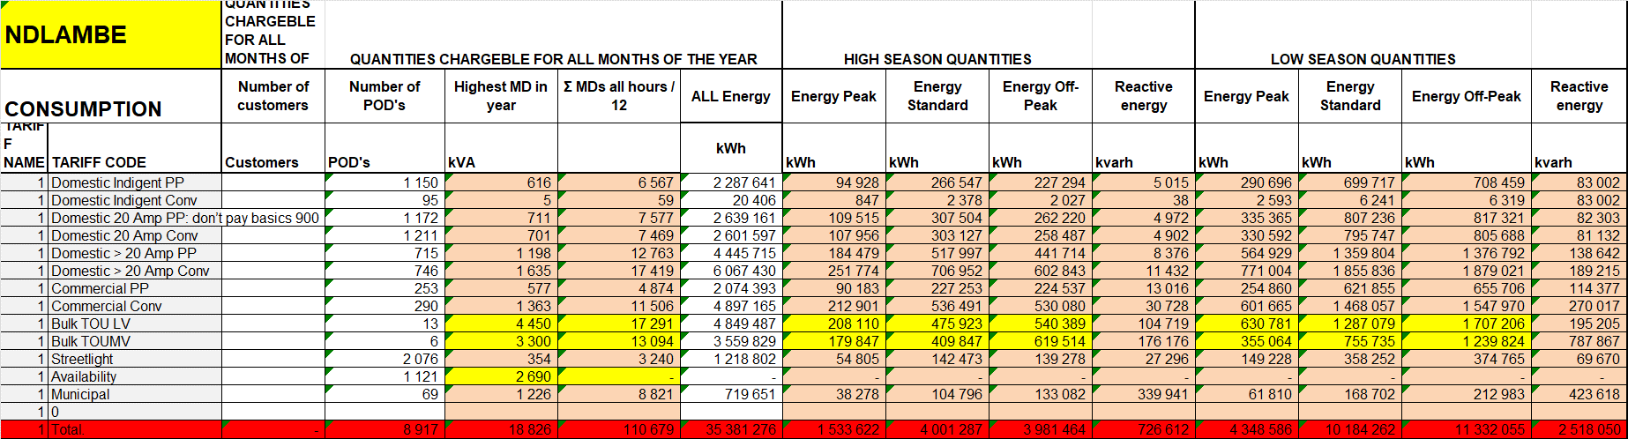

The following should be noted in this respect:

- The kVA for small customers represents the total maximum kVA placed on the network and not the actual installed capacity of customers. The peak values are calculated from the representative load profile quantities. This corresponds to using the individual maximum demand method for allocating network costs. If the average and access method was used, these values would be slightly different.
- The subsidised quantities: Basic and Free Basic Electricity (FBE) quantities are removed as we calculate costs.
- These quantities have been adjusted so that the same revenue as before is generated.

Table 53 shows the calculation of the total cost per tariff. It multiplies the per unit costs by the number of units to obtain total revenue.

Table 53
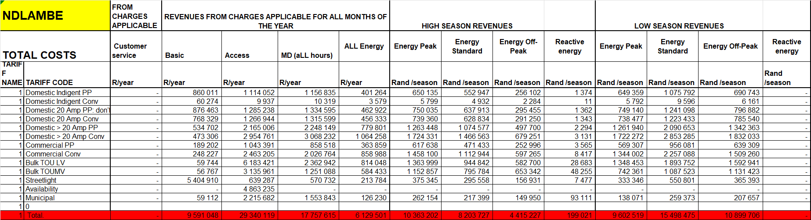
The following very important point must be noted:

- In the sales analysis it was shown that the calculated revenue using the sales data and tariff data does not exactly achieve the revenue as indicated in the trial balance.
- This is because of inaccurate data provided because of various reasons including journals made in Rand values but not is sales volumes.
- The target sales revenue will thus not be that in the trial balance but that calculated from current tariffs plus adjustments.
- The adjustments are to add back the income foregone from FBE if not included in “n-1” calculations.
- The target revenue from the new cost reflective tariffs is shown in Table 54.

Table 54
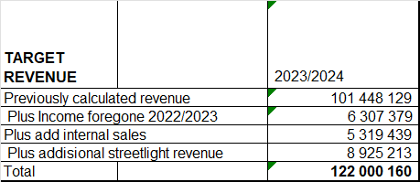

The adjustments that were made to the per unit costs are shown in Table 55

Table 55
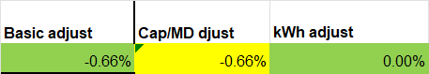

The expanded summary data is shown in Table 56.

Table 56
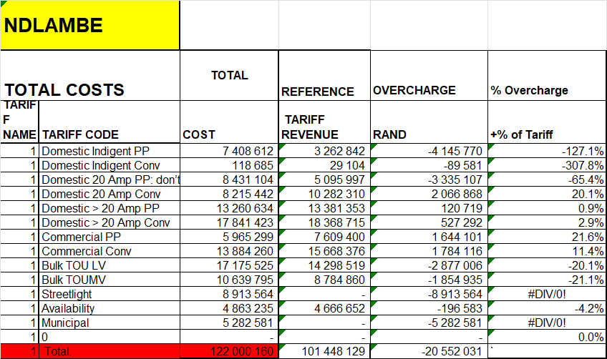

The results are illustrated below in Figure 15 in % of cost and in Figure 16 in Rand difference between cost and current revenue. The vertical axis refers to % over or under recovery and the horizontal axis refer to the tariff.

Figure 15
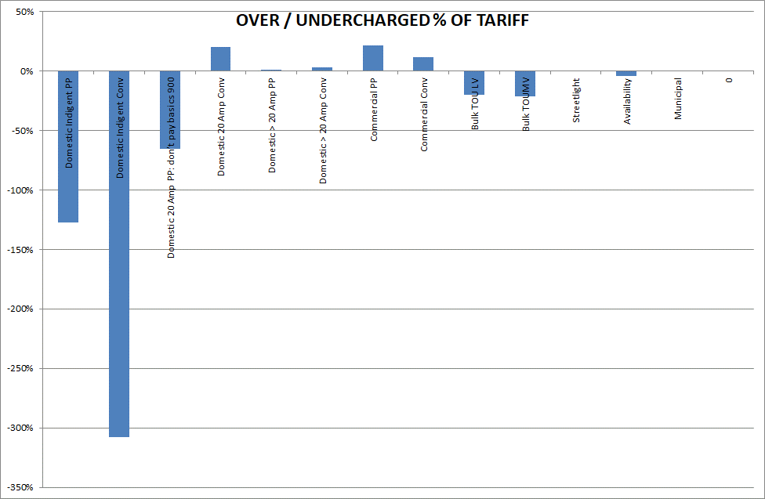

Figure 16
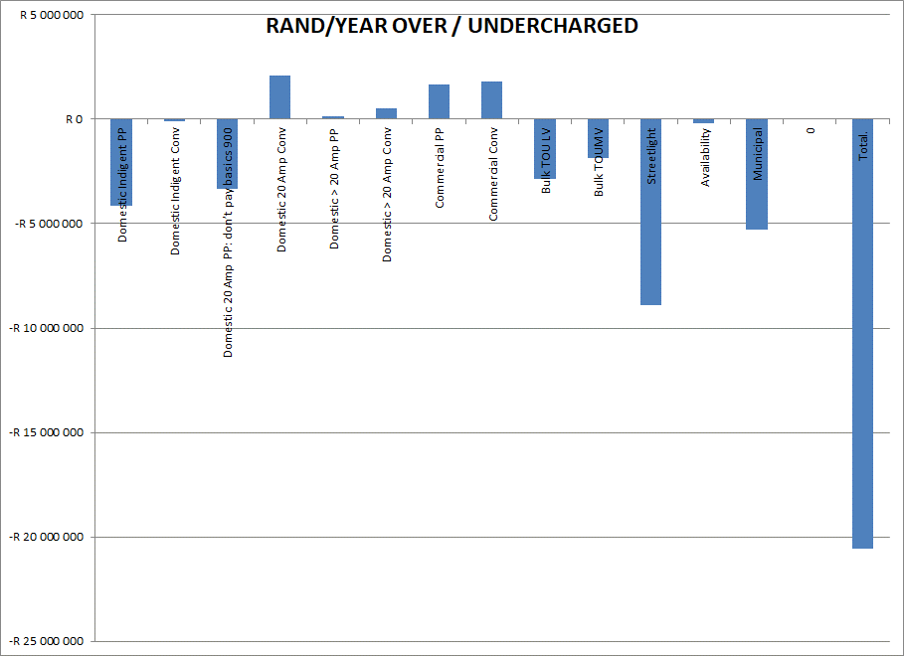

Tariff structure analysis

The cost of supply analysis shows the total cost vs revenue impact of the various tariffs. This section compares the current tariff components with the costs for the same tariff components. This is illustrated in Table 57.

Table 57
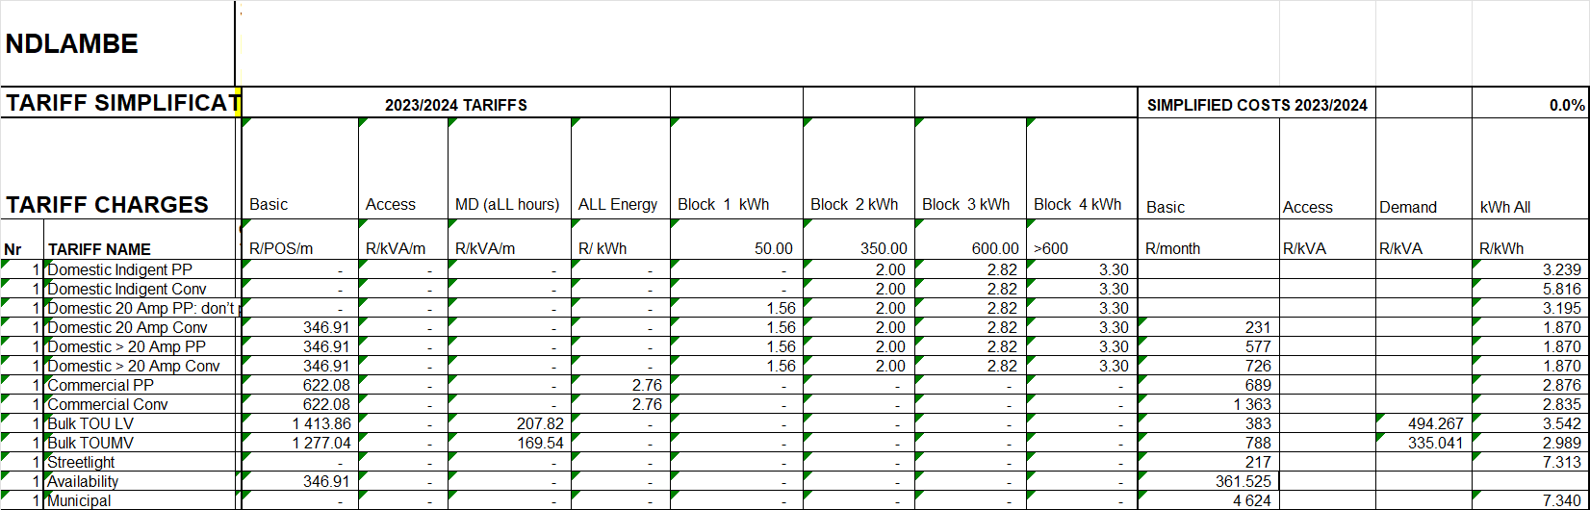

Key findings

The following key findings can be made in terms of the tariff levels and structures:

- Indigent customers are seriously. This is due the lack of fixed charges, the low first 2 blocks energy rates and FBE.
- Households alternative are also seriously subsidised due to the same issues as for Indigent consumers.
- Other domestic consumers are close to cost or slightly overcharged.
- Commercial customers without basic charges are overcharged when average consumption is high and undercharged when low.
- All other commercial tariffs are extensively overcharged.
- Bulk consumers at LV and LV undercharged but municipal supplies overcharged due to bad load factors.
- TOU at MV and LV customers are slightly overcharged.
- Streetlight tariffs are too low and do not cover the fixed maintenance costs.

PRICING STUDY

Now that the costs are known and how it differs from revenue, new tariffs can be developed. The first step in this process is to develop a new pricing policy.

Pricing Policy Drivers

It is now clear that the tariffs fall short in being cost reflective tariffs. The challenge is to determine what must guide the changes to be made to become more cost reflective. This section proposes the pricing principles and policies to be followed in making tariff changes.

The key sources used for purpose of formulating these policies are:

- The South African Constitution.
- The South African Electricity Pricing Policy (EPP).
- Municipal Finance Management Act (MFMA).
- Municipal Systems Act (MSA).

NERSA regulates the electricity tariffs in South Africa. The NERSA policies and guidelines thus have to be followed. There are however various NERSA guidelines in conflict with some of the legislation and regulations. The results of the cost of supply study must thus be used to move NERSA in accepting the municipal proposals.

Principles obtained from the Municipal Systems Act are as follows:

Pricing policy.

In view of the findings to date, the summarised pricing policy is provided below:

- It should be in line with the National Electricity Pricing Policy.
- All tariffs should be set as close as possible to the cost of supply.
- Indigent customers as registered in terms of indigent policy.
  - These customers limited to 20 Amps with no fixed charges.
  - The current IBT energy rates be retailed.
  - Free Basic Electricity (FBE) of 50 kWh/m off-set by equitable share.
  - The cost of FBE be based on the second block price, thus first block removed????
- Cross subsidisation of low usage domestic customers (poor but not indigent) customers should be done as follows:
  - Customers limited to 20 Amps with no fixed charges.
  - The current IBT energy rates be retailed but first block price be set equal to the second block???
  - No FBE is granted.
- All small customers (domestic / business) > 20 Amp should have a fully cost reflective tariff:
  - A basic charge to reflect the fixed metering, billing, revenue collection and customer services costs.
  - A capacity charge based on the installed / limited capacity of the customer. In other words, the total network costs as calculated for that tariff before (using the relevant demand allocation method), is now divided by the customers’ actual capacity.
  - An energy charge that covers the full energy cost, losses and surplus mark-up.
- All large customers should be charged on a TOU tariff with structure and TOU slots as per the Eskom Megaflex tariff applicable to Ndlambe including changes over time:
  - Basic charge.
  - Capacity charge based on the highest of the following:
    - Notified demand or highest annual maximum demand to cover Eskom Access charge plus dedicated municipal network costs.
  - Maximum demand charge based on monthly highest maximum during Peak and Standard Periods only.
  - Energy charges for:
    - High Demand (June, July and August) and Low demand (all other months)
    - Peak, Standard and Off-peak (See diagram below)
  - Reactive energy charge based on kvarh in excess of 30% of kWh during all peak and Standard period for both seasons.
  - Public holidays treated as the day they fall on.
  - The tariffs should be different small consumers (<100 kVA), LV and MV.
This means that each customer will pay an average price depending on its own TOU ratio’s and load factor. This is the same as applied by Eskom on its TOU tariffs.

TOU periods are as shown in Figure 17.

Figure 17

- Co-generation charges. (SSEG-tariff)
  - The standard Access / Capacity charges remain.
  - Energy purchased by the customer be charged at the relevant standard tariff charges.
  - An additional basic charge be levied to cover the additional metering / billing costs.
  - The energy purchased from the customer be credited on TOU period based on 90% of Eskom TOU energy rates (excluding non-TOU energy charges such as levies). The municipality proposes to reduce this to 50% despite the fact that the current rate is very close to 80%)

Cross subsidies to the poor.

In view of the proposed pricing policy, it is further proposed that the tariffs for Indigents and 20 Amp customers are not increased structurally. The extent of the cross subsidy in this case is then calculated.

The results of these calculations are shown in Table 58 existing and Table 59 proposed.

Table 58
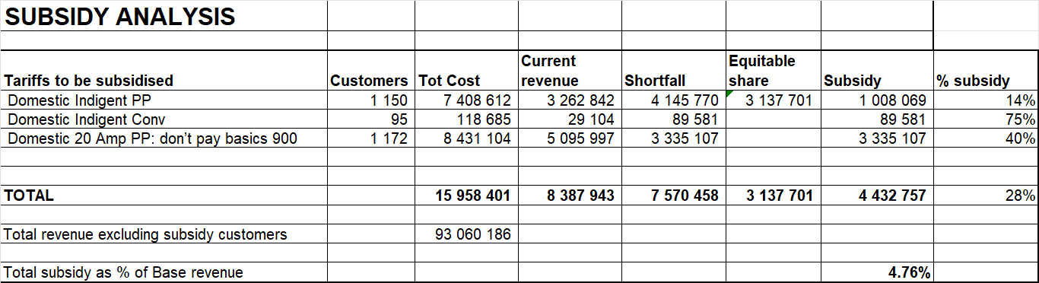

This subsidy % is of non-subsidised revenue. The question thus is what the charge for the indigent customers should be.

Table 59
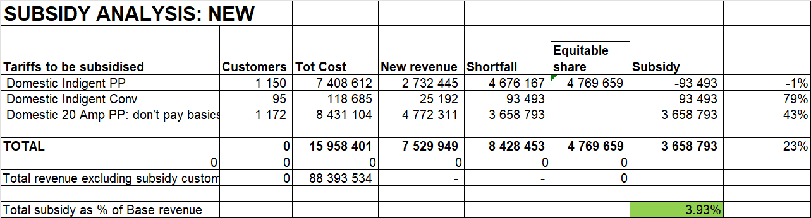

Table 60 shows the calculation of the marginal Eskom purchase costs. The marginal costs do not refer to the average Eskom purchase price but the price of the domestic customers on its own. In other words, the impact that domestic customers have on increasing the access charge, maximum demand charge, energy charges during the various periods and the reactive energy charges.

Table 60
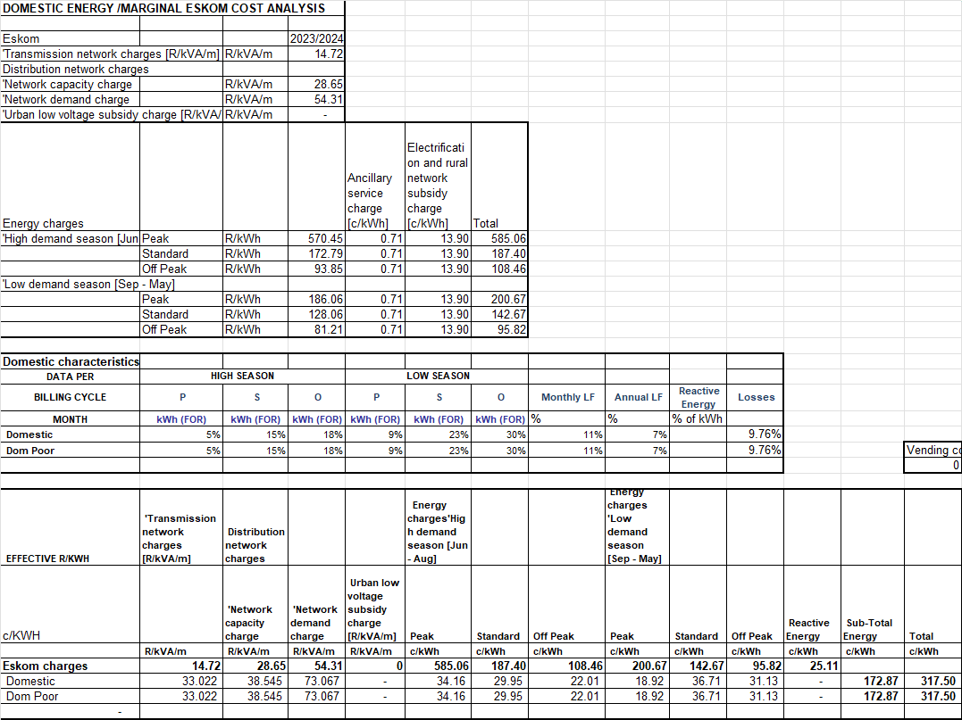

The following in this respect:

- The Megaflex charges are those applicable to Ndlambe municipality.
- The TOU consumption ratios and load factors were calculated from the representative load profiles.
- The monthly vending costs is the total vending cost divided by the number of customers divided by 12. This is then converted to a c/kWh for each domestic tariff category.
- This shows that the marginal cost of Eskom purchases for Indigent customers is 166 c/kWh in 2023/2024 values.
- In time this can be reviewed depending on the subsidy on non-subsidised customers.

The equitable share is calculated as shown in Table 61 and compared with the actual amount applied. It shows that the current equitable share covers more than the revenue foregone. It is thus proposed that the equitable share for FBE be calculated at the second block price not the first block.

Table 61
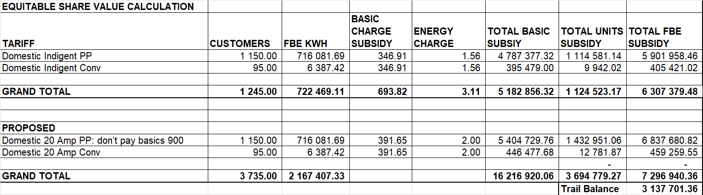

PROPOSED TARIFFS

In view of the proposed pricing policy the following tariffs are proposed for Ndlambe as shown below:

Table 62. It shows the following:

- The current tariffs,
- The current costs escalated to 2023/2024.

Table 63. It shows the following:

- The current tariff
- The proposed rates before annual price increase and phase in.

Table 62 Table 63
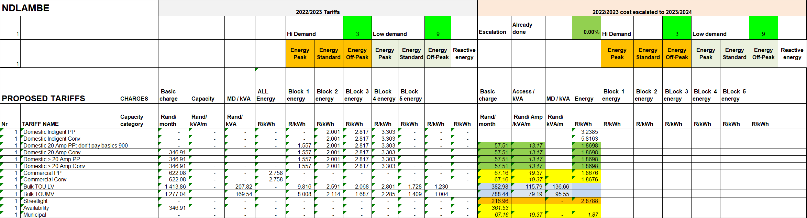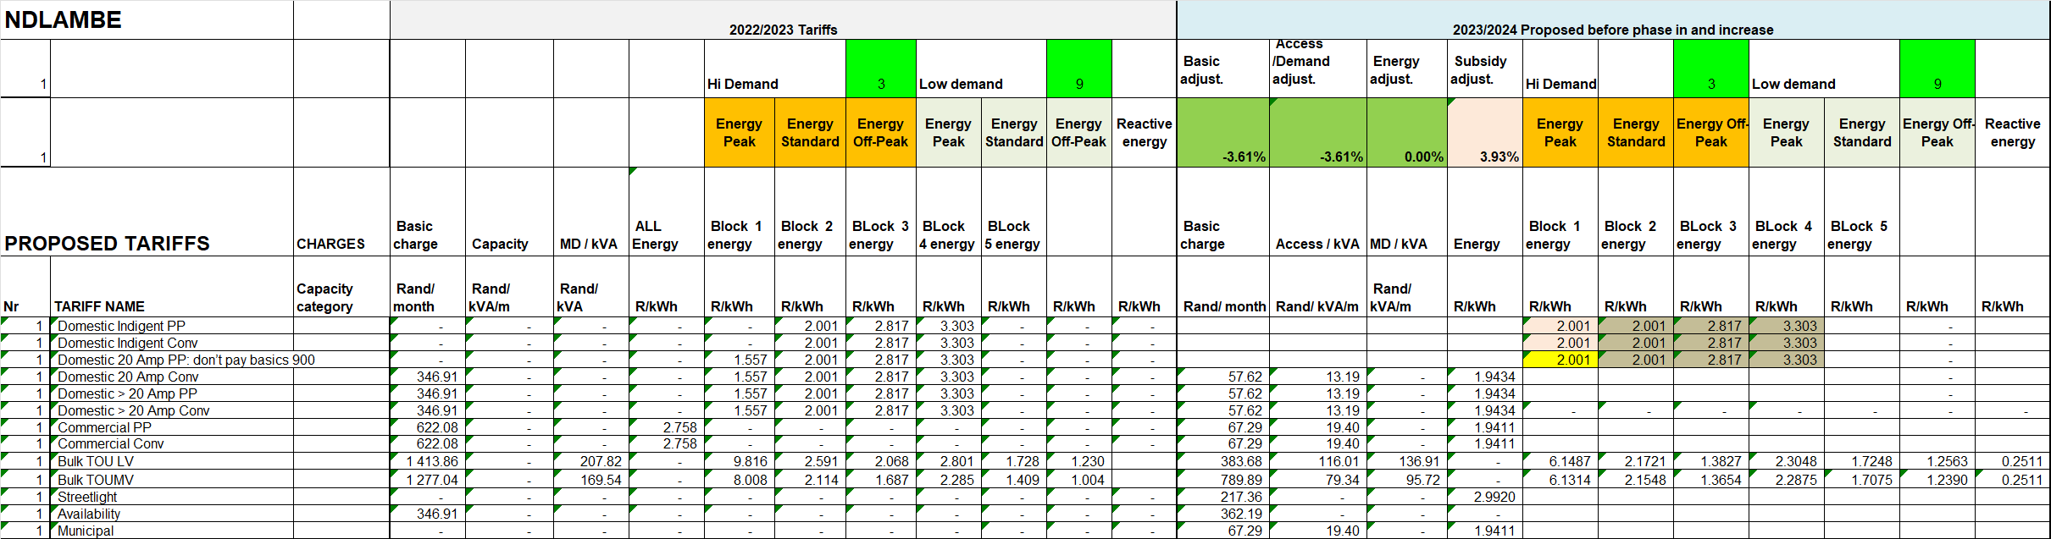

A slight adjustment is made to achieve the revenue target as shown in green in Table 64.

Table 64
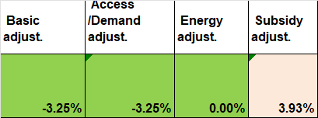

The following should be noted:

- The basic. Capacity and energy charges will be the same for all domestic consumers as proposed by the municipality. Although the cost of supply study indicates differences between indigent, low usage and high consumers.
- The basic charges for single and three phase consumers will not differ.

FINANCIAL IMPACT

The tariffs have been developed in a way that will ensure revenue neutrality from a tariff structure point of view:

- Provision has been made for customers to reduce their circuit breaker capacity thereby building in a small safety margin.
- With the application of cost reflective basic and amp charges, the net revenue loss when customers install renewable energy will be minimised.
- Some savings opportunity is opened by buying surplus renewable energy from customers at a price below that of Eskom power.
- With the more aggressive capacity charges, customers will be more inclined to reduce their peak capacity rather than energy thereby reducing Ndlambe’s Eskom and own network costs without sacrificing much municipal revenue thereby increasing profitability.

The proposed tariffs thus hold very little risk but real opportunities.

TARIFF IMPACT

Table 65 below show the overall impact on customers on each tariff on average. This is for the tariffs before phase in (in other words the whole impact). The impact of each would be about a third of this if phased in over 3 years.

- All Indigents get Basic and capacity charge and 50 kWh/m for free.
- All other poor consumers willing to accept 20 Amps get the Basic for free.
- These discounts are to be recovered via the equitable share. The impact is similar to the current equitable share amount.

Table 65
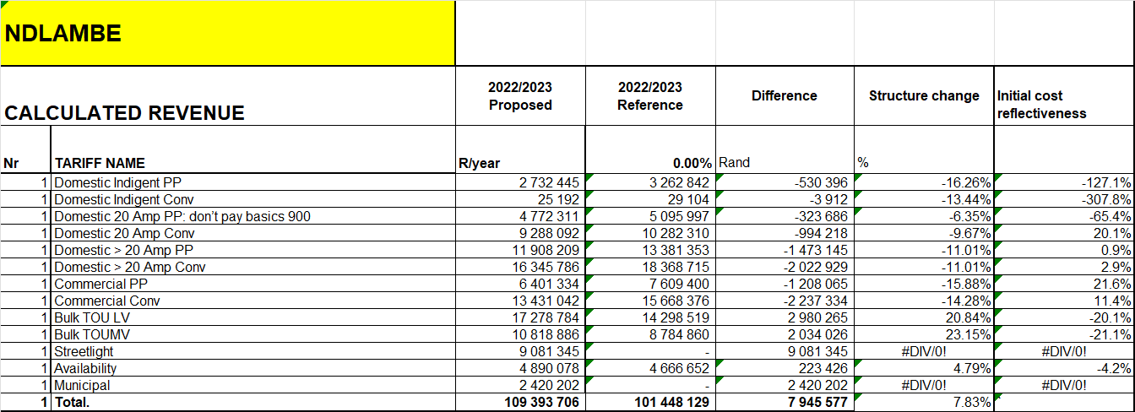

The income foregone is deducted as the full cost calculations include such amount as shown in Table 66 below.

Table 66
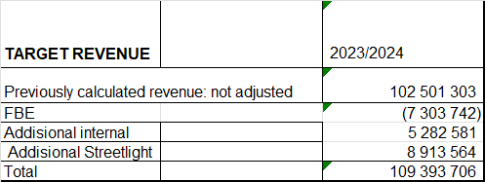

The following impacts will be experienced over the phase in period using the second option.
- Indigent customers will be limited to 20 Amp only.
- Domestic 20 Amp lifeline consumers will pay more for the first block.
- The general trend for other tariffs is as follows:
  - The category will move closer to cost reflective but still retaining the cross subsidy.

The impact for each customer will however be different. It will depend on the utilisation of the capacity provided to customers and the extent to which electricity is used in the peak times:

- The following customers will generally see increased bills:
  - Those that are not utilising their capacity and are not willing to reduce / manage their capacity, due to the Capacity/Access charges.
  - Customers who need large capacity only for a few months in the year.
  - TOU customers who use a lot of electricity during the expensive Winter Peak times and are not willing / able to shift load out of these periods.

If these tariffs are phased in over 3 years, customers will have time to adapt to the new rates and thus manage their bills. The impacts shown in the table above will thus be 1/3 for each of the 3 years.

CUSTOMER IMPACT

The detailed impact on domestic customers have been further analysed and is illustrated. Table 67 shows the revenue on existing and proposed tariffs, then the Rand impact of the % change. It also shows the number of consumers on each tariff and the average consumption and selected capacity of these.

Table 67
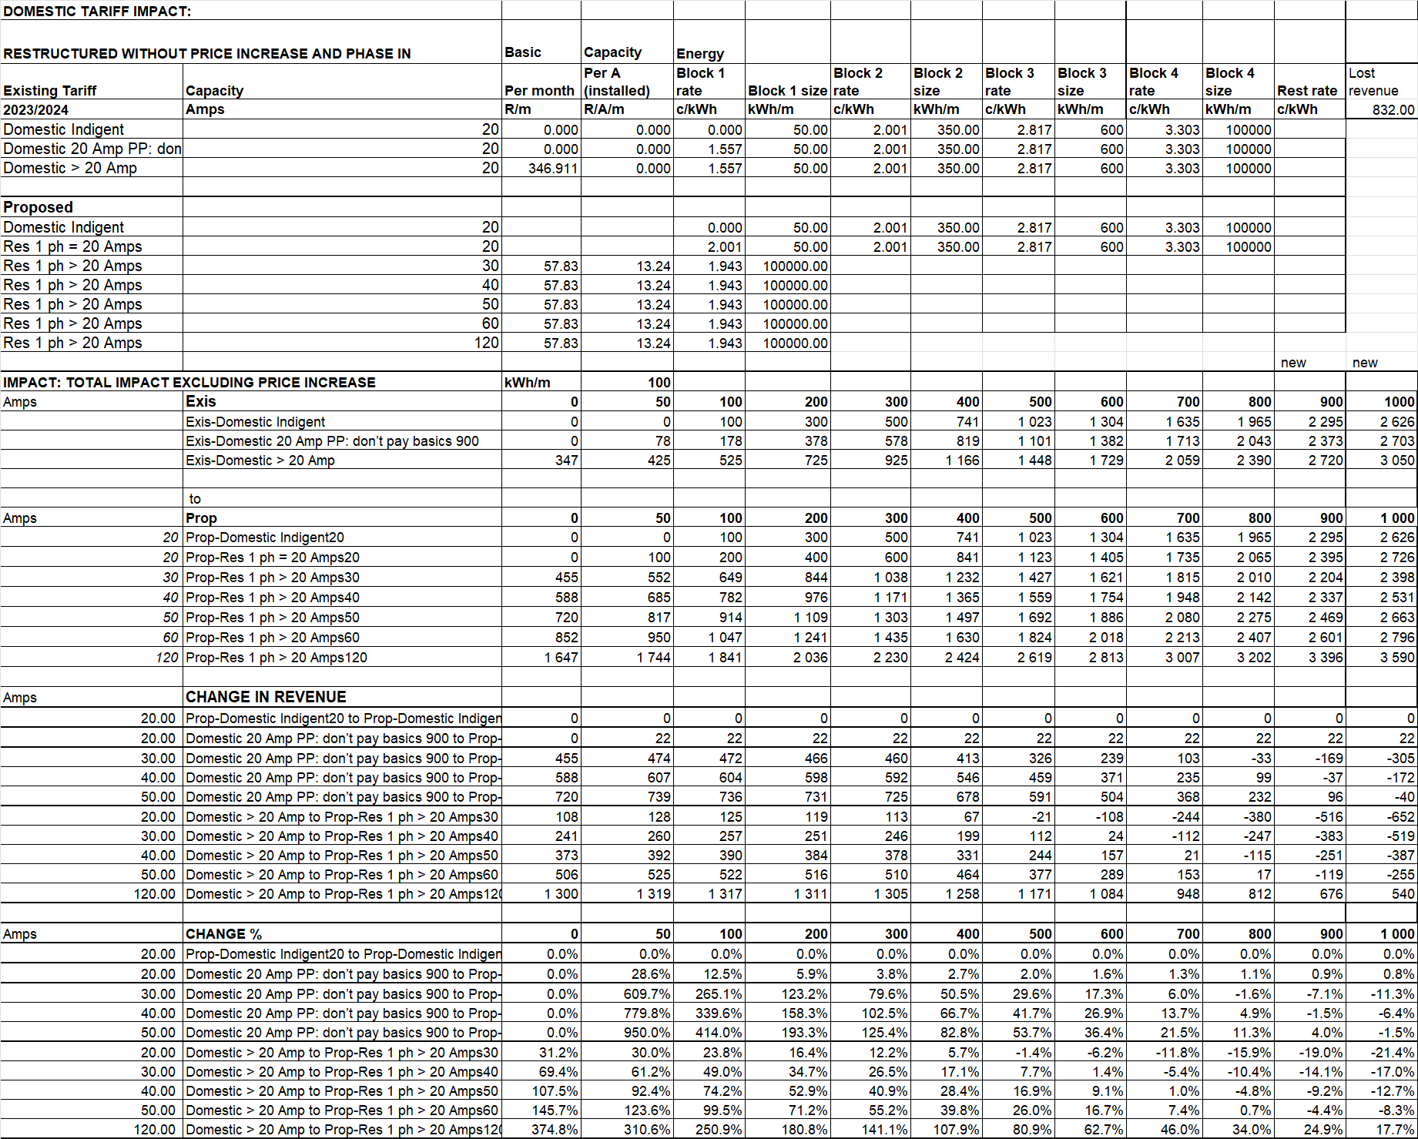

The average percentages only represent the average. The case will be different for each customer. It will depend largely on how effective customers utilise their capacity. In other words, customers with large capacity and low consumption will see higher increases and those with low capacity and high consumption will see lower increases. This clearly shows that only customers that are not willing to reduce / manage their capacity or have irregular usage over the months in the year will pay significantly more. If these tariffs are phased in over 3 years customers will have time to adapt to the new rates and thus manage their bills.

The impact on Business consumers is illustrated here. Table 68 below show the existing and proposed tariffs.

Table 68
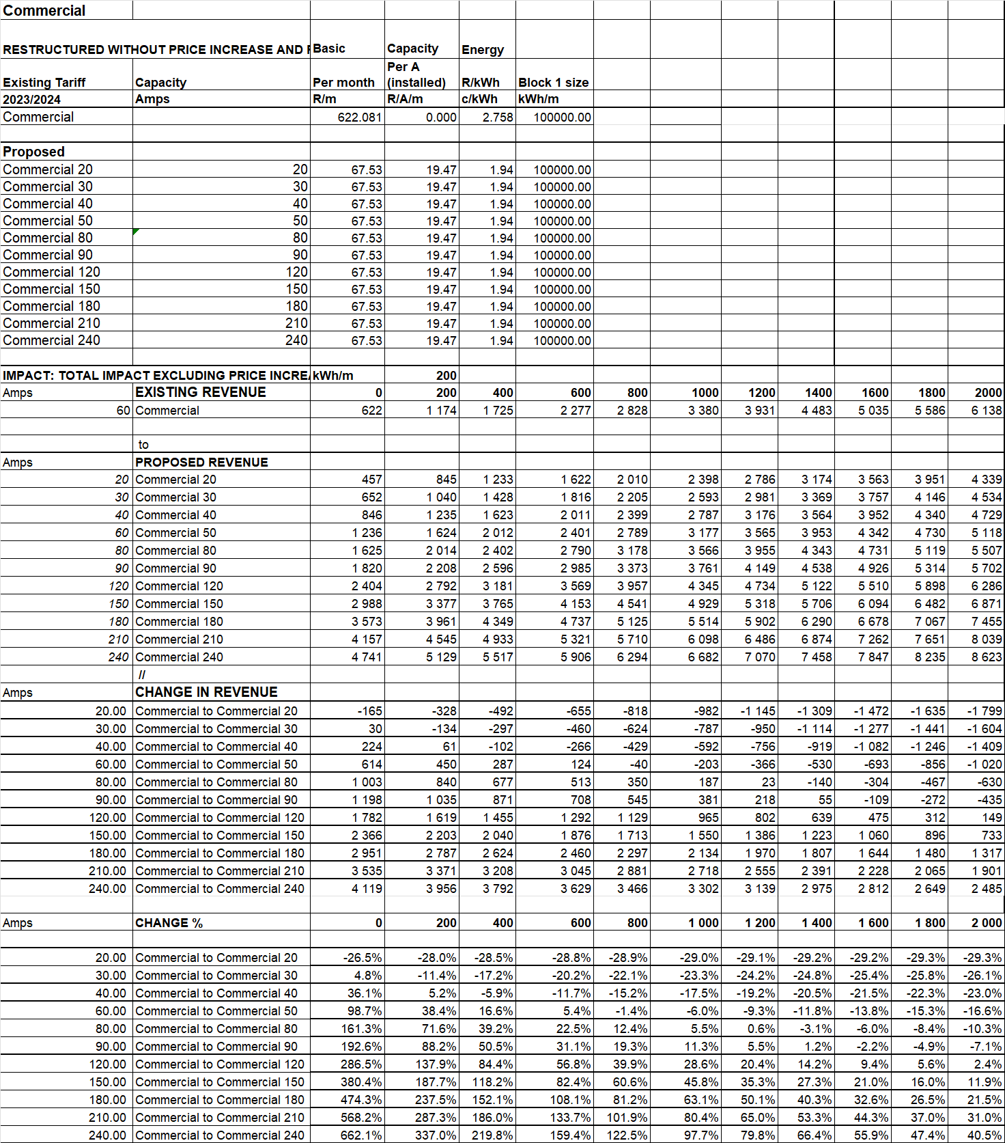

It is believed that if phased in over 3 years this impact should be acceptable and the results should be very good for the municipality.

BULK TOU TARIFFS

TOU tariffs must continue to be applied to Bulk consumers and even be applied to small customers. This is because:

- It offers opportunities for customers to shift load thereby reducing their own costs without any detrimental financial impact on the municipality.
- It offers savings to the municipality when the system peaks are reduced due to customer load shifting.
- Municipal own purchase costs can be reduced when the tariff is applied to internal consumption points such as sewerage works.
- This is a requirement in terms of the EPP.

The Cost of Supply study follows an approach of applying % surcharges to achieve the required revenue. When this is applied to the TOU energy rates, the tariffs are seriously distorted. This is because the same % surcharge on the more expensive Peak energy charges cause a very high c/kWh mark-up compared with that on the cheaper off-peak period. This means that when customers shift load from the Peak to Standard or Off-peak, the loss in revenue far exceeds the savings in Eskom purchase costs.

The tariffs are then redesigned by applying the same c/kWh on all energy rates but to still achieve the same revenue as shown in Table 69. It also shows the load shifting impact of the initial tariffs. Under the proposed tariffs the load shift impact is zero as the mark-up in the different periods are the same and thus no net revenue (change in revenue minus charge in purchase cost) is lost.

Table 69
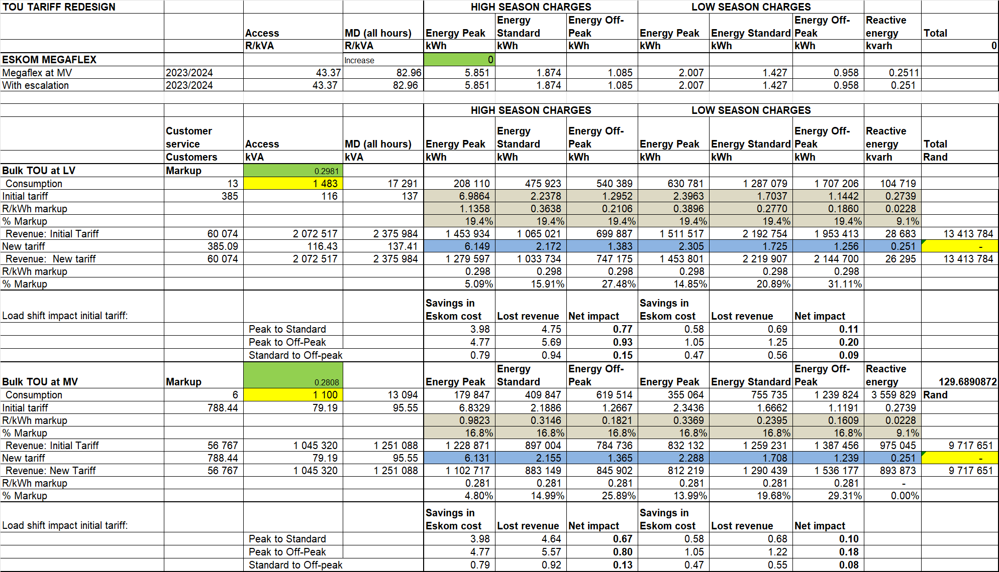

The following is important to note from this change to TOU tariffs:

- The basic, capacity and demand charges remain the same.
- The energy charges are set with the same c/kWh markup on each Eskom TOU energy charge.
- The revenue from each TOU tariff remains the same (difference in yellow)
- This is done by adjusting the c/kWh markup (in green).

Bulk TOU tariff impact study

Although the cost of supply study proposes tariffs that are cost reflective with subsidies for the poor it is important to get an idea of the impact on individual customers. Normally individual impact studies are done for all Bulk customers. Not all load profile data available to the municipality was made available for analysis. There was also an argument that the load profile data may not be displayed with any customer names. The data that was made available was analysed to illustrate the individual customer impact.

The tariffs used for the analysis is shown in Table 70. The existing maximum demand charges that are different for each TOU period has been recalculated to reflect one demand charge by using the relative demands of consumers in the different periods times the rate for each period.
Table 70
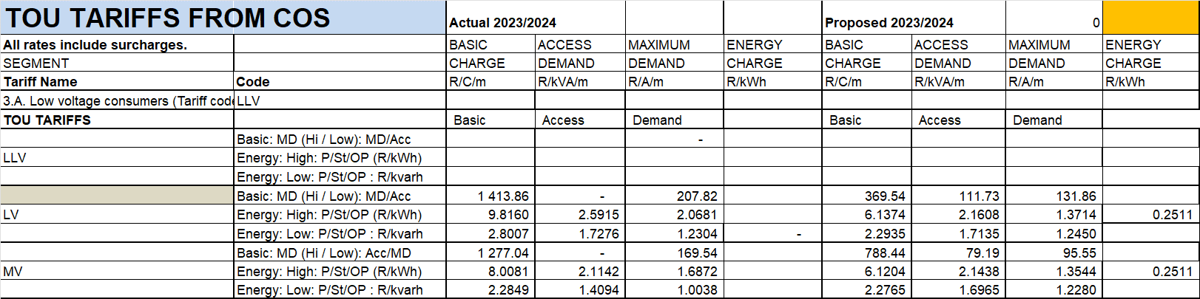

The ½ hourly load profile of all the profiles that were sent were analysed. The result of this analysis is illustrated in Table 71 for one customer.

Table 71
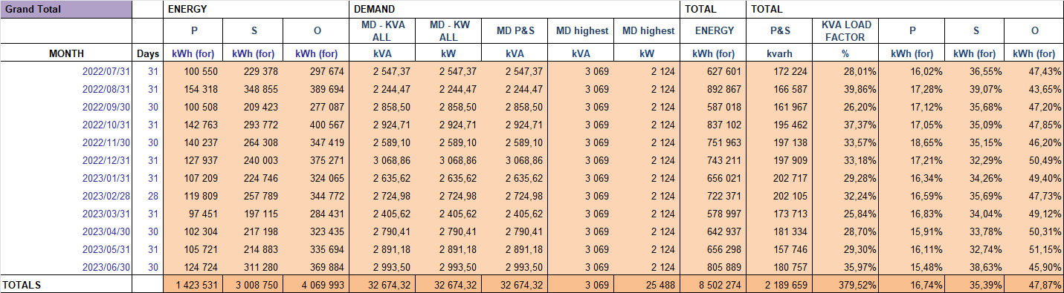

The calculation of the revenue for each of the tariff components for each month is shown in Table 72. This is done for each of the tariff options.

Table 72
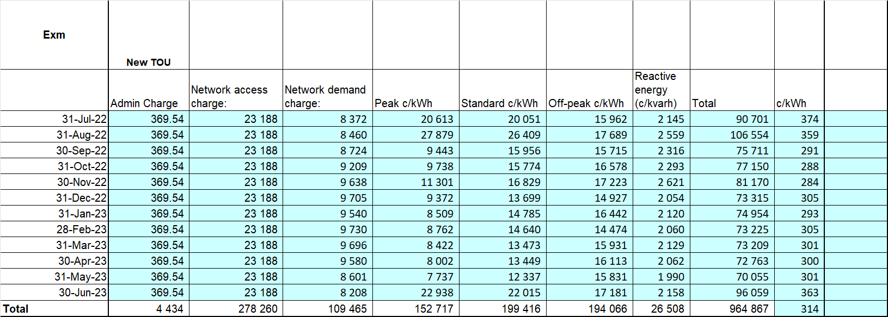

This is then done for all customers. The results are shown in Table 73. It shows the following impact for each customer. The table shows the impact for the consumers who’s load profiles were provided. This represents about 25% of the total bulk sales. The names have been hidden for privacy.

- Old to New TOU

Negative (-) amounts shown reduction in bill and positive (+) amounts show increases.

Table 73
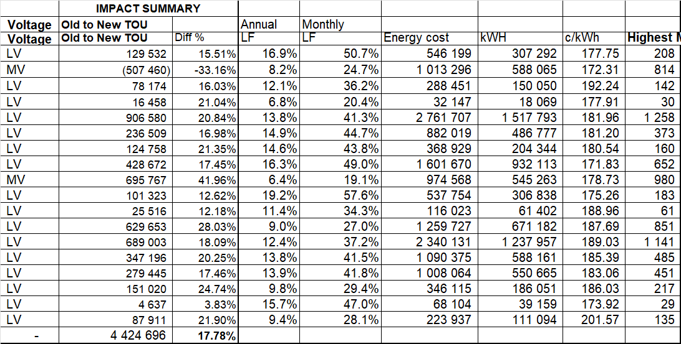

This shows a total decrease in revenue higher that on the main study. This is because this is only a part of the total consumer base.

The impacts are illustrated graphically in Figure 19.

Figure 19
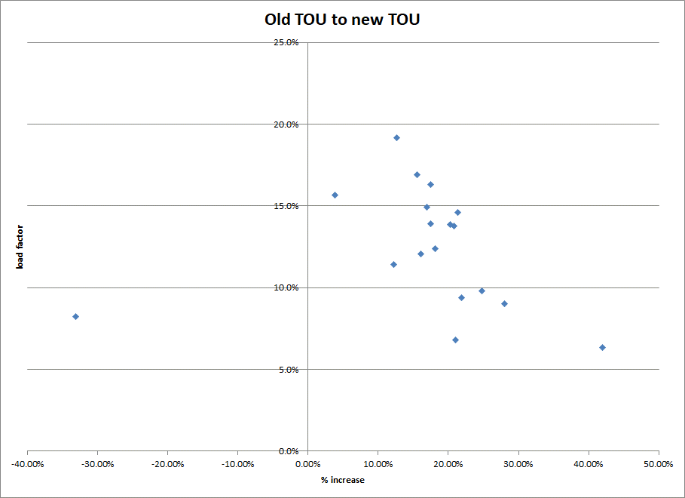

The main reason for the big savings for many of these consumers is because the current demand charges are too high and the energy rates are too low. Those customers with low load factors were thus heavily overcharged in the past.

TOU tariff recommendations

The following is thus proposed in this respect:

- The tariffs thus be developed based on the cost of supply results.
- The differentiation will be set as per cost differences.
- The markup on energy will be in R/kWh and not in %.
- The surcharges be removed and be replaced with new tariff rates to achieve the desired revenue.
- A TOU tariff also needs to be created for small consumers.

AVAILABILITY CHARGES

The municipality uses the incorrect terminology by referring to availability charges when they mean Basic charges. The terms availability charges is generally refer to in the industry as stands where the supply is available but not taken by the owner. Basic charges refer to the charge levied to consumers to covered the following costs:

- Meter kiosk with circuit breakers, supply cable / line and meter.
- Meter reading, billing, revenue collection, vending, customer services.
- Meter repairs, replacement, maintenance, auditing, fault replies, etc.

The calculation of availability charges is done in the following way:

- No contribution is made to the costs covered by the basic charge.
- No contribution is made to the Maximum demand charge which include:
  - The Eskom maximum demand charge
  - 50% of the municipal network costs
- The full contribution is made to the Access charge which include:
  - 50% of the municipal network costs (the more dedicated portion)
  - The Eskom Access charge as capacity has to be reserved to Eskom.
- The demand on the network to calculate the access charge is based on the following:
  - The design capacity of the network. This refer to the so called ADMD (After Diversity maximum Demand) which is usually about 1 to 5 kVA depending on the type of area.
  - This can be expressed by the installed capacity before diversity. For these calculations a 30 Amp single phase supply with a 30% co-incident factor is used which comes to:
    - 30 Amps x 240 Volts = 7.2 kVA ÷ 3 = 2.4 kVA (ADMD).

This represents the minimum that should be charged as the whole network still needs to be maintained and be paid for whether consumers use electricity or not.

BASIC CHARGES

The is an issue in Ndlambe that consumers are complaining hat they have to pay a basic charge per meter in cases where multiple points of supply is provided on single properties. The following should be noted in this respect:

- The law in fact stipulated that only one point of supply is allowed per erf.
- In other words it is a concession by the municipality to allow multiple supplies on one stand.
- These multiple supplies neds itself to electricity theft as multiple wires enter the property which are not metered thus exposing the municipality to risk.
- The current basic charge covers the normal basic customer services costs but also makes a contribution to the network.
- The new tariffs will split these costs and thus each meter will only pay:
  - The basic consumer services associated with a meter.
  - The capacity of each supply (meter).
- With the new meter the system would thus be more fair as the capacity that can be associated with the different meters will each make its fair contribution to the network costs.

If consumers feal unhappy with this arrangement they can take a single supply from the municipality and distribute and supply meters and vend (sell) their own units to the various different supplies on the property themselves.

SMALL SCALE EMBEDDED GENERATION (SSEG)

The important issue in respect of SSEG customers is that they must be on a cost reflective tariff with fixed and capacity / demand charges close to cost.

Ideally all SSEG consumers should be on a TOU tariff with 4 quadrant meters:
- A new TOU tariff for small consumers, <100 kVA, has been developed.
- Any consumer can select this tariff, but all SSEG consumers must be on this tariff.
- It is subject to an application and payment for the supply and installation of a 4 wire, 4 quadrant TOU meter.
- The tariff has been designed as follows:
  - The basic charge equal to the average of a 1 and 3 phase TOU meter supply.
  - The capacity charge is set at the average of the Domestic and Commercial tariff capacity charge.
  - The energy rates are set equal to the Bulk LV plus the additional losses on the LV network.
  - No reactive any charge is levied.

The SSEG Feed-in tariff, which caters for consumers who want to feed-in to the network, is as follows:

- An additional basic charge to cater for the additional metering & administration costs to administer the feed-in.
- The energy credit rates are set at 80% of Eskom Megaflex energy charges applicable to Ndlambe.
- This tariff applies to any customer wanting to feed-in irrespective of whether they have a LV or MV connection.
- Various other conditions apply.

The proposed TOU to be applied to SSEG consumers smaller than 50 kVA and the SSEG additional basic charge and feedin rates which apply to all SSEG consumers are shown in Table 74 below.

Table 74
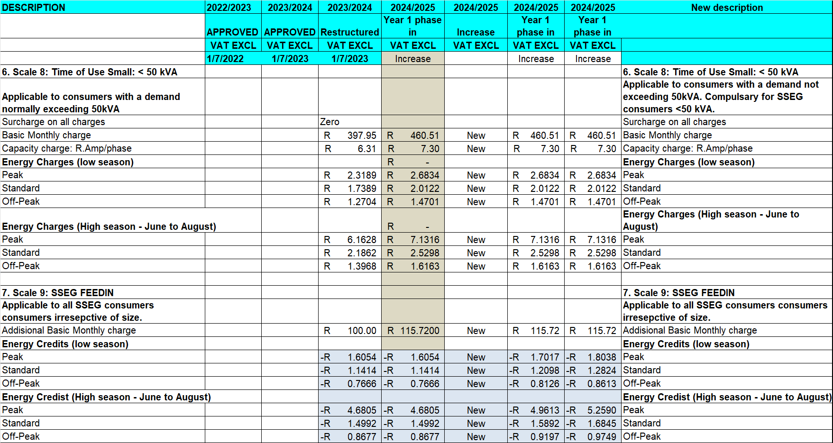

Realistically the municipality does not currently have the resources to manage many electronic meters.
An alternative option is as follows:
- SSEGS consumers pay the standard domestic tariff plus the additional SSEG basic charge.
- The energy charge for consumption remains the same.
- The export tariff be set as a single energy rate.
- The standard Ferraris disc meters cannot be used as these meters turn backwards when any energy is exported. The consumer will thus at least have to pay for any electronic meter that will block / not record any export energy.
- These consumers must at least take a 30/40 Amp supply.

It is realised that many SSEG consumers use very little energy. In terms of the current industry accepted norm consumers can only export so much energy as the value of their energy consumed. This seriously limits any exports. Cape Town has obtained approval from NERSA to buy more than the value of what the consumer buys from National Treasury.

The potential to buy massive amounts of energy from SSEG consumers is very real. It is therefore proposed that the TOU option with 4 quadrant meters be the preferred way to address these consumers. In terms of managing the electronic meters with remote access it is strongly proposed that an external contractor be appointed to do this management. The additional cost can be the basis for the additional SSEG basic charge and thus it would not have a negative financial impact on the municipality.

PHASE IN

It is accepted that the proposed tariff structure changes will have a marked impact on customers. Some customers will pay much less and others much more. For this reason, the possibility to phase the changes in evenly over 3 years could be considered. This can be done as follows:

- Calculate the difference between the current charge and the proposed charge. (basic, Amp, R/kVA, energy).
- Divide the difference by 3 and add to the current charge.
- Then add annual price increase %.
- In year two add 1/3 of the difference and year three the full difference.
- Continue this trend to the end of the 3 year phase in.
- In some cases, combine different tariffs to reduce the total number.

This phase in plan has many difficulties:

Domestic.
- Indigents and 20 Amp will see no change.
- Those with supplies > 20 Amp single phase with see basic charges reducing and capacity charges increasing and the higher energy block prices reducing.

Commercial
- They will see basic charges reducing and capacity charges increasing and the energy charges reducing.

Bulk.
- Two Bulk tariffs will exist during the phase in period:
  - TOU either LV or MV

All of this will create careful administration.

The following is proposed for implementation with no phase in:

- All SSEG consumer go to the full cost reflective tariffs.
- Streetlight tariff.
- Internal supplies. (own use)

The schedule containing the proposed phase in rates for year one including the annual price increase is shown in Table 75.

Table 75
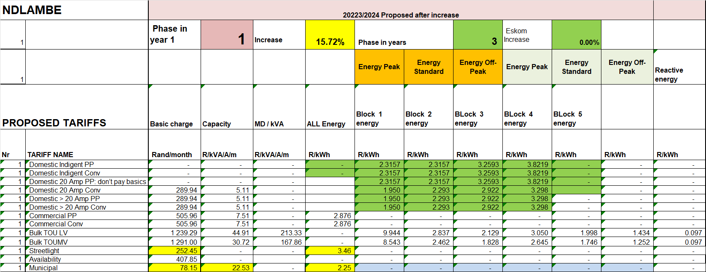

The calculated revenue using the phase I rates with annual price increase is shown in Table 76 and the summary in Table 77.

Table 76
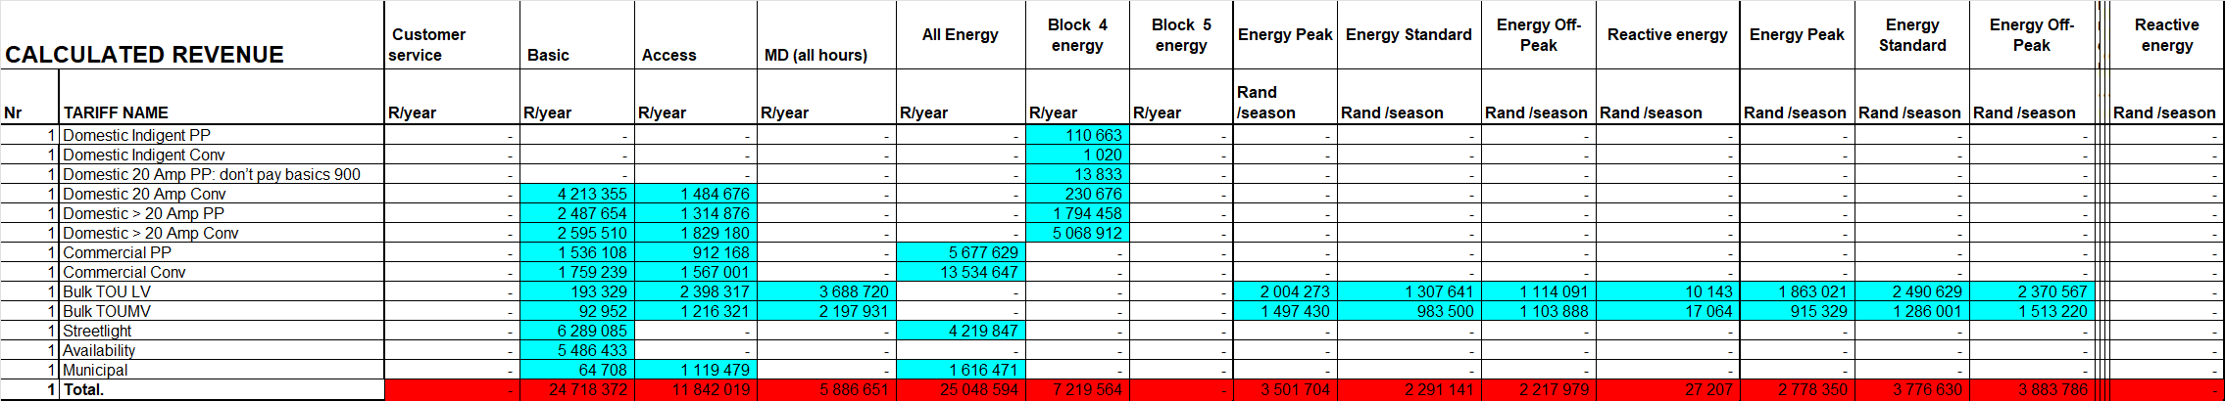
Table 77
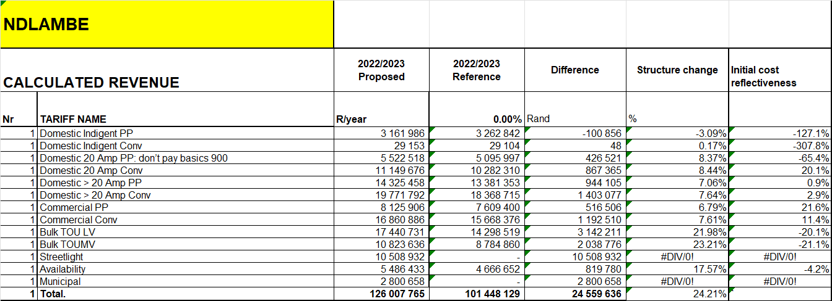

This shown an increase of 15% on the reference value.

TARIFF SCHEDULE

The proposed tariff schedule is shown in Table 78 It shows the following rates:

- The fully cost reflective rates for 2023/2024 without phase in or annual price increase for 2024/2025.

Table 78
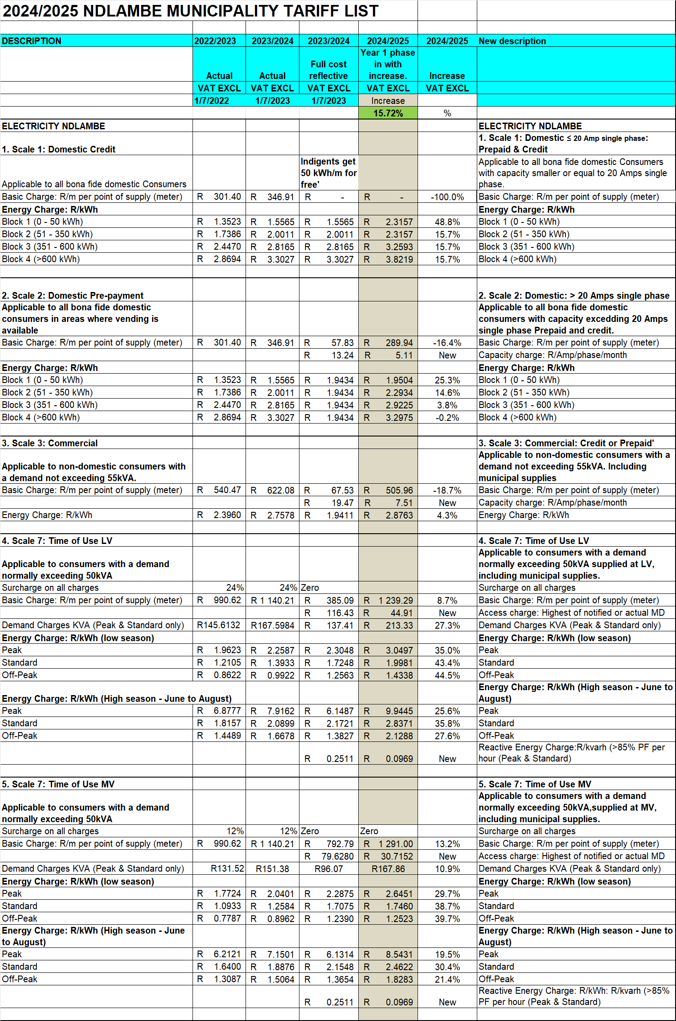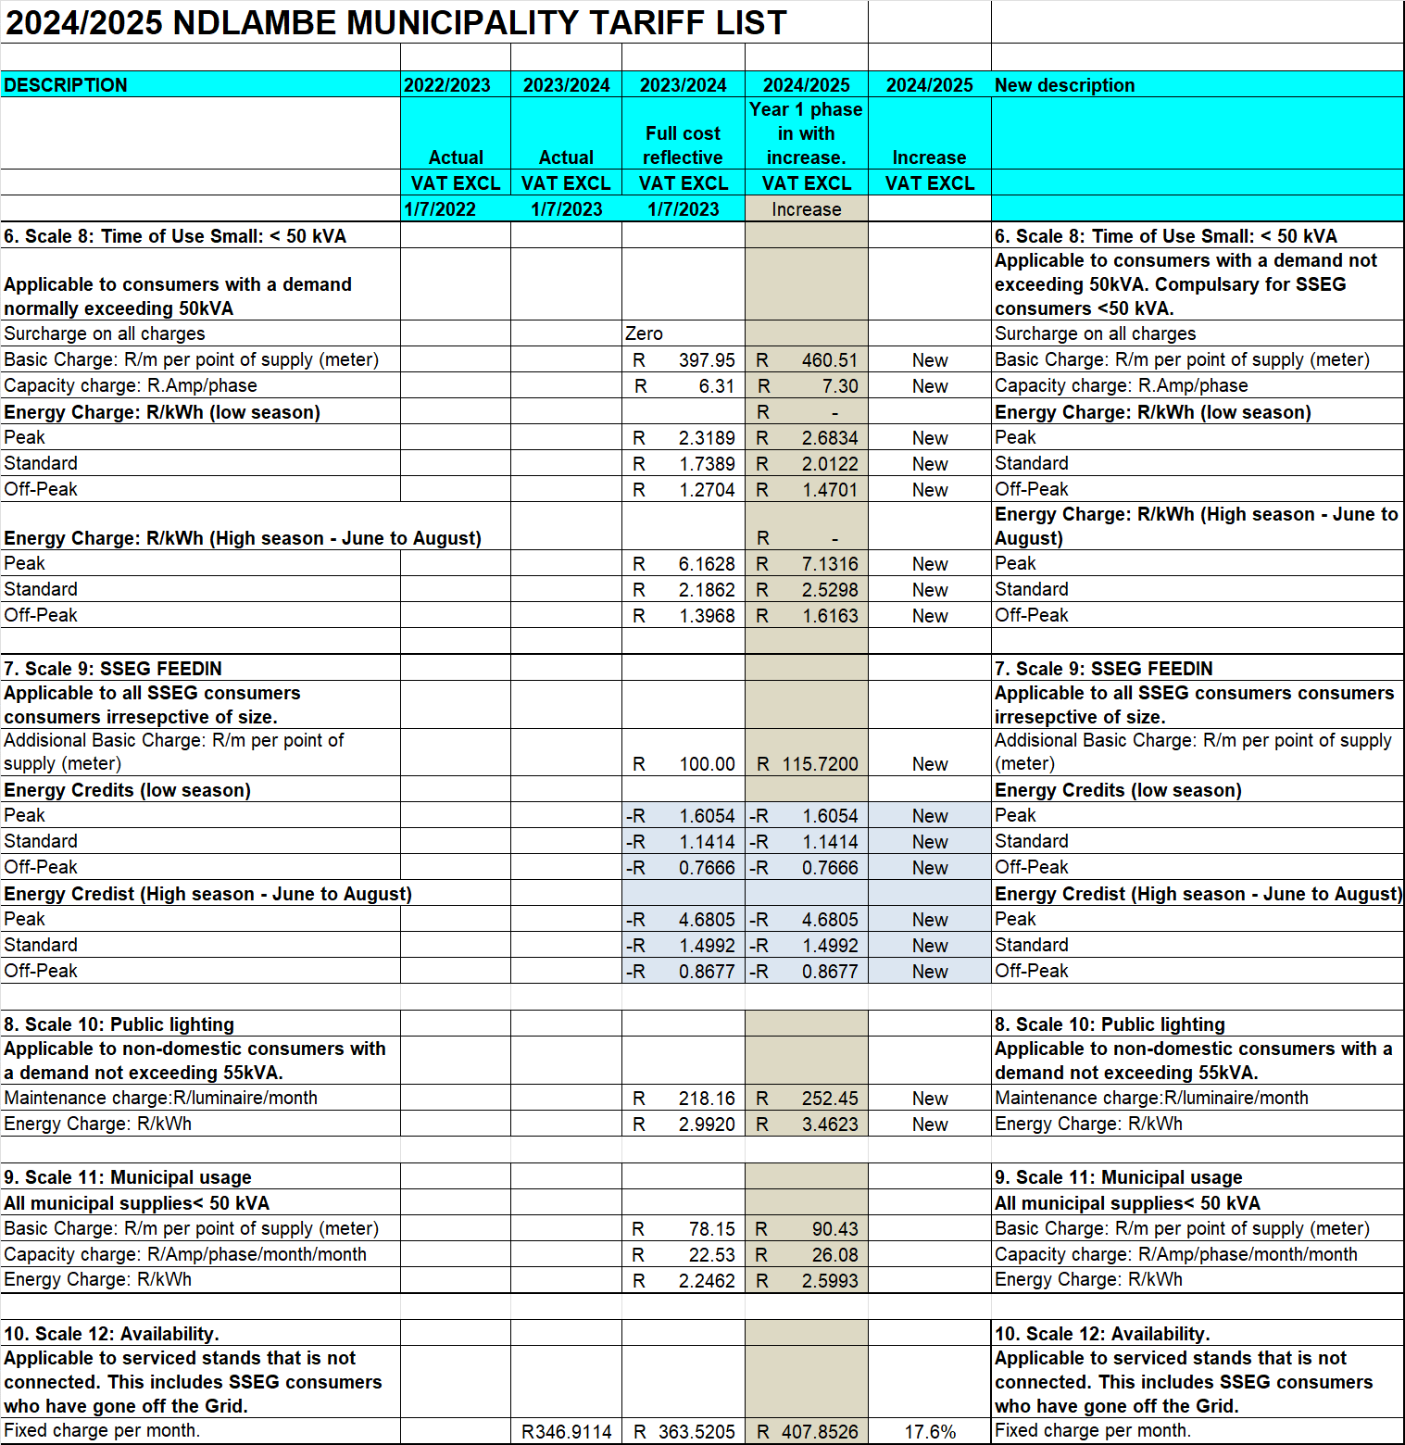

CONCLUSIONS

This detailed Ringfencing, Cost of supply and Pricing study presented many different challenges. All these have been addressed and the results obtained are considered 95% accurate. The current tariffs were found needing major changes. These will send a clear signal about the value of capacity which in time will assist the municipality in controlling it costs which are largely dictated by capacity.

The COS study must now be workshopped internally and be approved by Council and then be submitted to NERSA. Once the budget process starts the proposed tariffs need to be submitted to proper public participation. Only once NERSA approval and public participation process is completed can implementation begin.

ANNEXURE

Allocation of network costs to tariff categories.

Before proceeding to calculation of unit costs the issues of how to allocate network costs to different tariff categories need to be explored. NRS058 explores various methods. It is the consultant’s expert view that the method that best allocates costs to the category of customers who cause the high demand and thus high costs should be based on each category of customer’s contribution to the system peak. Various approaches could be followed in this respect such as not just using one single peak demand but maybe the average of the highest week or average of the 12 highest demands etc. The problem is that this requires very accurate data. The work in previous sections have already illustrated the problems with the data obtained reflected mainly in the fact the peak in the Eskom profile data and that from the simulated profile differ such that one is in the morning and the next in the evening. This caused the requirement to analyse the impact using the different methods. The results for the allocation of network costs at the highest voltage level network are reflected in Table 79.

Table 79
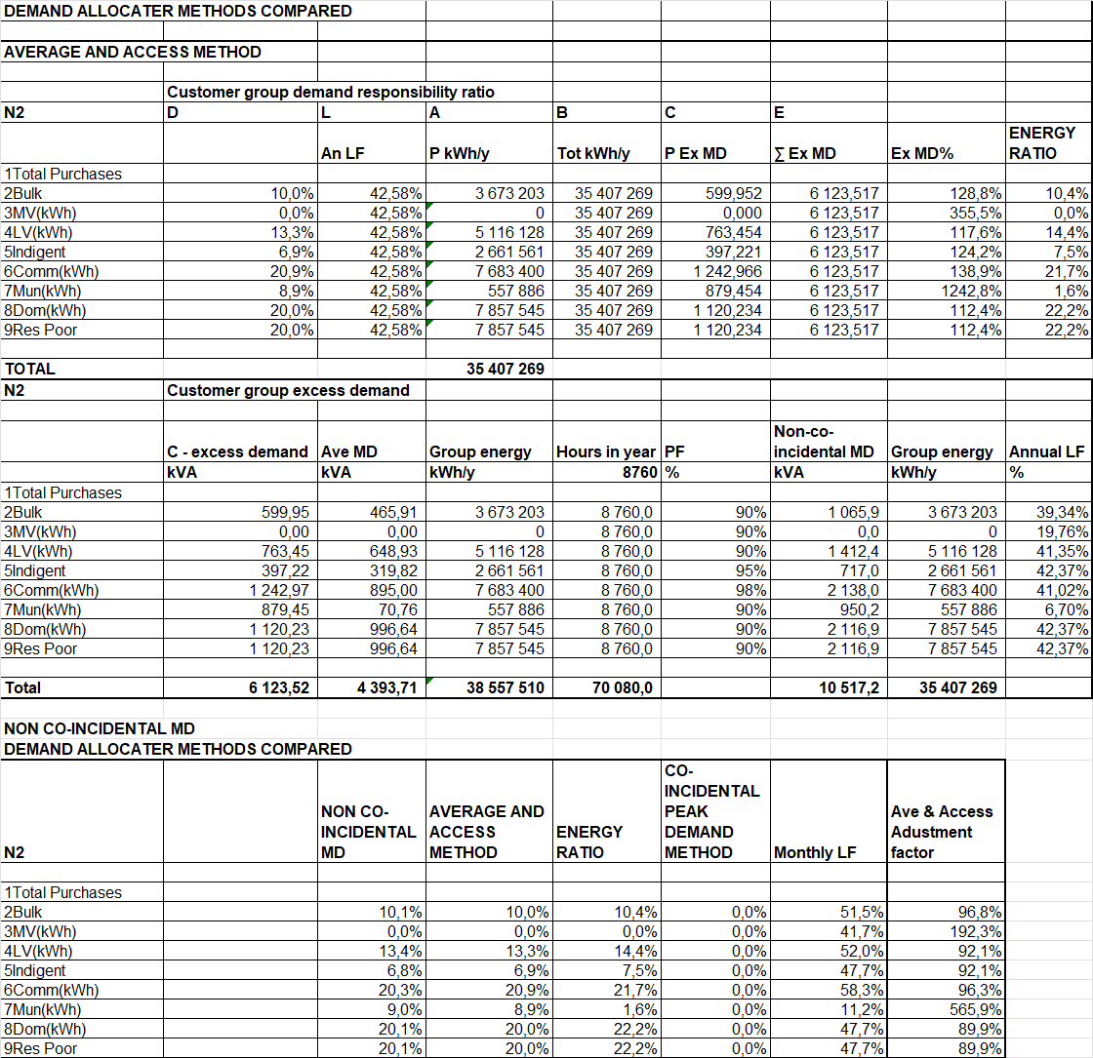

This shows the following:

The following in this respect:

- All methods yield similar results.
- The energy ratio method seems out of line with the other methods, as is to be expected.
- The average and access method and Non-co-incidental methods are almost identical.
- From the profiles it is clear that the annual peak demands are mainly caused by residential customers.
- The co-incidental peak demand methods best reflect this reality which will show domestic costs even higher.

For simplicity’s sake and close results with the Average and access method the non-co-incidental peak demand method was used as basis to allocate all network costs.

Definitions.

Ampere (A): The unit in which electric current is measured being the rate of flow of electric current through a conductor and which is comparable to the rate of volume of water flow through a pipe.

Capacity utilisation. – This refers to the extent to which the capacity that has been installed for a customer has been utilised by the customer.

Charges. – This refers to different charges that a customer has to pay such as a charge for energy or charge for installed capacity.

Clients. – This refers to other contacts of the utility such as contractors, consultants, etc.

Connection fee: The minimum, once-off, up-front payment for new or additional capacity

Consumers. – This refers to any user of electricity whether it be an illegal connected supply, unpaid supply or third-party person.

Cross subsidy. – This refers to cases where one set of customers are subsidised by another set of customers because their tariff does not cover their cost of supply.

Customer. – This refers to a consumer that is legally connected to the electricity network, is contracted with the supply utility and is paying their dues.

Demand charge: A R/kVA or R/kW charge which is time and/or seasonally differentiated and is applied to the chargeable demand registered during the month.

Demand tariffs. – This refers to tariffs that charge for the maximum demand taken by the customer every month.

Diversity Factor: This is defined as the ratio of the sum of individual consumers’ non-coincident maximum demands to the total maximum demand of a group, which is an indication of the extent to which the same capacity can be used for different consumers

Electrical Energy – This refers to the amounts of units of electricity consumed. This is normally measured for a month.

Gigawatt (GW): Equal to one thousand MW or one million kW.

Inter tariff cross subsidies. – This is where one category of customers is cross-subsidising another category of customers.

Intra tariff cross subsidies. – This is where there is cross subsidisation between the different customers within a particular customer category such as high usage customers cross-subsidising low usage customers.

kWh (kilo Watt hour) – This is the unit of measure for energy. It means 1000 of Watt hours. In other words, if a 100 Watt globe was burning for 10 hours.

Kilovolt-Ampere (kVA): The product of volts and amperes times 1 000, i.e. V x A x 1 000. This is a measure of “apparent” electrical power.

Kilowatt (kW): The product of kVA and power factor which is a measure of “true” electrical power. The expression for kW is V x A x power factor x 1 000.

Kilowatt-hour (kWh): The total amount of energy used in one hour by a device that requires one kilowatt of power for continuous operation, i.e. the product of kilowatts and hours.

kVA (kilo Volt Ampere) – This is the unit of measure for maximum demand. It includes the real and reactive components of power.

kW (kilo Watt) – This is also a unit of measure for maximum demand but only the real component. Here the calculation is done over a 1-hour period. The maximum demand taken by ten 100-Watt globes equals to 1 kW.

Load factor. – This refers to the amount of electricity consumed by a customer in a billing period relative to the amount of energy that could have been consumed had the appliances been kept on all the time. This indicates how effective the capacity had been used.

Load factor (LF) annual: Total kWh/y divided by the highest maximum demand in the year times 12 times the total hours in the year. (Total kWh for year) ÷ (Highest maximum demand in year x 12 x hours in year).

Load factor (LF) average monthly: Total kWh/y divided by the sum of the maximum demands of all months in the year times 12 times the total hours in the year. (Total kWh for year) ÷ (Sum of 12 maximum demands in year hours in year).

Life line. – This refers to a tariff that provides support, subsidy, discount to customers. This is usually not available to all customers and provide more support at low consumption levels and become more expensive at high consumption levels.

Maximum demand. – This refers to the maximum demand that the customer places on the network normally averaged over a half hour period.

Megawatt (MW): Equal to one million Watts or 1 000 kW.

Network voltage. – This refers to the voltage at which the network operates. This voltage is usually higher to transfer large amounts of power.

Network capacity. – This refers to the maximum rating of the network equipment that has been installed to supply a customer. This is expressed as kVA or A (Amperes).

Point of delivery (POD): A physical point on the electrical network, where electricity is delivered to a customer, usually the metering point.

Point of supply: It could be a single point of delivery to a customer or a specific group of points of delivery on the System from where electricity is supplied to the customer.

Power Factor (PF): The ratio kW / kVA indicates the ratio of “true” electrical power to “apparent” electrical power, i.e. the ratio of useful work to the total quantity of volts and amperes supplied.

Reactive energy charge: In case of Megaflex, it is levied on every kvarh which is registered in excess of 30% of the kWh supplied during the specified periods of the month.

Supply voltage. – This refers to the voltage at which customers are supplied. The supply voltage for households is usually 240 V (volt).

Single energy rate tariff. – This refers to a tariff that only has one charge and that is a simple energy charge eg. 25 c/kWh.

Seasonal tariffs. - This refers to tariffs where the price for electricity consumed during different seasons of the year is different. This is because there is a much higher demand for electricity typically in Winter making it more expensive to provide.

Tariff. – A tariff is the combination of various charges as mentioned above to make up a tariff applicable for a specific customer category.

Tariff structure. – This refers to the type of charges in the tariff as well as the relative sizes of the different charges.

Tariff restructuring. – This refers to the process of changing the charges in a tariff but also the relationship with other tariffs.

Two part tariff. - This refers to a tariff that has a single energy rate plus a fixed charge, sometimes called a basic charge. For example, the tariff has a basic charge of R100/month and an energy rate if 105 c/kWh.

TOU (Time of Use) tariffs. - This refers to tariffs where the electricity consumed at different times of the day is measured separately and are charged for differently.

Time-of-use (TOU) tariff: A tariff that has different energy rates for different time periods and seasons in order to reflect different cost of supply at different times more accurately.

Voltage discount. – This refers to a discount applied to customers supplied at higher voltages because it is cheaper to supply, and the customer incurs more costs to transfer the energy for their own applications.

Voltage (V): Measure of electric pressure that drives electric current through a conductor.

Watt (W): The unit of electrical power or energy transfer equivalent to one ampere flowing due to an electrical pressure of one volt at unity power factor, W = V x A

Abbreviations

< | less than | CRC | Current replacement cost.
≤ | less than or equal to | ROA | Return on Assets
> | greater than | HV | High Voltage ≥ 40 kV
≥ | greater than or equal to | MV | Medium Voltage ≥ 1000 V < 40 kV
A | ampere | LV | Low Voltage < 1000 V
c | cents | COS | Cost Of Supply
c/kvarh | cents / reactive kilovolt-ampere-hour | POD | Point of delivery
c/kWh | cents per kilowatt-hour | POS | Point of Supply
CPI | consumer price index | EPP | South African Electricity Pricing Policy
GWh | gigawatt-hour | MFMA. | Municipal Finance Management Act
km | kilometre | MSA | Municipal Systems Act
kVA | kilovolt-ampere | IBT | Inclining Block Rate Tariff
kvarh | reactive kilovolt-ampere-hour | CRC | Current replacement cost.
kV | kilovolt | LF | Load factor
kW | kilowatt | FBE. | Free Basic Electricity
kWh | kilowatt-hour
MVA | megavolt-ampere
N/A | Not applicable
NERSA | National Electricity Regulator of South Africa
NMD | Notified Maximum Demand
PF | Power factor
R | Rand
R/kVA | Rand per kilovolt-ampere
R/kW | Rand per kilowatt
TOU | Time-of-Use
V | volt
VAT | value added tax
W | watt

----------------------------------------------------------------------------------

